Power BI Data Analyst Associate

# Get started with Microsoft data analytics

## Discover data analysis

### Introduction

As a data analyst, you are on a journey. Think about all the data that is being generated each day and that is available in an organization, from transactional data in a traditional database, telemetry data from services that you use, to signals that you get from different areas like social media.

[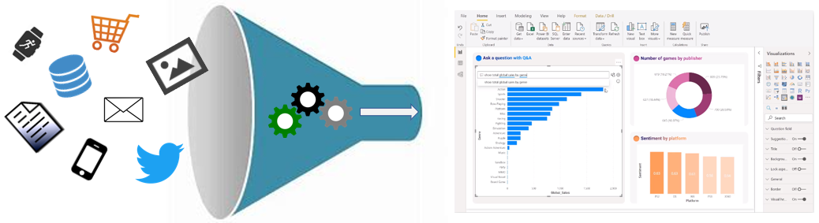](https://learn.microsoft.com/en-us/training/modules/data-analytics-microsoft/media/abundance-data-ss.png#lightbox)

For example, today's retail businesses collect and store massive amounts of data that track the items you browsed and purchased, the pages you've visited on their site, the aisles you purchase products from, your spending habits, and much more.

With data and information as the most strategic asset of a business, the underlying challenge that organizations have today is understanding and using their data to positively effect change within the business. Businesses continue to struggle to use their data in a meaningful and productive way, which impacts their ability to act.

A retail business should be able to use their vast amounts of data and information in such a way that impacts the business, including:

* Tracking inventory
* Identifying purchase habits
* Detecting user trends and patterns
* Recommending purchases
* Determining price optimizations
* Identifying and stopping fraud

Additionally, you might be looking for daily/monthly sale patterns. Common data segments that you might want to examine include day-over-day, week-over-week, and month-over-month so that you can compare how sales have been to where they were in the same week last year, for example.

The key to unlocking this data is being able to tell a story with it. In today's highly competitive and fast-paced business world, crafting reports that tell that story is what helps business leaders take action on the data. Business decision makers depend on an accurate story to drive better business decisions. The faster a business can make precise decisions, the more competitive they will be and the better advantage they will have. Without the story, it is difficult to understand what the data is trying to tell you.

However, having data alone is not enough. You need to be able to act on the data to effect change within the business. That action could involve reallocating resources within the business to accommodate a need, or it could be identifying a failing campaign and knowing when to change course. These situations are where telling a story with your data is important.

The underlying challenge that businesses face today is understanding and using their data in such a way that impacts their business and ultimately their bottom line. You need to be able to look at the data and facilitate trusted business decisions. Then, you need the ability to look at metrics and clearly understand the meaning behind those metrics.

This requirement might seem daunting, but it's a task that you can accomplish. Your first step is to partner with data experts within your organization, such as data engineers and data scientists, to help get the data that you need to tell that story. Ask these experts to participate in that data journey with you.

Your journey of telling a story with data also ties into building that data culture within your organization. While telling the story is important, *where* that story is told is also crucial, ensuring that the story is told to the right people. Also, make sure that people can discover the story, that they know where to find it, and that it is part of the regular interactions.

Data analysis exists to help overcome these challenges and pain points, ultimately assisting businesses in finding insights and uncovering hidden value in troves of data through storytelling. As you read on, you will learn how to use and apply analytical skills to go beyond a single report and help impact and influence your organization by telling stories with data and driving that data culture.

### Overview of data analysis

Before data can be used to tell a story, it must be run through a process that makes it usable in the story. Data analysis is the process of identifying, cleaning, transforming, and modeling data to discover meaningful and useful information. The data is then crafted into a story through reports for analysis to support the critical decision-making process.

[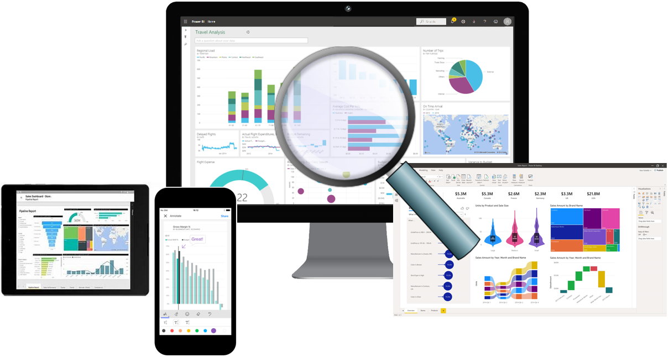](https://learn.microsoft.com/en-us/training/modules/data-analytics-microsoft/media/reporting-trusted-data-ss.png#lightbox)

As the world becomes more data-driven, storytelling through data analysis is becoming a vital component and aspect of large and small businesses. It is the reason that organizations continue to hire data analysts.

Data-driven businesses make decisions based on the story that their data tells, and in today's data-driven world, data is not being used to its full potential, a challenge that most businesses face. Data analysis is, and should be, a critical aspect of all organizations to help determine the impact to their business, including evaluating customer sentiment, performing market and product research, and identifying trends or other data insights.

While the process of data analysis focuses on the tasks of cleaning, modeling, and visualizing data, the concept of data analysis and its importance to business should not be understated. To analyze data, core components of analytics are divided into the following categories:

* Descriptive
* Diagnostic
* Predictive
* Prescriptive
* Cognitive

#### Descriptive analytics

Descriptive analytics help answer questions about what has happened based on historical data. Descriptive analytics techniques summarize large semantic models to describe outcomes to stakeholders.

By developing key performance indicators (KPIs), these strategies can help track the success or failure of key objectives. Metrics such as return on investment (ROI) are used in many industries, and specialized metrics are developed to track performance in specific industries.

An example of descriptive analytics is generating reports to provide a view of an organization's sales and financial data.

#### Diagnostic analytics

Diagnostic analytics help answer questions about why events happened. Diagnostic analytics techniques supplement basic descriptive analytics, and they use the findings from descriptive analytics to discover the cause of these events. Then, performance indicators are further investigated to discover why these events improved or became worse. Generally, this process occurs in three steps:

1. Identify anomalies in the data. These anomalies might be unexpected changes in a metric or a particular market.
2. Collect data that's related to these anomalies.
3. Use statistical techniques to discover relationships and trends that explain these anomalies.

#### Predictive analytics

Predictive analytics help answer questions about what will happen in the future. Predictive analytics techniques use historical data to identify trends and determine if they're likely to recur. Predictive analytical tools provide valuable insight into what might happen in the future. Techniques include a variety of statistical and machine learning techniques such as neural networks, decision trees, and regression.

#### Prescriptive analytics

Prescriptive analytics help answer questions about which actions should be taken to achieve a goal or target. By using insights from prescriptive analytics, organizations can make data-driven decisions. This technique allows businesses to make informed decisions in the face of uncertainty. Prescriptive analytics techniques rely on machine learning as one of the strategies to find patterns in large semantic models. By analyzing past decisions and events, organizations can estimate the likelihood of different outcomes.

#### Cognitive analytics

Cognitive analytics attempt to draw inferences from existing data and patterns, derive conclusions based on existing knowledge bases, and then add these findings back into the knowledge base for future inferences, a self-learning feedback loop. Cognitive analytics help you learn what might happen if circumstances change and determine how you might handle these situations.

Inferences aren't structured queries based on a rules database; rather, they're unstructured hypotheses that are gathered from several sources and expressed with varying degrees of confidence. Effective cognitive analytics depend on machine learning algorithms, and will use several natural language processing concepts to make sense of previously untapped data sources, such as call center conversation logs and product reviews.

#### Example

By enabling reporting and data visualizations, a retail business uses descriptive analytics to look at patterns of purchases from previous years to determine what products might be popular next year. The company might also look at supporting data to understand why a particular product was popular and if that trend is continuing, which will help them determine whether to continue stocking that product.

A business might determine that a certain product was popular over a specific timeframe. Then, they can use this analysis to determine whether certain marketing efforts or online social activities contributed to the sales increase.

An underlying facet of data analysis is that a business needs to trust its data. As a practice, the data analysis process will capture data from trusted sources and shape it into something that is consumable, meaningful, and easily understood to help with the decision-making process. Data analysis enables businesses to fully understand their data through data-driven processes and decisions, allowing them to be confident in their decisions.

As the amount of data grows, so does the need for data analysts. A data analyst knows how to organize information and distill it into something relevant and comprehensible. A data analyst knows how to gather the right data and what to do with it, in other words, making sense of the data in your data overload.

### Roles in data

Telling a story with the data is a journey that usually doesn't start with you. The data must come from somewhere. Getting that data into a place that is usable by you takes effort that is likely out of your scope, especially in consideration of the enterprise.

Today's applications and projects can be large and intricate, often involving the use of skills and knowledge from numerous individuals. Each person brings a unique talent and expertise, sharing in the effort of working together and coordinating tasks and responsibilities to see a project through from concept to production.

In the recent past, roles such as business analysts and business intelligence developers were the standard for data processing and understanding. However, excessive expansion of the size and different types of data has caused these roles to evolve into more specialized sets of skills that modernize and streamline the processes of data engineering and analysis.

[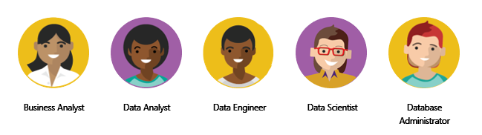](https://learn.microsoft.com/en-us/training/modules/data-analytics-microsoft/media/roles-data-ss.png#lightbox)

The following sections highlight these different roles in data and the specific responsibility in the overall spectrum of data discovery and understanding:

* Business analyst
* Data analyst
* Data engineer
* Data scientist
* Database administrator

#### Business analyst

While some similarities exist between a data analyst and business analyst, the key differentiator between the two roles is what they do with data. A business analyst is closer to the business and is a specialist in interpreting the data that comes from the visualization. Often, the roles of data analyst and business analyst could be the responsibility of a single person.

#### Data analyst

A data analyst enables businesses to maximize the value of their data assets through visualization and reporting tools such as Microsoft Power BI. Data analysts are responsible for profiling, cleaning, and transforming data. Their responsibilities also include designing and building scalable and effective semantic models, and enabling and implementing the advanced analytics capabilities into reports for analysis. A data analyst works with the pertinent stakeholders to identify appropriate and necessary data and reporting requirements, and then they are tasked with turning raw data into relevant and meaningful insights.

A data analyst is also responsible for the management of Power BI assets, including reports, dashboards, workspaces, and the underlying semantic models that are used in the reports. They are tasked with implementing and configuring proper security procedures, in conjunction with stakeholder requirements, to ensure the safekeeping of all Power BI assets and their data.

Data analysts work with data engineers to determine and locate appropriate data sources that meet stakeholder requirements. Additionally, data analysts work with the data engineer and database administrator to ensure that the analyst has proper access to the needed data sources. The data analyst also works with the data engineer to identify new processes or improve existing processes for collecting data for analysis.

#### Data engineer

Data engineers provision and set up data platform technologies that are on-premises and in the cloud. They manage and secure the flow of structured and unstructured data from multiple sources. The data platforms that they use can include relational databases, nonrelational databases, data streams, and file stores. Data engineers also ensure that data services securely and seamlessly integrate across data platforms.

Primary responsibilities of data engineers include the use of on-premises and cloud data services and tools to ingest, egress, and transform data from multiple sources. Data engineers collaborate with business stakeholders to identify and meet data requirements. They design and implement solutions.

While some alignment might exist in the tasks and responsibilities of a data engineer and a database administrator, a data engineer's scope of work goes well beyond looking after a database and the server where it's hosted and likely doesn't include the overall operational data management.

A data engineer adds tremendous value to business intelligence and data science projects. When the data engineer brings data together, often described as data wrangling, projects move faster because data scientists can focus on their own areas of work.

As a data analyst, you would work closely with a data engineer in making sure that you can access the variety of structured and unstructured data sources because they will support you in optimizing semantic models, which are typically served from a modern data warehouse or data lake.

Both database administrators and business intelligence professionals can transition to a data engineer role; they need to learn the tools and technology that are used to process large amounts of data.

#### Data scientist

Data scientists perform advanced analytics to extract value from data. Their work can vary from descriptive analytics to predictive analytics. Descriptive analytics evaluate data through a process known as exploratory data analysis (EDA). Predictive analytics are used in machine learning to apply modeling techniques that can detect anomalies or patterns. These analytics are important parts of forecast models.

Descriptive and predictive analytics are only partial aspects of data scientists' work. Some data scientists might work in the realm of deep learning, performing iterative experiments to solve a complex data problem by using customized algorithms.

Anecdotal evidence suggests that most of the work in a data science project is spent on data wrangling and feature engineering. Data scientists can speed up the experimentation process when data engineers use their skills to successfully wrangle data.

On the surface, it might seem that a data scientist and data analyst are far apart in the work that they do, but this conjecture is untrue. A data scientist looks at data to determine the questions that need answers and will often devise a hypothesis or an experiment and then turn to the data analyst to assist with the data visualization and reporting.

#### Database administrator

A database administrator implements and manages the operational aspects of cloud-native and hybrid data platform solutions that are built on Microsoft Azure data services and Microsoft SQL Server. A database administrator is responsible for the overall availability and consistent performance and optimizations of the database solutions. They work with stakeholders to identify and implement the policies, tools, and processes for data backup and recovery plans.

The role of a database administrator is different from the role of a data engineer. A database administrator monitors and manages the overall health of a database and the hardware that it resides on, whereas a data engineer is involved in the process of data wrangling, in other words, ingesting, transforming, validating, and cleaning data to meet business needs and requirements.

The database administrator is also responsible for managing the overall security of the data, granting and restricting user access and privileges to the data as determined by business needs and requirements.

### Tasks of a data analyst

A data analyst is one of several critical roles in an organization, who help uncover and make sense of information to keep the company balanced and operating efficiently. Therefore, it's vital that a data analyst clearly understands their responsibilities and the tasks that are performed on a near-daily basis. Data analysts are essential in helping organizations gain valuable insights into the expanse of data that they have, and they work closely with others in the organization to help reveal valuable information.

The following figure shows the five key areas that you'll engage in during the data analysis process.

[](https://learn.microsoft.com/en-us/training/modules/data-analytics-microsoft/media/tasks-data-analyst-ss.png#lightbox)

#### Prepare

As a data analyst, you'll likely divide most of your time between the prepare and model tasks. Deficient or incorrect data can have a major impact that results in invalid reports, a loss of trust, and a negative effect on business decisions, which can lead to loss in revenue, a negative business impact, and more.

Before a report can be created, data must be prepared. Data preparation is the process of profiling, cleaning, and transforming your data to get it ready to model and visualize.

Data preparation is the process of taking raw data and turning it into information that is trusted and understandable. It involves, among other things, ensuring the integrity of the data, correcting wrong or inaccurate data, identifying missing data, converting data from one structure to another or from one type to another, or even a task as simple as making data more readable.

Data preparation also involves understanding *how* you're going to get and connect to the data and the performance implications of the decisions. When connecting to data, you need to make decisions to ensure that models and reports meet, and perform to, acknowledged requirements and expectations.

Privacy and security assurances are also important. These assurances can include anonymizing data to avoid oversharing or preventing people from seeing personally identifiable information when it isn't needed. Alternatively, helping to ensure privacy and security can involve removing that data completely if it doesn't fit in with the story that you're trying to shape.

Data preparation can often be a lengthy process. Data analysts follow a series of steps and methods to prepare data for placement into a proper context and state that eliminate poor data quality and allow it to be turned into valuable insights.

#### Model

When the data is in a proper state, it's ready to be modeled. Data modeling is the process of determining how your tables are related to each other. This process is done by defining and creating relationships between the tables. From that point, you can enhance the model by defining metrics and adding custom calculations to enrich your data.

Creating an effective and proper semantic model is a critical step in helping organizations understand and gain valuable insights into the data. An effective semantic model makes reports more accurate, allows the data to be explored faster and efficiently, decreases time for the report writing process, and simplifies future report maintenance.

The model is another critical component that has a direct effect on the performance of your report and overall data analysis. A poorly designed model can have a drastically negative impact on the general accuracy and performance of your report. Conversely, a well-designed model with well-prepared data will ensure a properly efficient and trusted report. This notion is more prevalent when you are working with data at scale.

From a Power BI perspective, if your report is performing slowly, or your refreshes are taking a long time, you will likely need to revisit the data preparation and modeling tasks to optimize your report.

The process of preparing data and modeling data is an iterative process. Data preparation is the first task in data analysis. Understanding and preparing your data before you model it will make the modeling step much easier.

#### Visualize

The visualization task is where you get to bring your data to life. The ultimate goal of the visualize task is to solve business problems. A well-designed report should tell a compelling story about that data, which will enable business decision makers to quickly gain needed insights. By using appropriate visualizations and interactions, you can provide an effective report that guides the reader through the content quickly and efficiently, therefore allowing the reader to follow a narrative into the data.

The reports that are created during the visualization task help businesses and decision makers understand what that data means so that accurate and vital decisions can be made. Reports drive the overall actions, decisions, and behaviors of an organization that is trusting and relying on the information that is discovered in the data.

The business might communicate that they need all data points on a given report to help them make decisions. As a data analyst, you should take the time to fully understand the problem that the business is trying to solve. Determine whether all their data points are necessary because too much data can make detecting key points difficult. Having a small and concise data story can help find insights quickly.

With the built-in AI capabilities in Power BI, data analysts can build powerful reports, without writing any code, that enable users to get insights and answers and find actionable objectives. The AI capabilities in Power BI, such as the built-in AI visuals, enable the discovering of data by asking questions, using the Quick Insights feature, or creating machine learning models directly within Power BI.

An important aspect of visualizing data is designing and creating reports for accessibility. As you build reports, it is important to think about people who will be accessing and reading the reports. Reports should be designed with accessibility in mind from the outset so that no special modifications are needed in the future.

Many components of your report will help with storytelling. From a color scheme that is complementary and accessible, to fonts and sizing, to picking the right visuals for what is being displayed, they all come together to tell that story.

#### Analyze

The analyze task is the important step of understanding and interpreting the information that is displayed on the report. In your role as a data analyst, you should understand the analytical capabilities of Power BI and use those capabilities to find insights, identify patterns and trends, predict outcomes, and then communicate those insights in a way that everyone can understand.

Advanced analytics enables businesses and organizations to ultimately drive better decisions throughout the business and create actionable insights and meaningful results. With advanced analytics, organizations can drill into the data to predict future patterns and trends, identify activities and behaviors, and enable businesses to ask the appropriate questions about their data.

Previously, analyzing data was a difficult and intricate process that was typically performed by data engineers or data scientists. Today, Power BI makes data analysis accessible, which simplifies the data analysis process. Users can quickly gain insights into their data by using visuals and metrics directly from their desktop and then publish those insights to dashboards so that others can find needed information.

This feature is another area where AI integrations within Power BI can take your analysis to the next level. Integrations with Azure Machine Learning, cognitive services, and built-in AI visuals will help to enrich your data and analysis.

#### Manage

Power BI consists of many components, including reports, dashboards, workspaces, semantic models, and more. As a data analyst, you are responsible for the management of these Power BI assets, overseeing the sharing and distribution of items, such as reports and dashboards, and ensuring the security of Power BI assets.

Apps can be a valuable distribution method for your content and allow easier management for large audiences. This feature also allows you to have custom navigation experiences and link to other assets within your organization to complement your reports.

The management of your content helps to foster collaboration between teams and individuals. Sharing and discovery of your content is important for the right people to get the answers that they need. It is also important to help ensure that items are secure. You want to make sure that the right people have access and that you are not leaking data past the correct stakeholders.

Proper management can also help reduce data silos within your organization. Data duplication can make managing and introducing data latency difficult when resources are overused. Power BI helps reduce data silos with the use of shared semantic models, and it allows you to reuse data that you have prepared and modeled. For key business data, endorsing a semantic model as certified can help to ensure trust in that data.

The management of Power BI assets helps reduce the duplication of efforts and helps ensure security of the data.

### [Knowledge check](https://learn.microsoft.com/en-us/training/modules/data-analytics-microsoft/5-check)

### Summary

In this module, you learned that the role of data analyst is vital to the success of an organization. Additionally, the tasks that data analysts perform help ensure that the business decisions are based on trusted data. You also learned about the different roles in data and how the people in these roles work closely with a data analyst to deliver valuable insights into a business's data assets.

## Get started building with Power BI

### Introduction

**Microsoft Power BI** is a complete reporting solution that offers data preparation, data visualization, distribution, and management through development tools and an online platform.

Power BI can scale from simple reports using a single data source to reports requiring complex data modeling and consistent themes. Use Power BI to create visually stunning, interactive reports to serve as the analytics and decision engine behind group projects, divisions, or entire organizations.

Power BI is an essential tool to data analysts and their organization; however, all data professionals benefit from understanding how Power BI works to explore and present data insights within organizations.

### Use Power BI

In order to create reports with Power BI, you must first understand the tools necessary. There are three primary components to Power BI:

* Power BI Desktop (desktop application)
* Power BI service (online platform)
* Power BI Mobile (cross-platform mobile app)

Power BI Desktop is the development tool available to data analysts and other report creators. While the Power BI service allows you to organize, manage, and distribute your reports and other Power BI items. Power BI Desktop is available to download for free either through the Windows store or directly online.

You can access the Power BI service at [app.powerbi.com](https://app.powerbi.com/) with a school or work account. If your organization doesn't already use Power BI, you can still explore the service by getting a free trial or signing up for a free [Microsoft 365 Developer account](https://developer.microsoft.com/microsoft-365/dev-program).

Power BI Mobile allows consumers to view reports in a mobile-optimized format. You can create these optimized report views in Power BI Desktop.

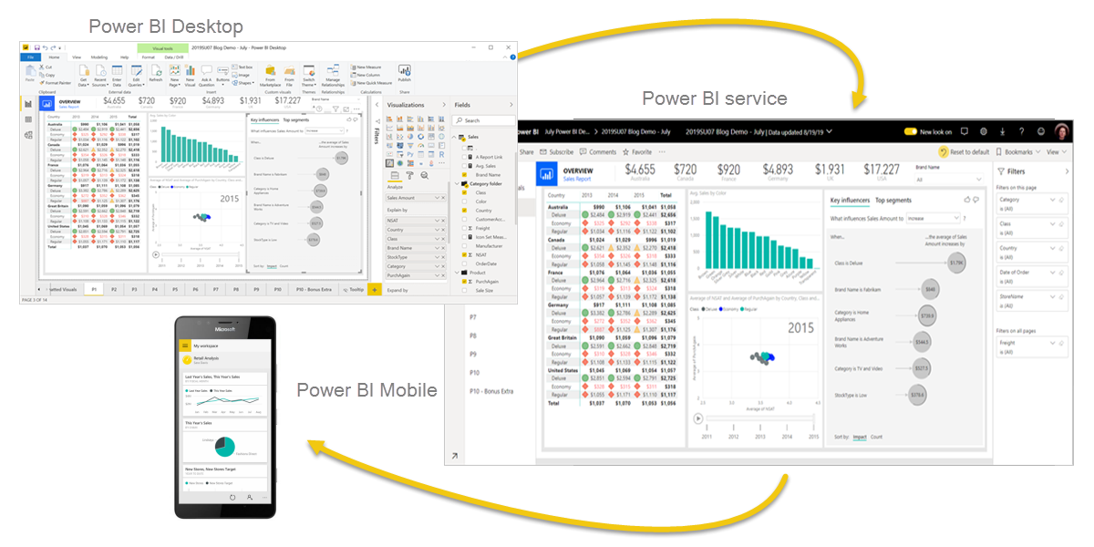

#### Explore the flow of Power BI

There's a common flow when creating reports with Power BI. First, you start with Power BI Desktop to connect to data and create the report. Then you publish the report to the Power BI service and distribute to consumers.

The flow of Power BI is:

1. Connect to data with Power BI Desktop.
2. Transform and model data with Power BI Desktop.
3. Create visualizations and reports with Power BI Desktop.
4. Publish report to Power BI service.
5. Distribute and manage reports in the Power BI service.

The Power BI service also allows you to create high-level dashboards that drill down to reports, and apps to easily group related reports to users in a simple format.

### Building blocks of Power BI

The building blocks of Power BI are **semantic models** and **visualizations**. Create a semantic model and then use visuals to build a report. Let's explore these items in more detail and how they relate to the flow of Power BI.

#### Create a semantic model

A **semantic model** consists of all connected data, transformations, relationships, and calculations. To follow the flow of Power BI, you first connect to data, transform data, and create relationships and calculations to create a semantic model.

First, connect to as many data sources you need. Then clean and transform the data to your needs. Add relationships between tables and calculations to extend the semantic model. After all of that, now you can create a report.

#### Create visualizations in a report

In Power BI Desktop, when you create a **visualization** (also called *visual*), you add it to the **canvas** for a report page. Choose your visualizations to build pages in your report. It's ideal to keep each page simple with related data, so consumers can easily see the insights.

Power BI is a low-code solution, which means that you can *"drag and drop"* data field directly onto the canvas. Power BI will choose a visual for your data field. You can easily change between visuals for the same fields, and add or remove data fields to the visual.

One of the most valuable features of Power BI reports is the interactivity between visuals. Consumers can select different data points in the visual and see how that affects the other visuals. Depending on your design, they can also drillthrough from one visual to more detail or filter based on different fields in the report.

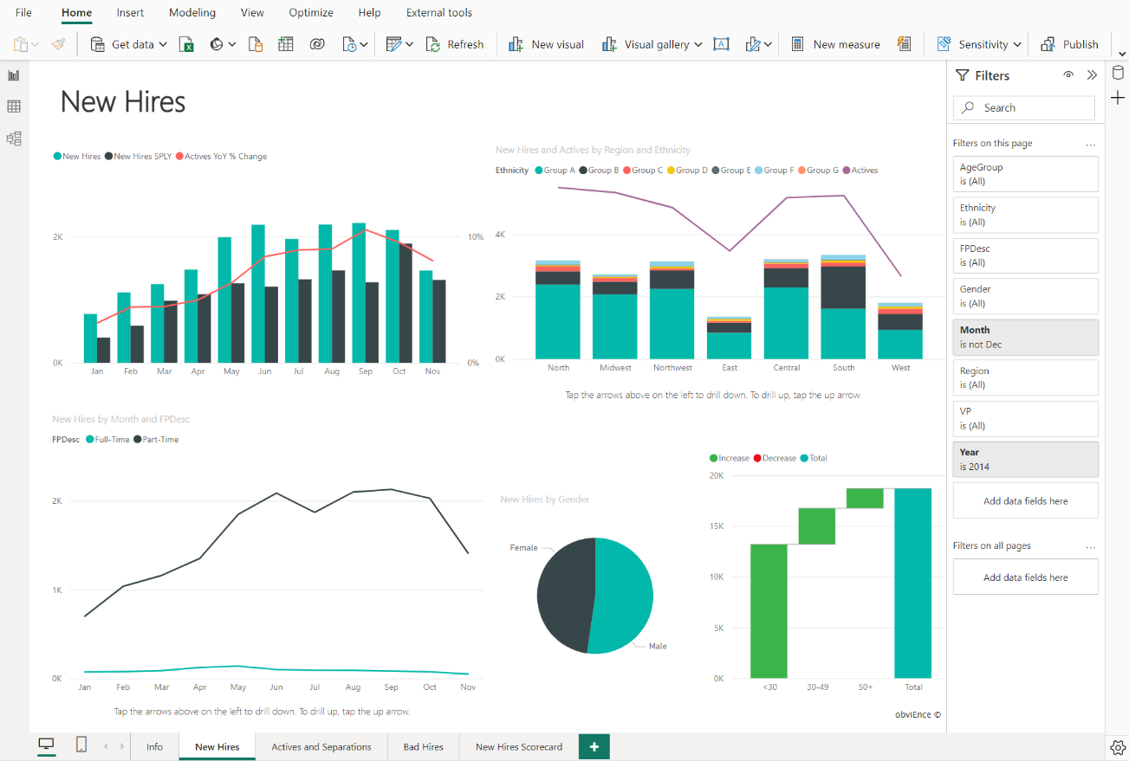

Once you're satisfied with your report, you publish it to the Power BI service.

#### Create a dashboard

In the Power BI service, you can also create **dashboards** after you've published a report. Dashboards consist of a single page made up of **tiles**. Add tiles to a dashboard by pinning a visual in a report to the dashboard. Tiles aren't interactive like visuals, so when a user interacts with the tile, they go to the underlying report for more information.

Dashboards are an excellent way to provide high-level information to consumers. Similar to a dashboard in a vehicle, include the most important information in a dashboard. Then consumers can go to the report for more details.

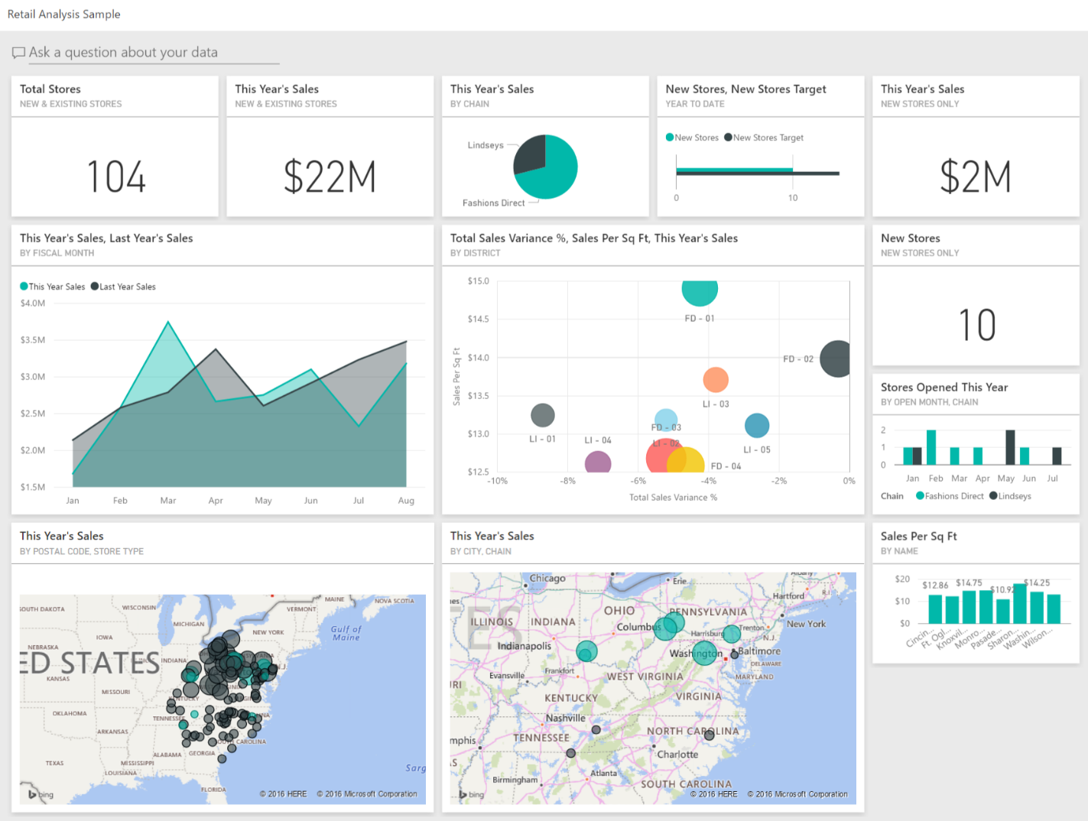

To recap, the building blocks of Power BI are **semantic models** and **visuals**. Using Power BI Desktop, you create the semantic model and use visuals to create reports.

In the Power BI service, you can distribute content to your consumers and use reports to create dashboards.

### Tour and use the Power BI service

Now that you understand how to create a report, let's explore the Power BI service. The Power BI service provides a simple and interactive user experience to take your data analytics to the next level.

#### Organize items with workspaces

**Workspaces** are the foundation of the Power BI service. When publishing any report, you must choose a workspace. By default, every user has access to *My workspace*, which is ideal only for testing. When you want to share content with others, **always** create and use a shared workspace.

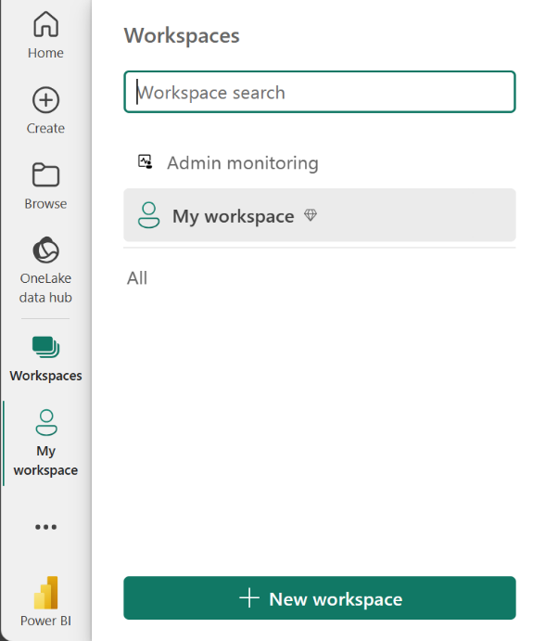

#### Explore sample reports

If you haven't created a report yet, Power BI offers several sample reports for you to explore. These reports load to My workspace so you can explore privately. You can access sample reports in the **Learn** section of the navigation pane.

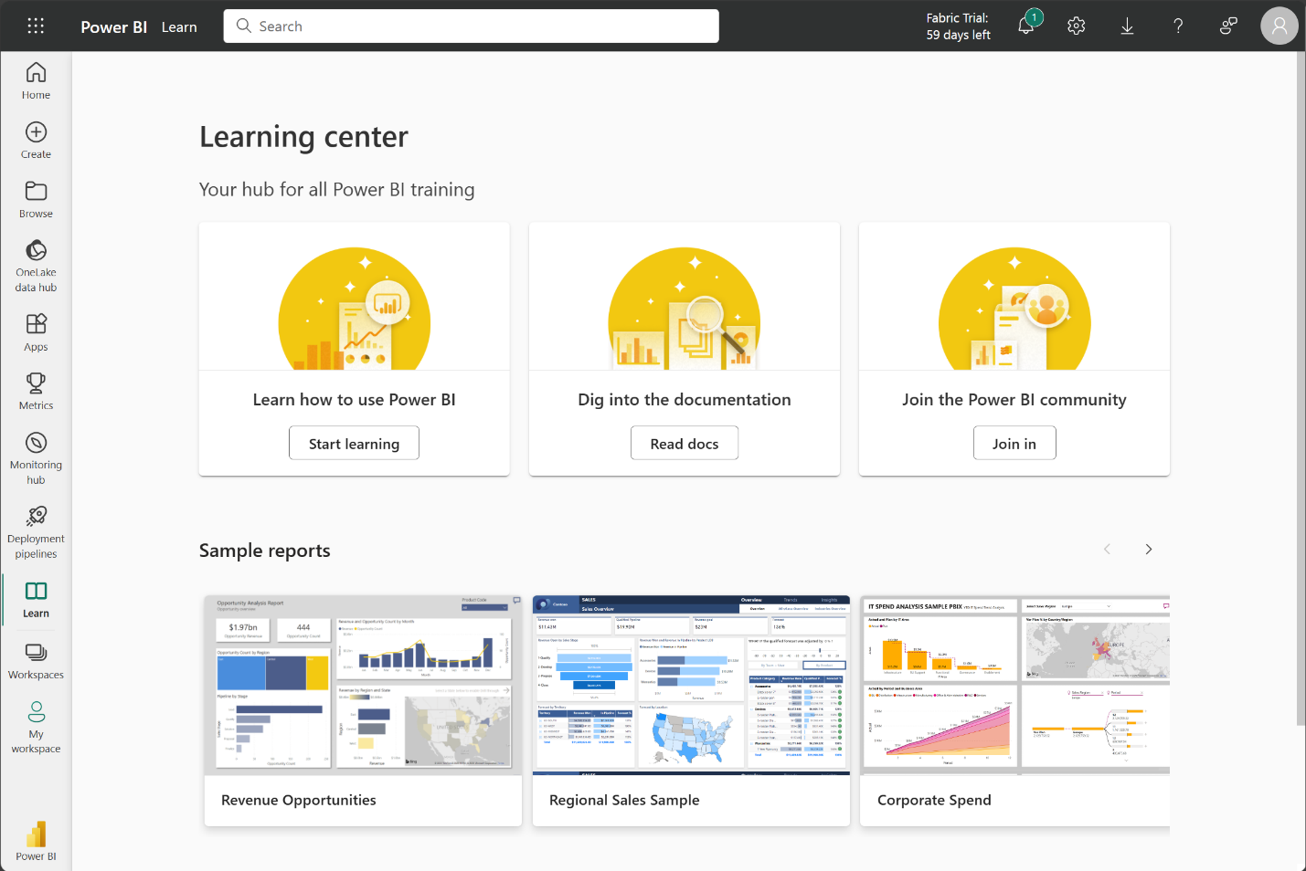

#### Distribute content

In a workspace, you can create an **app**, which provides consumers a simplified interface to access reports and dashboards. In the app configuration, you set up the app, select the content to include (limited to the current workspace), and choose your audience.

Once you create an app, you must update the app after each change to items in the workspace. The requirement to update the app allows you to control what version of the content is visible to your audience.

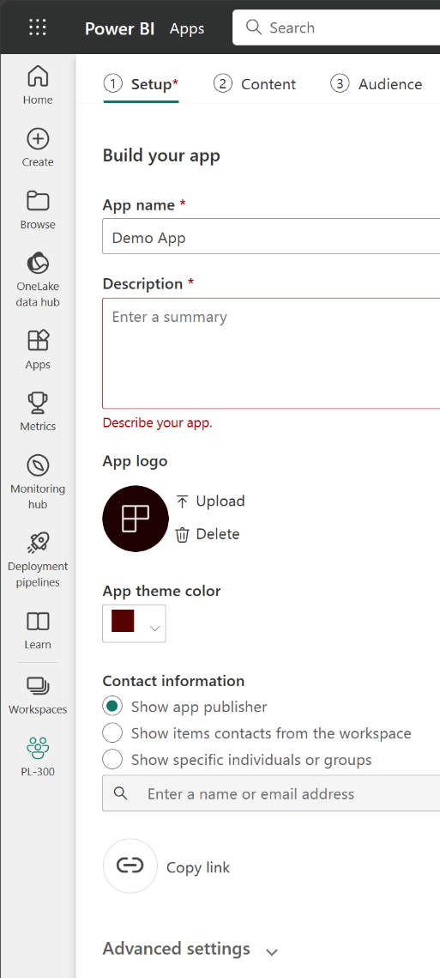

Apps are the ideal sharing solution within any organization. While you can grant access to the workspace, workspace permissions may grant users access to more content than desired. Sharing individual items also presents a problem if you make changes you don't want consumers to see yet.

#### Explore template apps

Now that you understand what an app is, let's look at **template apps**. Template apps allow you to find an existing app that suits your needs and then you connect your data. These apps can be a great way to quickly share insights with minimal effort.

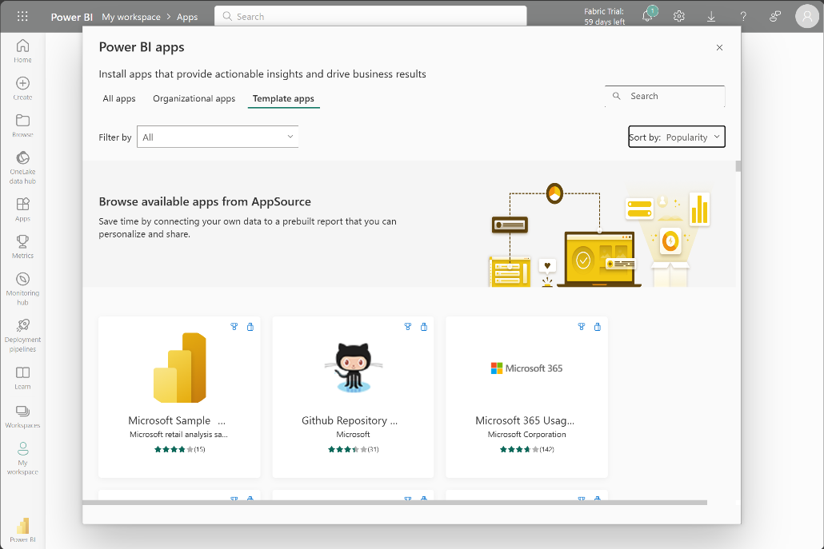

Tip

To access template apps, select the Apps icon from the left navigation pane > Get apps > Template apps.

In the following screenshot, we've installed the GitHub template app and have expanded the report. We can see different report pages, including *Top 100 Contributors* and *Pull Requests*. If your organization is using GitHub, using this template app can easily support your needs without starting from the beginning.

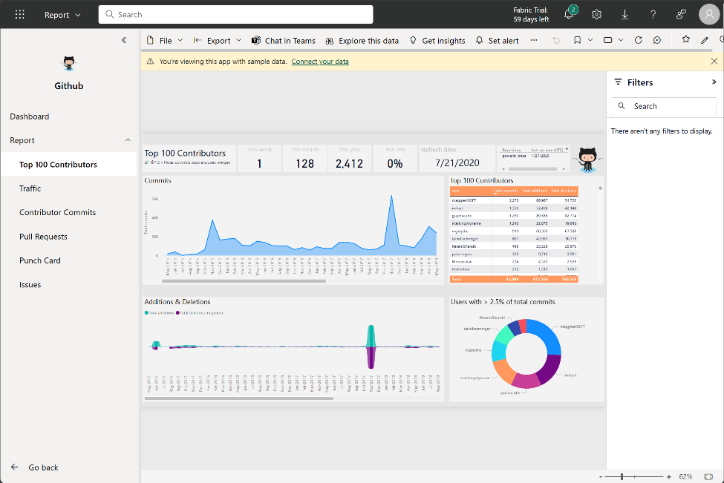

#### Refresh a semantic model

In order to support your ever-changing data, you can configure scheduled refreshes of your semantic models in the Power BI service. On-demand refreshes are also available.

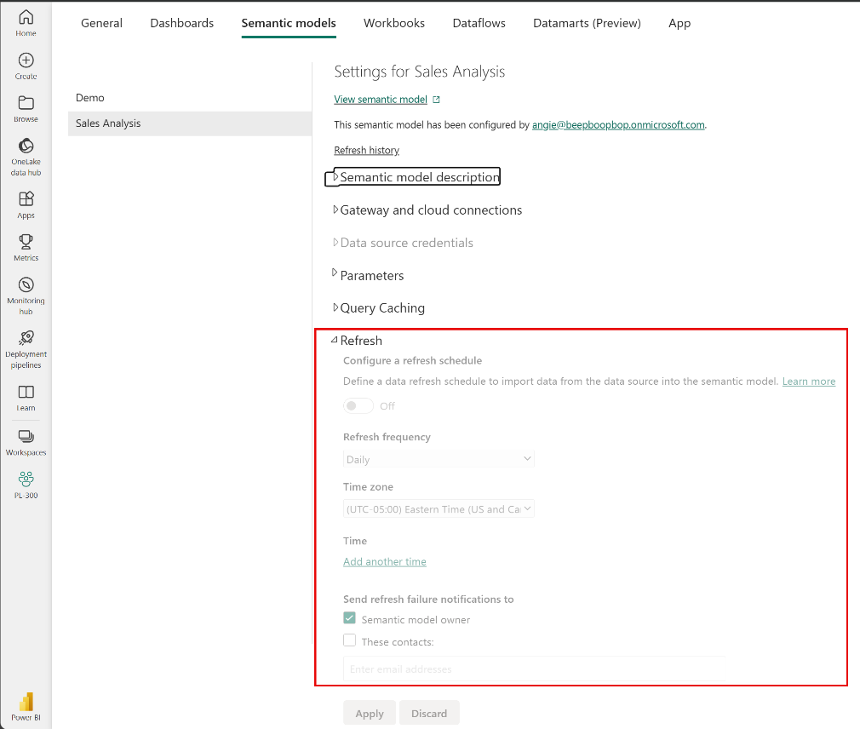

# Prepare data for analysis with Power BI

## Get data in Power BI

### Introduction

Like most of us, you work for a company where you're required to build Microsoft Power BI reports. The data resides in several different databases and files. These data repositories are different from each other, some are in Microsoft SQL Server, some are in Microsoft Excel, but all the data is related.  
[**Video**](https://learn.microsoft.com/en-us/training/modules/get-data/1-introduction)

 Note

The module sections prior to the lab are purely informational. You will be given the opportunity to work with real data during the lab.

In this module’s scenario, you work for Tailwind Traders. You’ve been tasked by senior leadership to create a suite of reports that are dependent on data in several different locations. The database that tracks sales transactions is in SQL Server, a relational database that contains what items each customer bought and when. It also tracks which employee made the sale, along with the employee name and employee ID. However, that database doesn’t contain the employee’s hire date, their title, or who their manager is. For that information, you need to access files that Human Resources keeps in Excel. You've been consistently requesting that they use an SQL database, but they haven't yet had the chance to implement it.

When an item ships, the shipment is recorded in the warehousing application, which is new to the company. The developers chose to store data in Cosmos DB, as a set of JSON documents.

Tailwind Traders has an application that helps with financial projections, so that they can predict what their sales will be in future months and years, based on past trends. Those projections are stored in Microsoft Azure Analysis Services. Here’s a view of the many data sources you're asked to combine data from.

[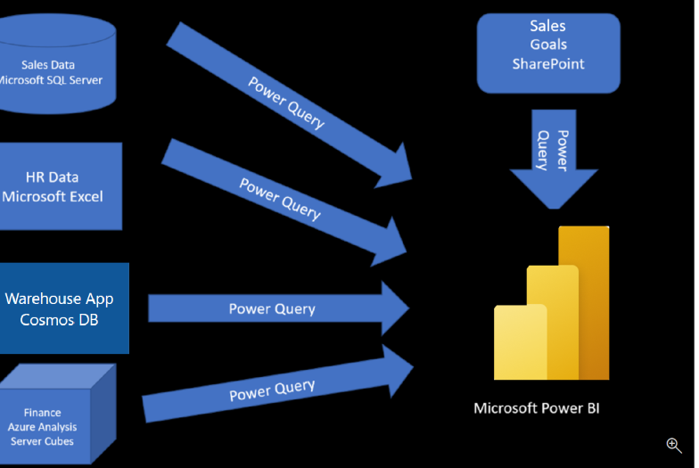](https://learn.microsoft.com/en-us/training/modules/get-data/media/1-data-source-scenario-c.png#lightbox)

Before you can create reports, you must first extract data from the various data sources. Interacting with SQL Server is different from Excel, so you should learn the nuances of both systems. After gaining understanding of the systems, you can use Power Query to help you clean the data, such as renaming columns, replacing values, removing errors, and combining query results. Power Query is also available in Excel. After the data has been cleaned and organized, you're ready to build reports in Power BI. Finally, you'll publish your combined semantic model and reports to Power BI service. From there, other people can use your semantic model and build their own reports or they can use the reports you’ve already built. Additionally, if someone else built a semantic model you'd like to use, you can build reports from that too!

This module will focus on the first step of getting the data from the different data sources and importing it into Power BI by using Power Query.

By the end of this module, you’ll be able to:

* Identify and connect to a data source
* Get data from a relational database, such as Microsoft SQL Server
* Get data from a file, such as Microsoft Excel
* Get data from applications
* Get data from Azure Analysis Services
* Select a storage mode
* Fix performance issues
* Resolve data import errors

### Get data from files

Organizations often export and store data in files. One possible file format is a flat file. A flat file is a type of file that has only one data table and every row of data is in the same structure. The file doesn't contain hierarchies. Likely, you're familiar with the most common types of flat files, which are comma-separated values (.csv) files, delimited text (.txt) files, and fixed width files. Another type of file would be the output files from different applications, like Microsoft Excel workbooks (.xlsx).

[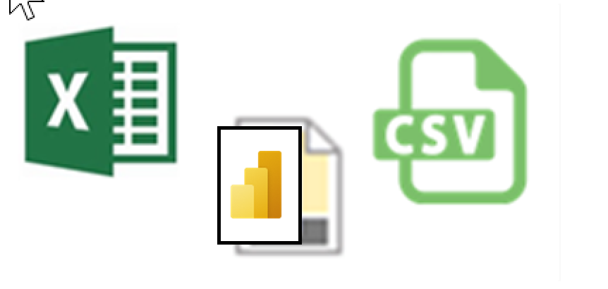](https://learn.microsoft.com/en-us/training/modules/get-data/media/2-file-types-c.png#lightbox)

Power BI Desktop allows you to get data from many types of files. You can find a list of the available options when you use the **Get data** feature in Power BI Desktop. The following sections explain how you can import data from an Excel file that is stored on a local computer.

#### Scenario

The Human Resources (HR) team at Tailwind Traders has prepared a flat file that contains some of your organization's employee data, such as employee name, hire date, position, and manager. They've requested that you build Power BI reports by using this data, and data that is located in several other data sources.

#### Flat file location

The first step is to determine which file location you want to use to export and store your data.

Your Excel files might exist in one of the following locations:

* **Local** - You can import data from a local file into Power BI. The file isn't moved into Power BI, and a link doesn't remain to it. Instead, a new semantic model is created in Power BI, and data from the Excel file is loaded into it. Accordingly, changes to the original Excel file aren't reflected in your Power BI semantic model. You can use local data import for data that doesn't change.
* **OneDrive for Business** - You can pull data from OneDrive for Business into Power BI. This method is effective in keeping an Excel file and your semantic model, reports, and dashboards in Power BI synchronized. Power BI connects regularly to your file on OneDrive. If any changes are found, your semantic model, reports, and dashboards are automatically updated in Power BI.
* **OneDrive - Personal** - You can use data from files on a personal OneDrive account, and get many of the same benefits that you would with OneDrive for Business. However, you'll need to sign in with your personal OneDrive account, and select the **Keep me signed in** option. Check with your system administrator to determine whether this type of connection is allowed in your organization.
* **SharePoint - Team Sites** - Saving your Power BI Desktop files to SharePoint Team Sites is similar to saving to OneDrive for Business. The main difference is how you connect to the file from Power BI. You can specify a URL or connect to the root folder.

[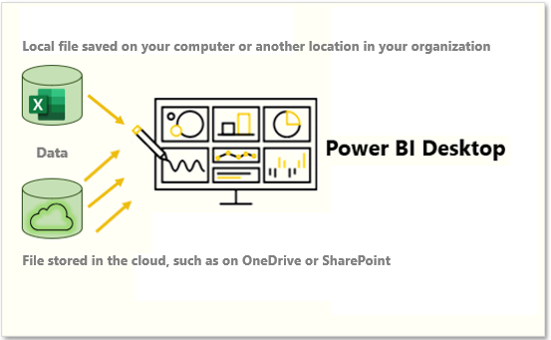](https://learn.microsoft.com/en-us/training/modules/get-data/media/2-local-vs-cloud-c.png#lightbox)

Using a cloud option such as OneDrive or SharePoint Team Sites is the most effective way to keep your file and your semantic model, reports, and dashboards in Power BI in-sync. However, if your data doesn't change regularly, saving files on a local computer is a suitable option.

#### Connect to data in a file

In Power BI, on the **Home** tab, select **Get data**. In the list that displays, select the option that you require, such as **Text/CSV** or **XML**. For this example, you'll select **Excel**.

Tip

The **Home** tab contains quick access data source options, such as **Excel**, next to the **Get data** button.

[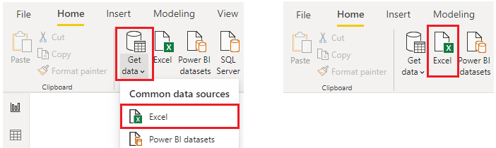](https://learn.microsoft.com/en-us/training/modules/get-data/media/2-get-data-excel-ssm.png#lightbox)

Depending on your selection, you need to find and open your data source. You might be prompted to sign into a service, such as OneDrive, to authenticate your request. In this example, you'll open the **Employee Data** Excel workbook that is stored on the Desktop (Remember, no files are provided for practice, these are hypothetical steps).

[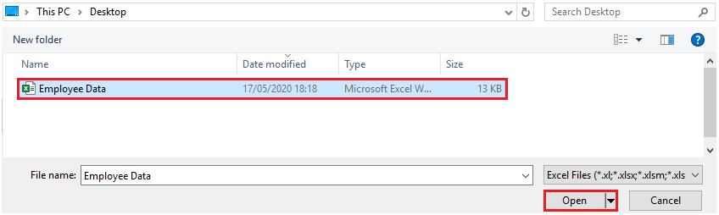](https://learn.microsoft.com/en-us/training/modules/get-data/media/2-excel-save-data-ssm.png#lightbox)

#### Select the file data to import

After the file has connected to Power BI Desktop, the **Navigator** window opens. This window shows you the data that is available in your data source (the Excel file in this example). You can select a table or entity to preview its contents, to ensure that the correct data is loaded into the Power BI model.

Select the check box(es) of the table(s) that you want to bring in to Power BI. This selection activates the **Load** and **Transform Data** buttons as shown in the following image.

[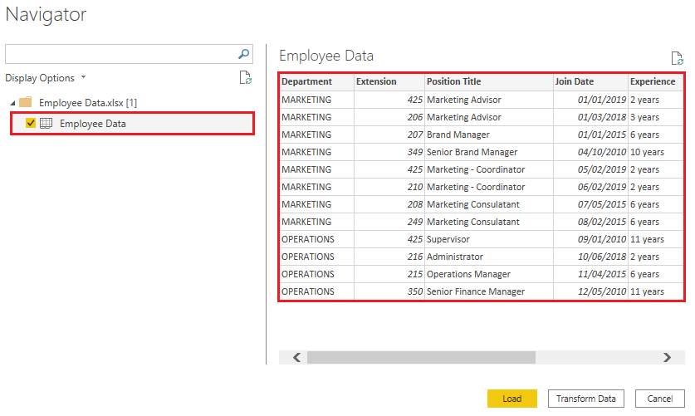](https://learn.microsoft.com/en-us/training/modules/get-data/media/2-excel-worksheet-ssm.png#lightbox)

Now you can select the **Load** button to automatically load your data into the Power BI model or select the **Transform Data** button to launch the Power Query Editor, where you can review and clean your data before loading it into the Power BI model.

We often recommend that you transform data, but that process will be discussed later in this module. For this example, you can select **Load**.

#### Change the source file

You might have to change the location of a source file for a data source during development, or if a file storage location changes. To keep your reports up to date, you'll need to update your file connection paths in Power BI.

Power Query provides many ways for you to accomplish this task, so that you can make this type of change when needed.

1. Data source settings
2. Query settings
3. Advanced Editor

 Warning

If you are changing a file path, make sure that you reconnect to the same file with the same file structure. Any structural changes to a file, such as deleting or renaming columns in the source file, will break the reporting model.

For example, try changing the data source file path in the data source settings. Select **Data source settings** in Power Query. In the **Data source settings** window, select your file and then select **Change Source**. Update the **File path** or use the **Browse** option to locate your file, select **OK**, and then select **Close**.

[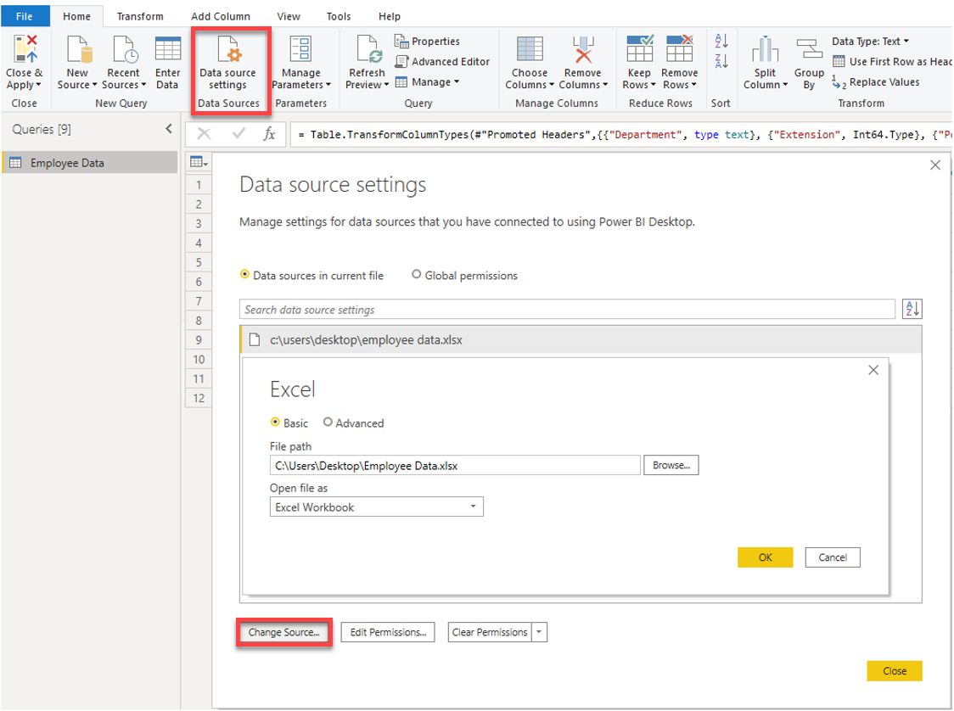](https://learn.microsoft.com/en-us/training/modules/get-data/media/2-excel-data-source-settings-ssm.png#lightbox)

### Get data from relational data sources

If your organization uses a relational database for sales, you can use Power BI Desktop to connect directly to the database instead of using exported flat files.

Connecting Power BI to your database will help you to monitor the progress of your business and identify trends, so you can forecast sales figures, plan budgets and set performance indicators and targets. Power BI Desktop can connect to many relational databases that are either in the cloud or on-premises.

#### Scenario

The Sales team at Tailwind Traders has requested that you connect to the organization's on-premises SQL Server database and get the sales data into Power BI Desktop so you can build sales reports.

[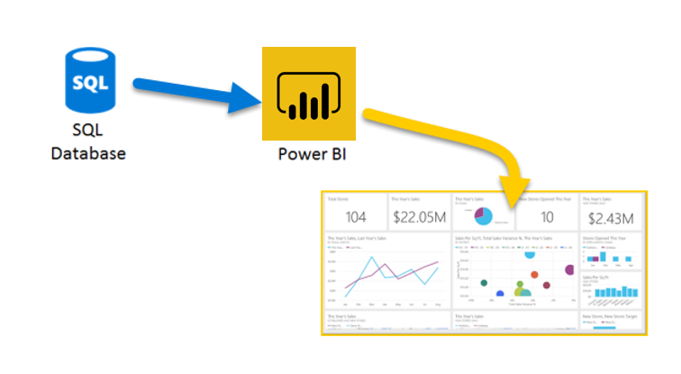](https://learn.microsoft.com/en-us/training/modules/get-data/media/3-get-data-sql-server-ssm.png#lightbox)

#### Connect to data in a relational database

You can use the **Get data** feature in Power BI Desktop and select the applicable option for your relational database. For this example, you would select the **SQL Server** option, as shown in the following screenshot.

 Tip

Next to the **Get Data** button are quick access data source options, such as **SQL Server.**

[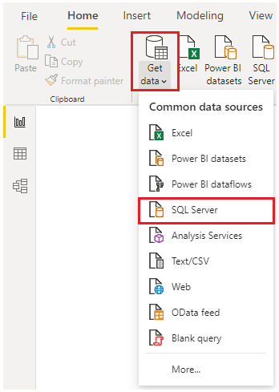](https://learn.microsoft.com/en-us/training/modules/get-data/media/3-get-data-sql-server-dropdown-ssm..png#lightbox)

Your next step is to enter your database server name and a database name in the **SQL Server database** window. The two options in data connectivity mode are: **Import** (selected by default, recommended) and **DirectQuery**. Mostly, you select **Import.** Other advanced options are also available in the **SQL Server database** window, but you can ignore them for now.

[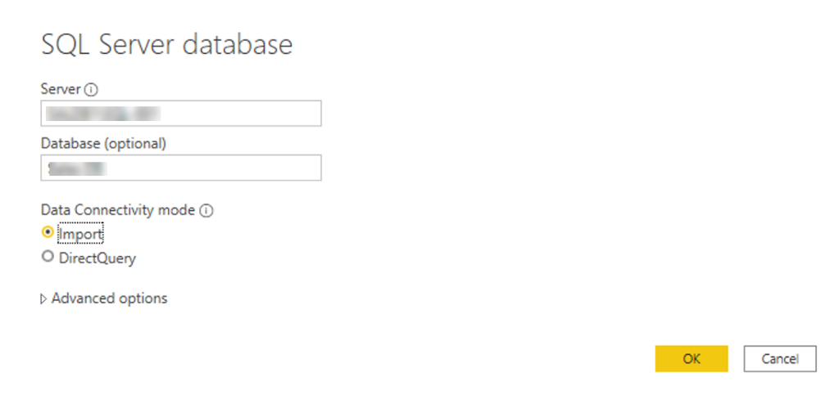](https://learn.microsoft.com/en-us/training/modules/get-data/media/3-get-data-sql-server-db-ss.png#lightbox)

After you've added your server and database names, you'll be prompted to sign in with a username and password. You'll have three sign-in options:

* **Windows** - Use your Windows account (Azure Active Directory credentials).
* **Database** - Use your database credentials. For instance, SQL Server has its own sign-in and authentication system that is sometimes used. If the database administrator gave you a unique sign-in to the database, you might need to enter those credentials on the **Database** tab.
* **Microsoft account** - Use your Microsoft account credentials. This option is often used for Azure services.

Select a sign-in option, enter your username and password, and then select **Connect**.

[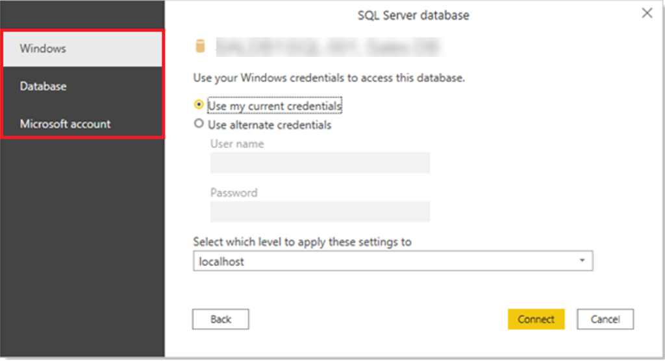](https://learn.microsoft.com/en-us/training/modules/get-data/media/3-sql-creds-ssm.png#lightbox)

#### Select data to import

After the database has been connected to Power BI Desktop, the **Navigator** window displays the data that is available in your data source (the SQL database in this example). You can select a table or entity to preview its contents and make sure that the correct data will be loaded into the Power BI model.

Select the check box(es) of the table(s) that you want to bring in to Power BI Desktop, and then select either the **Load** or **Transform Data** option.

* **Load** - Automatically load your data into a Power BI model in its current state.
* **Transform Data** - Open your data in Microsoft Power Query, where you can perform actions such as deleting unnecessary rows or columns, grouping your data, removing errors, and many other data quality tasks.

[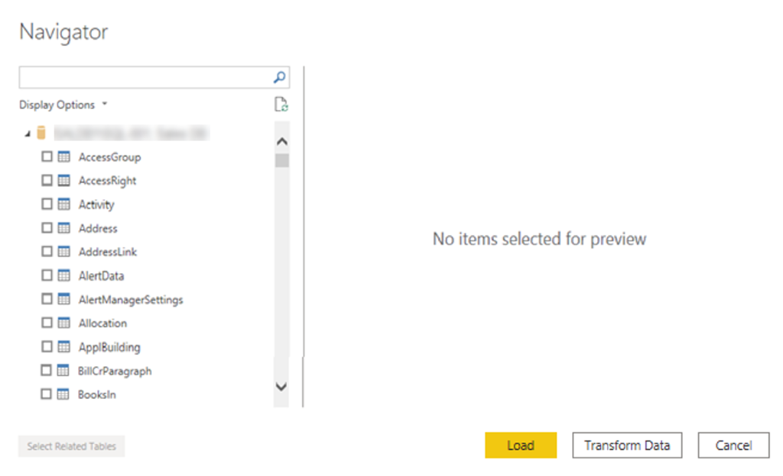](https://learn.microsoft.com/en-us/training/modules/get-data/media/3-table-selection-ssm.png#lightbox)

#### Import data by writing an SQL query

Another way you can import data is to write an SQL query to specify only the tables and columns that you need.

To write your SQL query, on the **SQL Server database** window, enter your server and database names, and then select the arrow next to **Advanced options** to expand this section and view your options. In the **SQL statement** box, write your query statement, and then select **OK**. In this example, you'll use the **Select** SQL statement to load the ID, NAME and SALESAMOUNT columns **from** the SALES table.

[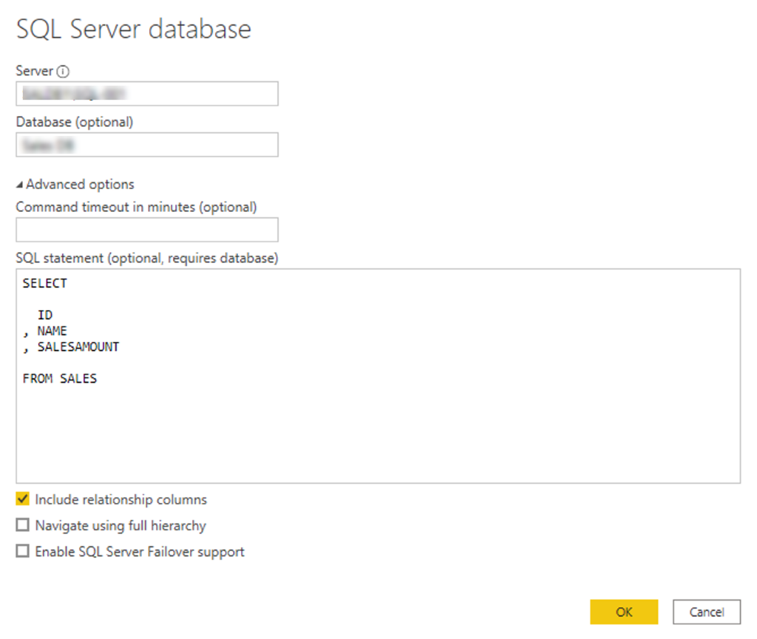](https://learn.microsoft.com/en-us/training/modules/get-data/media/3-sql-statement-ss.png#lightbox)

#### Change data source settings

After you create a data source connection and load data into Power BI Desktop, you can return and change your connection settings at any time. This action is often required due to a security policy within the organization, for example, when the password needs to be updated every 90 days. You can change the data source, edit permissions or clear permissions.

On the **Home** tab, select **Transform data,** and then select the **Data source settings** option.

[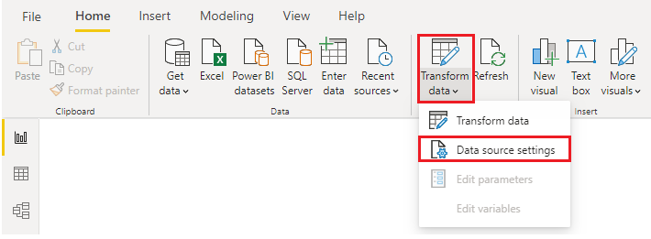](https://learn.microsoft.com/en-us/training/modules/get-data/media/3-change-sql-settings-ssm.png#lightbox)

From the list of data sources that displays, select the data source that you want to update. Then, you can right-click that data source to view the available update options or you can use the update option buttons on the lower left of the window. Select the update option that you need, change the settings as required, and then apply your changes.

[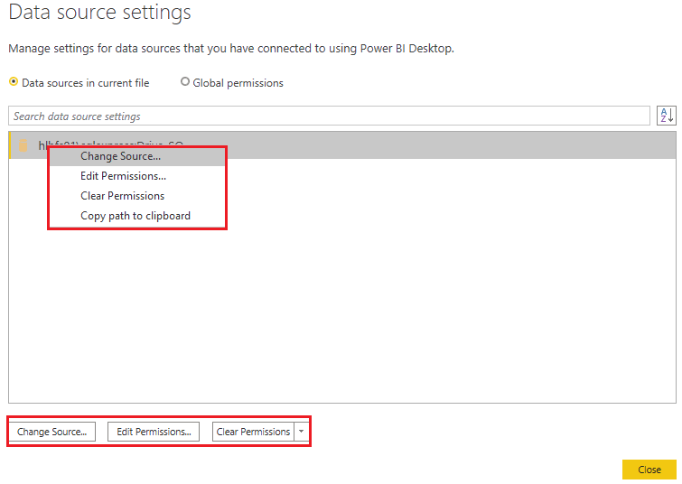](https://learn.microsoft.com/en-us/training/modules/get-data/media/3-sql-data-source-edit-ssm.png#lightbox)

You can also change your data source settings from within Power Query. Select the table, and then select the **Data source settings** option on the **Home** ribbon. Alternatively, you can go to the **Query Settings** panel on the right side of the screen and select the settings icon next to Source (or double Select Source). In the window that displays, update the server and database details, and then select **OK**.

[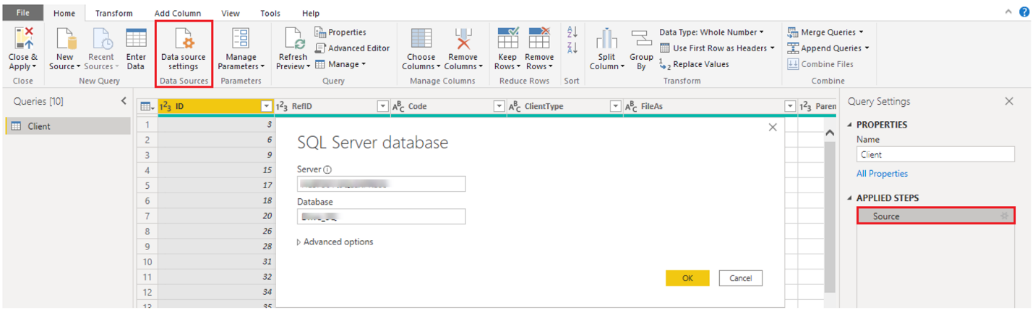](https://learn.microsoft.com/en-us/training/modules/get-data/media/3-edit-creds-ssm.png#lightbox)

After you have made the changes, select **Close and Apply** to apply those changes to your data source settings.

#### Write an SQL statement

As previously mentioned, you can import data into your Power BI model by using an SQL query. SQL stands for Structured Query Language and is a standardized programming language that is used to manage relational databases and perform various data management operations.

Consider the scenario where your database has a large table that is comprised of sales data over several years. Sales data from 2009 isn't relevant to the report that you're creating. This situation is where SQL is beneficial because it allows you to load only the required set of data by specifying exact columns and rows in your SQL statement and then importing them into your semantic model. You can also join different tables, run specific calculations, create logical statements, and filter data in your SQL query.

The following example shows a simple query where the ID, NAME and SALESAMOUNT are selected from the SALES table.

The SQL query starts with a **Select** statement, which allows you to choose the specific fields that you want to pull from your database. In this example, you want to load the ID, NAME, and SALESAMOUNT columns.

SQL

SELECT

ID

, NAME

, SALESAMOUNT

FROM

FROM specifies the name of the table that you want to pull the data from. In this case, it's the SALES table. The following example is the full SQL query:

SQL

SELECT

ID

, NAME

, SALESAMOUNT

FROM

SALES

When using an SQL query to import data, try to avoid using the wildcard character (*) in your query. If you use the wildcard character (*) in your SELECT statement, you import all columns that you don't need from the specified table.

The following example shows the query using the wildcard character.

SQL

SELECT *

FROM

SALES

The wildcard character (*) will import all columns within the **Sales** table. This method isn't recommended because it will lead to redundant data in your semantic model, which will cause performance issues and require extra steps to normalize your data for reporting.

All queries should also have a **WHERE** clause. This clause will filter the rows to pick only filtered records that you want. In this example, if you want to get recent sales data after January 1st, 2020, add a **WHERE** clause. The evolved query would look like the following example.

SQL

SELECT

ID

, NAME

, SALESAMOUNT

FROM

SALES

WHERE

OrderDate >= ‘1/1/2020’

It's a best practice to avoid doing this directly in Power BI. Instead, consider writing a query like this in a view. A view is an object in a relational database, similar to a table. Views have rows and columns, and can contain almost every operator in the SQL language. If Power BI uses a view, when it retrieves data, it participates in query folding, a feature of Power Query. Query folding will be explained later, but in short, Power Query will optimize data retrieval according to how the data is being used later.

### Create dynamic reports with parameters

**Dynamic** reports are reports in which the data can be changed by a developer according to user specifications. Dynamic reports are valuable because a single report can be used for multiple purposes. If you use dynamic reports, you'll have fewer individual reports to create, which will save organizational time and resources.

You can use parameters by determining the values that you want to see data for in the report, and the report updates accordingly by filtering the data for you.

Creating dynamic reports allows you to give users more power over the data that is displayed in your reports; they can change the data source and filter the data by themselves.

In the following example, you've created a report for the Sales team at Tailwind Traders that displays the sales data in the SQL Server database. The report gives a holistic view of how the Sales team is performing. While the report is useful, the Sales team members want to be able to filter the report so that they can view their own data only and track their performance against their sales targets.

#### Create dynamic reports for individual values

To create a dynamic report, you first need to write your SQL query. Then use the **Get data** feature in Power BI Desktop to connect to the database.

In this example, you connect to your database on SQL Server by following these steps:

1. After you have entered your server details, in the **SQL Server database** window, select **Advanced options**.
2. Paste the SQL query into the **SQL statement** box and then select **OK**.

[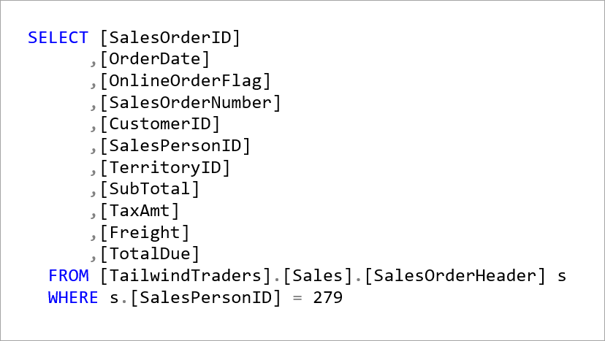](https://learn.microsoft.com/en-us/training/modules/get-data/media/2-sql-query-ss.png#lightbox)

[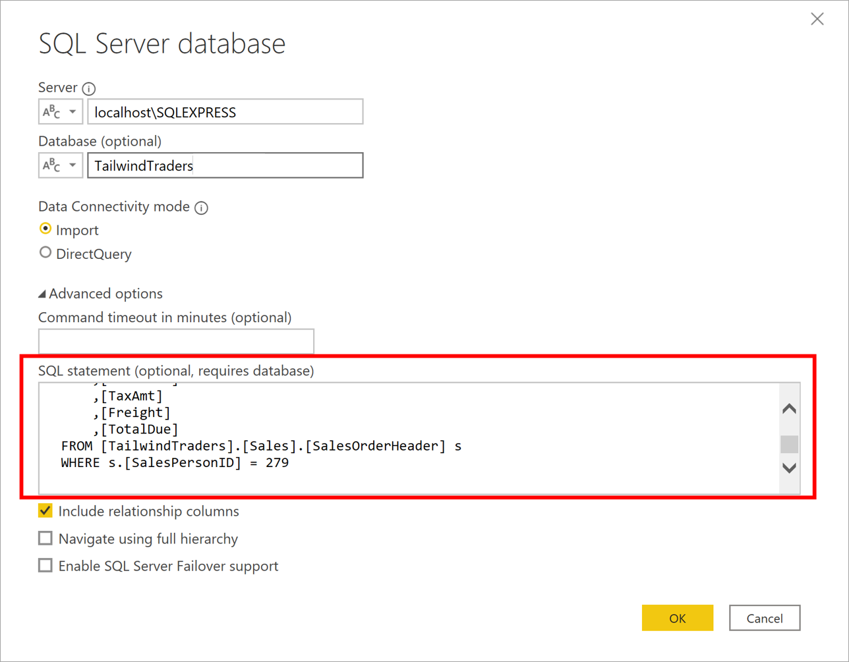](https://learn.microsoft.com/en-us/training/modules/get-data/media/2-add-query-execution-statement-ssm.png#lightbox)

When the connection is made, the data is shown in the preview window.

1. Select **Edit** to open the data in Power Query Editor.

Next, you create the parameter by following these steps:

1. On the **Home** tab, select **Manage parameters > New parameter**.
2. On the **Parameters** window, change the default parameter name to something more descriptive so that its purpose is clear. In this case, you change the name to **SalesPerson**.
3. Select **Text** from the **Type** list and then select **Any value** from the **Suggested value** list.
4. Select **OK**.

[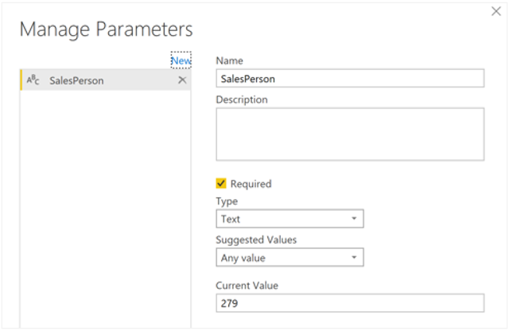](https://learn.microsoft.com/en-us/training/modules/get-data/media/2-add-parameter-ss.png#lightbox)

A new query is shown for the parameter that you created.

[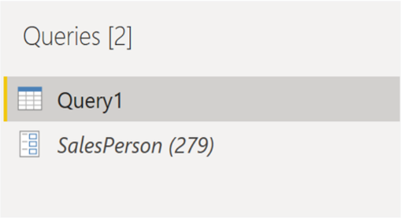](https://learn.microsoft.com/en-us/training/modules/get-data/media/2-parameter-query-ss.png#lightbox)

Now, you need to adjust the code in SQL query to assess your new parameter:

1. Right-click **Query1** and then select **Advanced editor**.
2. Replace the existing value in the execute statement with an ampersand (**&**) followed by your parameter name (**SalesPerson**), as illustrated in the following image.

[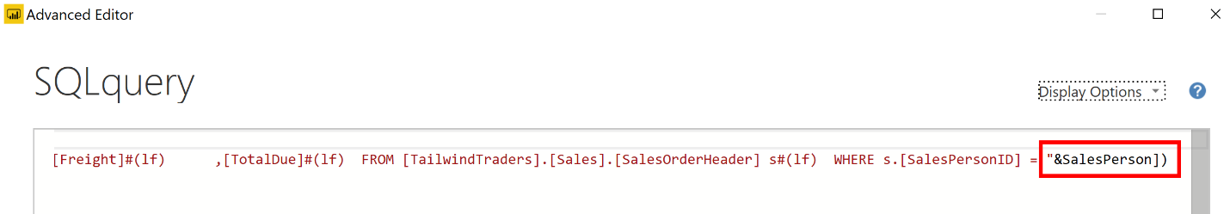](https://learn.microsoft.com/en-us/training/modules/get-data/media/2-adjust-sql-query-statement-ssm.png#lightbox)

1. Make sure that no errors are shown at bottom of the window and then select **Done**.

Though you don't see a difference on the screen, Power BI ran the query.

1. To confirm that the query was run, you can run a test by selecting the parameter query and entering a new value in the **Current Value** box.

[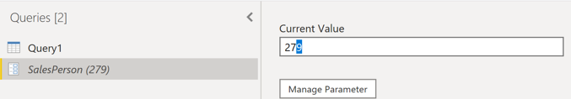](https://learn.microsoft.com/en-us/training/modules/get-data/media/2-enter-parameter-value-ss.png#lightbox)

1. A warning icon might display next to the query. If so, select that query to view the warning message, which states that permission is required to run this native database query. Select **Edit Permission** and then select **Run**.

When the query runs successfully, the parameter displays the new value.

[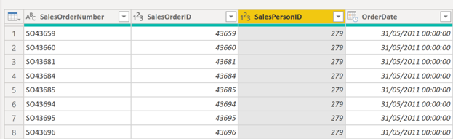](https://learn.microsoft.com/en-us/training/modules/get-data/media/2-paramenter-updated-values-ss.png#lightbox)

1. Select **Close and Apply** to return to the report editor.

Now, you can apply the parameter to the report:

1. Select **Edit queries > Edit parameters**.
2. On the **Edit Parameters** window, enter a new value and then select **OK**.
3. Select **Apply changes** and then run the native query again.

Now, when you view the data, you see the data for the new value that was passed through the parameter.

[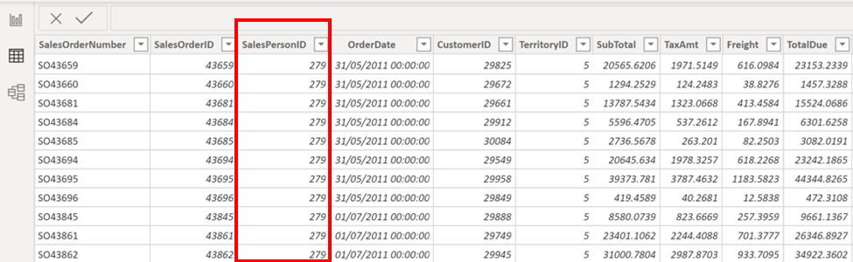](https://learn.microsoft.com/en-us/training/modules/get-data/media/2-apply-parameter-report-ss.png#lightbox)

You can now create a report that displays data for one particular value at a time. More steps are needed to display data for multiple values at the same time.

#### Create dynamic reports for multiple values

To accommodate multiple values at a time, you first need to create a Microsoft Excel worksheet that has a table consisting of one column that contains the list of values.

Next, use the **Get data** feature in Power BI Desktop to connect to the data in that Excel worksheet, and then follow these steps:

1. On the **Navigator** window, select **Edit** to open the data in Power Query Editor, where you see a new query for the data table.

[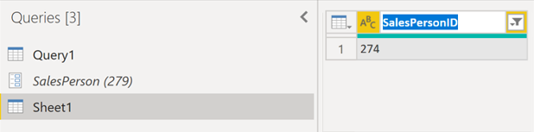](https://learn.microsoft.com/en-us/training/modules/get-data/media/2-table-query-pane-ss.png#lightbox)

1. Rename the column in the table to something more descriptive.
2. Change the column data type to **Text** so that it matches the parameter type and you avoid data conversion problems.
3. In the query **Properties** section, change the name of the data source to something more descriptive. For this example, enter **SalesPersonID**.

Next, you need to create a function that passes the new **SalesPersonID** query into **Query1**:

1. Right-click **Query1** and then select **Create function**.

[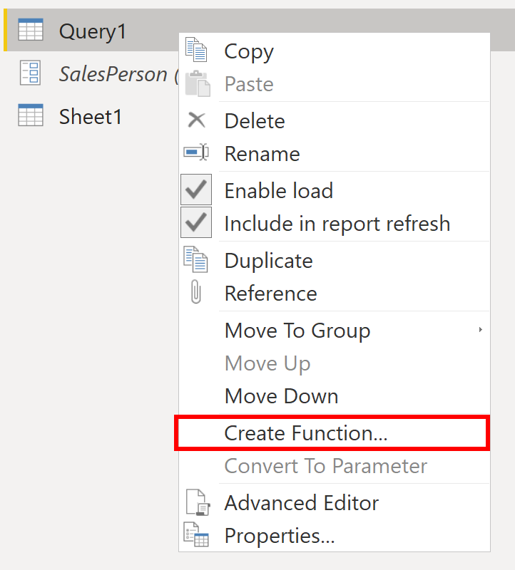](https://learn.microsoft.com/en-us/training/modules/get-data/media/2-create-function-option-ssm.png#lightbox)

1. Enter a name for the function and then select **OK**.

[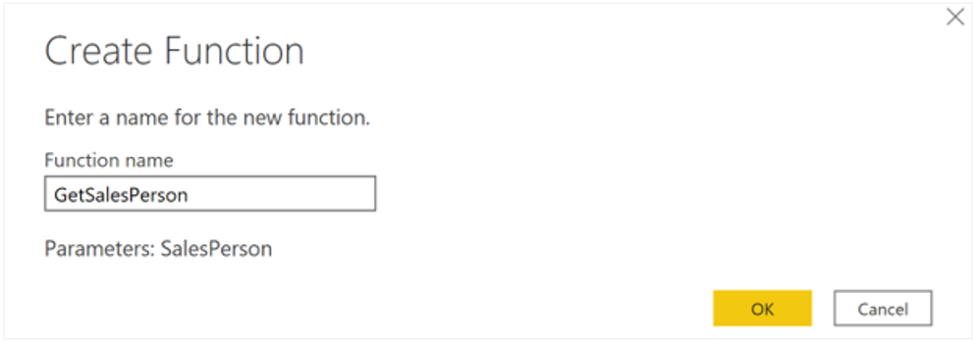](https://learn.microsoft.com/en-us/training/modules/get-data/media/2-create-function-window-ss.png#lightbox)

Your new function appears in the **Queries** pane.

[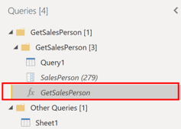](https://learn.microsoft.com/en-us/training/modules/get-data/media/2-function-query-pane-ssm.png#lightbox)

1. To ensure that **Query1** doesn't show up in the field list for the report, which could potentially confuse users, you can disable it from loading in the report by right-clicking **Query1** again and then selecting **Enable load** (selected by default) to disable the feature.

[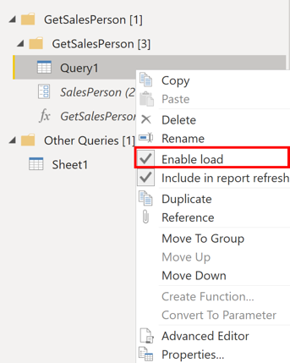](https://learn.microsoft.com/en-us/training/modules/get-data/media/2-enable-load-option-ssm.png#lightbox)

1. Select the **SalesPersonID** query that you loaded from the Excel worksheet and then, on the **Add Column** tab, select **Invoke custom function** to run the custom function that you created.

[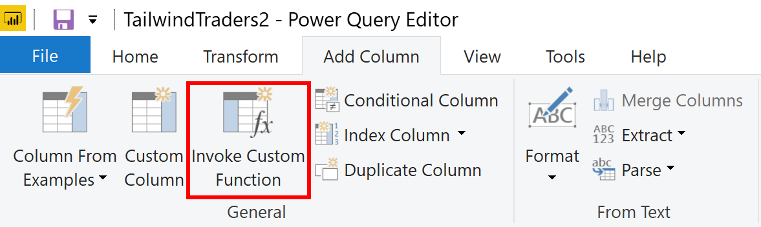](https://learn.microsoft.com/en-us/training/modules/get-data/media/2-invoke-custom-function-option-ssm.png#lightbox)

1. On the **Invoke Custom Function** window, select your function from the **Function query** list.

The **New column name** updates automatically and the table that contains the values that you're going to pass through the parameter is selected by default.

1. Select **OK** and, if necessary, run the native query.

[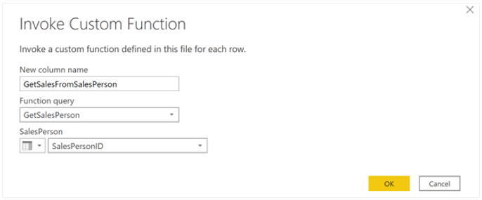](https://learn.microsoft.com/en-us/training/modules/get-data/media/2-invoke-custom-function-window-ss.png#lightbox)

A new column for your **GetSalesFromSalesPerson** function appears next to the **SalesPersonID** column.

[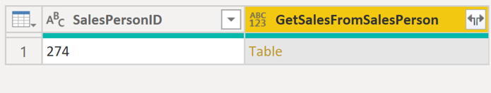](https://learn.microsoft.com/en-us/training/modules/get-data/media/2-function-column-ss.png#lightbox)

1. Select the two arrows icon in the new column header and then select the check boxes of the columns that you want to load. This section is where you determine the details that are available in the report for each value (sales person ID).
2. Clear the **Use original column name as prefix** check box at the bottom of the screen because you don't need to see a prefix with the column names in the report.
3. Select **OK**.

[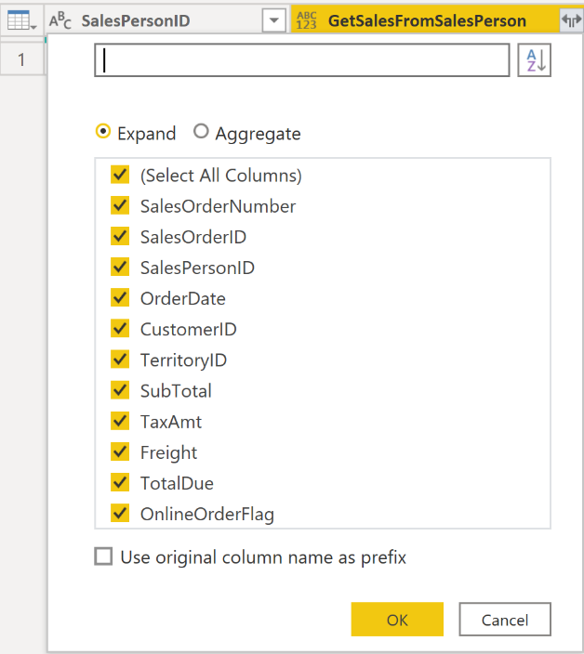](https://learn.microsoft.com/en-us/training/modules/get-data/media/2-select-columns-function-ss.png#lightbox)

You should be able to view the data for the columns that you selected, for each value (sales person ID).

[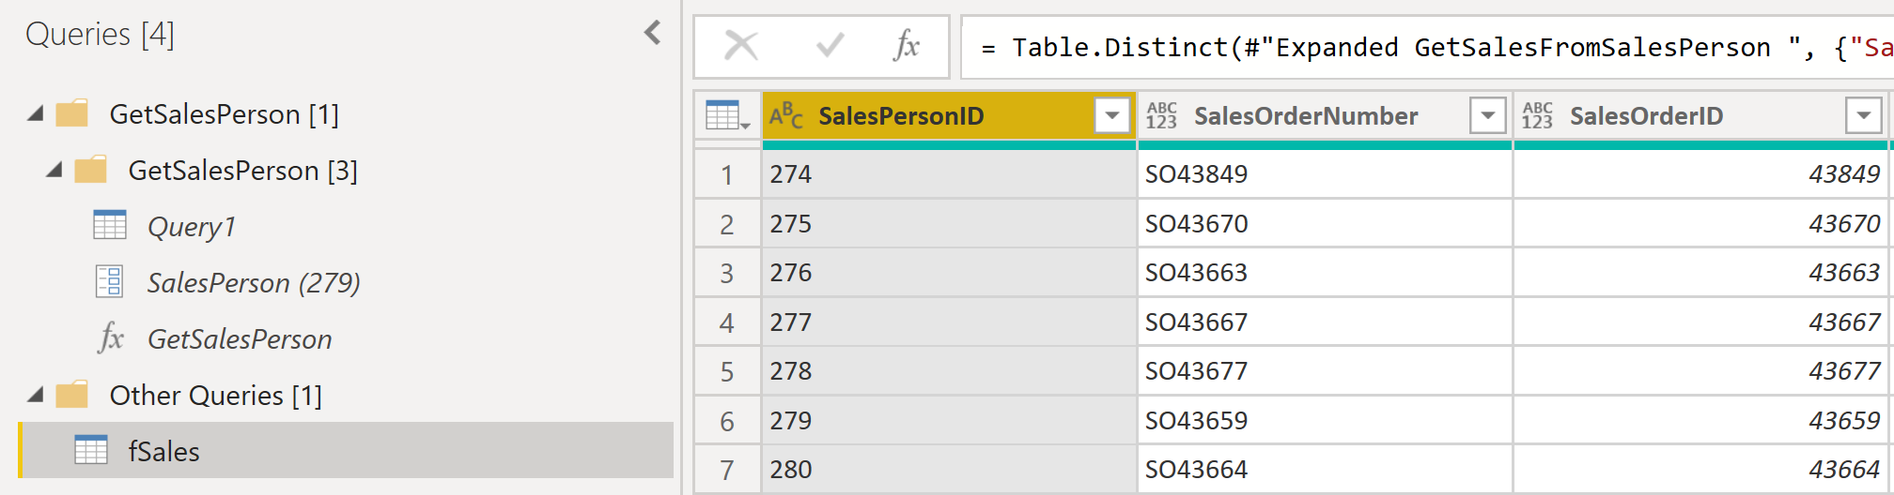](https://learn.microsoft.com/en-us/training/modules/get-data/media/2-view-columns-function-ss.png#lightbox)

If necessary, you can add more values (sales people IDs) to the **SalesPersonID** column in the Excel worksheet, or you can change the existing values.

1. Save your changes and then return to Power Query Editor.
2. On the **Home** tab, select **Refresh Preview**, and then run the native query again (if necessary). You should see the sales from the new sales people IDs that you added into the worksheet.
3. Select **Close and Apply** to return to the report editor, where you see the new column names in the Fields pane.

Now, you can start building your report.

### Get data from a NoSQL database

Some organizations don't use a relational database but instead use a *NoSQL* database. A NoSQL database (also referred to as non-SQL, not only SQL or *non-relational*) is a flexible type of database that doesn't use tables to store data.

#### Scenario

Software developers at Tailwind Traders created an application to manage shipping and tracking products from their warehouses. The application uses Cosmos DB, a NoSQL database, as the data repository. Data is stored as JSON documents, which are open standard file formats that are primarily used to transmit data between a server and web application. You need to import this data into a Power BI semantic model for reporting.

#### Connect to a NoSQL database (Azure Cosmos DB)

In this scenario, you'll use the **Get data** feature in Power BI Desktop. However, this time you'll select the **More...** option to locate and connect to the type of database that you use. In this example, you'll select the **Azure** category, select **Azure Cosmos DB,** and then select **Connect**.

[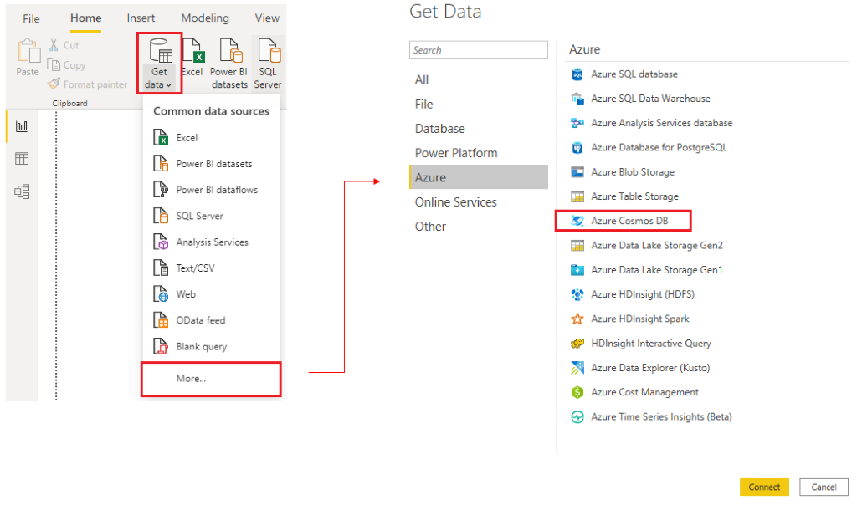](https://learn.microsoft.com/en-us/training/modules/get-data/media/4-get-data-cosmos-ssm.png#lightbox)

On the **Preview Connector** window, select **Continue** and then enter your database credentials. In this example, on the **Azure Cosmos DB** window, you can enter the database details. You can specify the Azure Cosmos DB account endpoint URL that you want to get the data from (you can get the URL from the **Keys** blade of your Azure portal). Alternatively, you can enter the database name, collection name or use the navigator to select the database and collection to identify the data source.

If you're connecting to an endpoint for the first time, as you are in this example, make sure that you enter your account key. You can find this key in the **Primary Key** box in the **Read-only Keys** blade of your Azure portal.

#### Import a JSON file

If you're working with data stored in JSON format, it's often necessary to extract and normalize the data first. This is because JSON data is often stored in a nested or unstructured format, which makes it difficult to analyze or report on directly.

In this example, the data must be extracted and normalized before you can report on them, so you need to transform the data before loading it into Power BI Desktop.

After you've connected to the database account, the **Navigator** window opens, showing a list of databases under that account. Select the table that you want to import. In this example, you'll select the Product table. The preview pane only shows **Record** items because all records in the document are represented as a Record type in Power BI.

[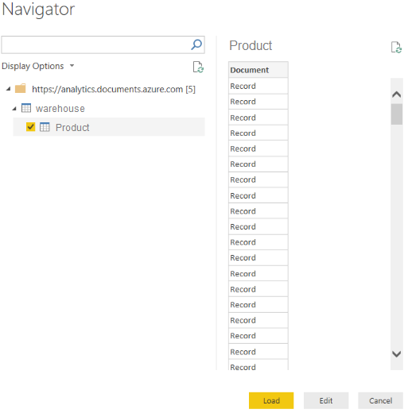](https://learn.microsoft.com/en-us/training/modules/get-data/media/4-cosmos-navigator-ss.png#lightbox)

Select the **Edit** button to open the records in Power Query.

In Power Query, select the **Expander** button to the right side of the **Column1** header, which displays the context menu with a list of fields. Select the fields that you want to load into Power BI Desktop, clear the **Use original column name as prefix** checkbox, and then select **OK**.

[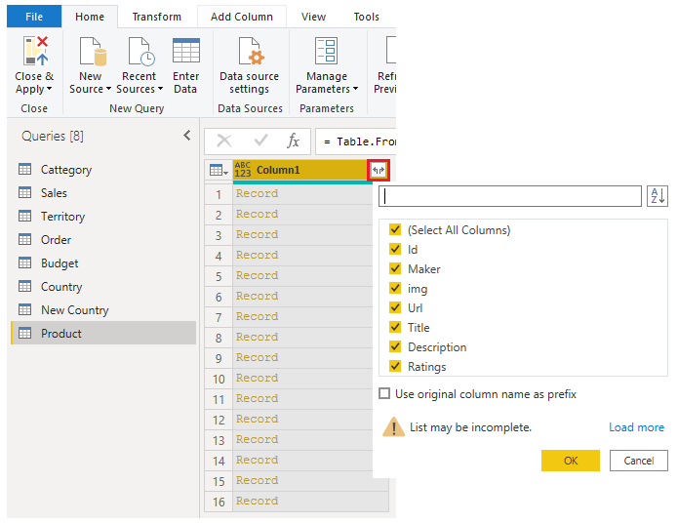](https://learn.microsoft.com/en-us/training/modules/get-data/media/4-expand-record-ssm.png#lightbox)

Review the selected data to ensure that you're satisfied with it, then select **Close & Apply** to load the data into Power BI Desktop.

[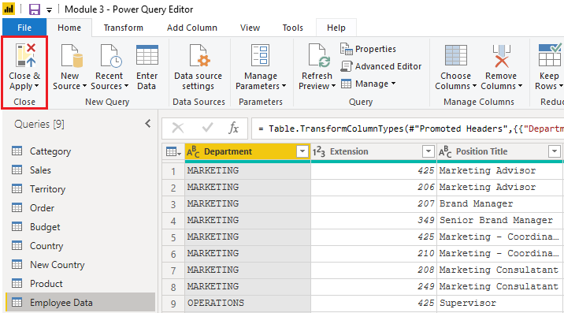](https://learn.microsoft.com/en-us/training/modules/get-data/media/4-cosmos-results-ssm.png#lightbox)

The data now resembles a table with rows and columns. Data from Cosmos DB can now be related to data from other data sources and can eventually be used in a Power BI report.

### Get data from online services

To support their daily operations, organizations frequently use a range of software applications, such as SharePoint, OneDrive, Dynamics 365, Google Analytics and so on. These applications produce their own data. Power BI can combine the data from multiple applications to produce more meaningful insights and reports.

#### Scenario

Tailwind Traders uses SharePoint to collaborate and store sales data. It's the start of the new financial year and the sales managers want to enter new goals for the sales team. The form that the leadership uses exists in SharePoint. You're required to establish a connection to this data within Power BI Desktop, so that the sales goals can be used alongside other sales data to determine the health of the sales pipeline.

The following sections examine how to use the Power BI Desktop **Get Data** feature to connect to data sources that are produced by external applications. To illustrate this process, we've provided an example that shows how to connect to a SharePoint site and import data from an online list.

#### Connect to data in an application

When connecting to data in an application, you would begin in the same way as you would when connecting to the other data sources: by selecting the **Get data** feature in Power BI Desktop. Then, select the option that you need from the **Online Services** category. In this example, you select **SharePoint Online List**.

After you've selected **Connect**, you'll be asked for your SharePoint URL. This URL is the one that you use to sign into your SharePoint site through a web browser. You can copy the URL from your SharePoint site and paste it into the connection window in Power BI. You don't need to enter your full URL file path; you only need to load your site URL because, when you're connected, you can select the specific list that you want to load. Depending on the URL that you copied, you might need to delete the last part of your URL, as illustrated in the following image.

[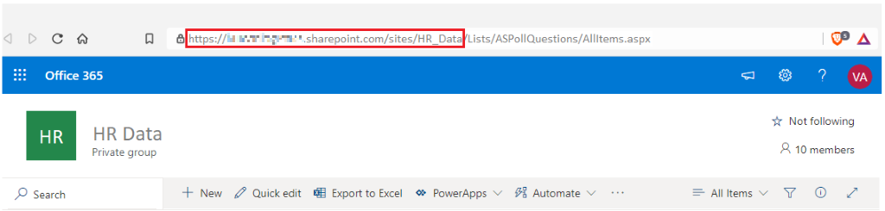](https://learn.microsoft.com/en-us/training/modules/get-data/media/5-sharepoint-url-orig-location-ssm.png#lightbox)

After you've entered your URL, select **OK**. Power BI needs to authorize the connection to SharePoint, so sign in with your Microsoft account and then select **Connect**.

[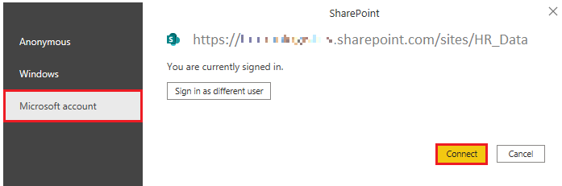](https://learn.microsoft.com/en-us/training/modules/get-data/media/5-authorization-step-sharepoint-access-ssm.png#lightbox)

#### Choose the application data to import

After Power BI has made the connection with SharePoint, the **Navigator** window appears, as it does when you connect to other data sources. The window displays the tables and entities within your SharePoint site. Select the list that you want to load into Power BI Desktop. Similar to when you import from other data sources, you have the option to automatically load your data into a Power BI model or launch the Power Query Editor to transform your data before loading it.

For this example, you select the **Load** option.

[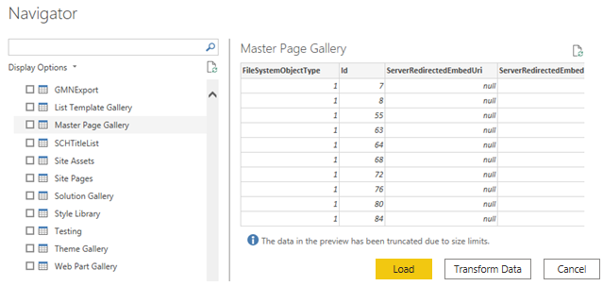](https://learn.microsoft.com/en-us/training/modules/get-data/media/5-navigator-window-view-tables-ss.png#lightbox)

### Select a storage mode

The most popular way to use data in Power BI is to import it into a Power BI semantic model. Importing the data means that the data is stored in the Power BI file and gets published along with the Power BI reports. This process helps make it easier for you to interact directly with your data. However, this approach might not work for all organizations.

To continue with the scenario, you're building Power BI reports for the Sales department at Tailwind Traders, where importing the data isn't an ideal method. The first task you need to accomplish is to create your semantic models in Power BI so you can build visuals and other report elements. The Sales department has many different semantic models of varying sizes. For security reasons, you aren't allowed to import local copies of the data into your reports, so directly importing data is no longer an option. Therefore, you need to create a direct connection to the Sales department’s data source. The following section describes how you can ensure that these business requirements are satisfied when you're importing data into Power BI.

However, sometimes there may be security requirements around your data that make it impossible to directly import a copy. Or your semantic models may simply be too large and would take too long to load into Power BI, and you want to avoid creating a performance bottleneck. Power BI solves these problems by using the DirectQuery storage mode, which allows you to query the data in the data source directly and not import a copy into Power BI. DirectQuery is useful because it ensures you're always viewing the most recent version of the data.

The three different types of storage modes you can choose from:

* Import
* DirectQuery
* Dual (Composite)

You can access storage modes by switching to the **Model** view, selecting a data table, and in the resulting Properties pane, selecting which mode that you want to use from the **Storage mode** drop-down list, as shown in the following visual.

[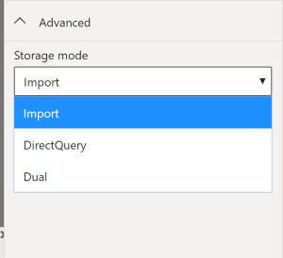](https://learn.microsoft.com/en-us/training/modules/get-data/media/6-storage-mode-ssm.png#lightbox)

Let’s take a closer look at the different types of Storage Modes.

#### Import mode

The Import mode allows you to create a local Power BI copy of your semantic models from your data source. You can use all Power BI service features with this storage mode, including Q&A and Quick Insights. Data refreshes can be scheduled or on-demand. Import mode is the default for creating new Power BI reports.

#### DirectQuery mode

The DirectQuery option is useful when you don't want to save local copies of your data because your data won't be cached. Instead, you can query the specific tables that you'll need by using native Power BI queries, and the required data will be retrieved from the underlying data source. Essentially, you're creating a direct connection to the data source. Using this model ensures that you're always viewing the most up-to-date data, and that all security requirements are satisfied. Additionally, this mode is suited for when you have large semantic models to pull data from. Instead of slowing down performance by having to load large amounts of data into Power BI, you can use DirectQuery to create a connection to the source, solving data latency issues as well.

#### Dual (Composite mode)

In Dual mode, you can identify some data to be directly imported and other data that must be queried. Any table that is brought in to your report is a product of both Import and DirectQuery modes. Using the Dual mode allows Power BI to choose the most efficient form of data retrieval.

For more information regarding Storage Modes, refer to [Storage Modes](https://learn.microsoft.com/en-us/power-bi/transform-model/desktop-storage-mode/).

### Get data from Azure Analysis Services

Azure Analysis Services is a fully managed platform as a service (PaaS) that provides enterprise-grade semantic models in the cloud. You can use advanced mashup and modeling features to combine data from multiple data sources, define metrics, and secure your data in a single, trusted tabular semantic model. The semantic model provides an easier and faster way for users to perform ad hoc data analysis using tools like Power BI.

To resume the scenario, Tailwind Traders uses Azure Analysis Services to store financial projection data. You’ve been asked to compare this data with actual sales data in a different database. Getting data from Azure Analysis Services server is similar to getting data from SQL Server, in that you can:

* Authenticate to the server.
* Pick the model you want to use.
* Select which tables you need.

Notable differences between Azure Analysis Services and SQL Server are:

* Analysis Services models have calculations already created.
* If you don’t need an entire table, you can query the data directly. Instead of using Transact-SQL (T-SQL) to query the data, like you would in SQL Server, you can use multi-dimensional expressions (MDX) or data analysis expressions (DAX).

#### Connect to data in Azure Analysis Services

As previously mentioned, you use the **Get data** feature in Power BI Desktop. When you select **Analysis Services**, you're prompted for the server address and the database name with two options: **Import** and **Connect live**.

[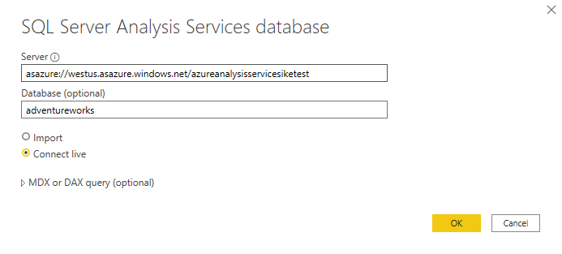](https://learn.microsoft.com/en-us/training/modules/get-data/media/7-analysis-services-connection-ss.png#lightbox)

**Connect live** is an option for Azure Analysis Services. Azure Analysis Services uses the tabular model and DAX to build calculations, similar to Power BI. These models are compatible with one another. Using the Connect live option helps you keep the data and DAX calculations in their original location, without having to import them all into Power BI. Azure Analysis Services can have a fast refresh schedule, which means that when data is refreshed in the service, Power BI reports will immediately be updated, without the need to initiate a Power BI refresh schedule. This process can improve the timeliness of the data in your report.

Similar to a relational database, you can choose the tables that you want to use. If you want to directly query the Azure Analysis Services model, you can use DAX or MDX.

You'll likely import the data directly into Power BI. An acceptable alternative is to import all other data that you want (from Excel, SQL Server, and so on) into the Azure Analysis Services model and then use a live connection. This approach simplifies your solution by keeping the semantic modeling and DAX measures in one place.

For more information on connecting Power BI to Azure Analysis Services, see [Connect with Power BI documentation.](https://learn.microsoft.com/en-us/azure/analysis-services/analysis-services-connect-pbi/)

### Fix performance issues

Occasionally, organizations will need to address performance issues when running reports. Power BI provides the Performance Analyzer tool to help fix problems and streamline the process.

Consider the scenario where you're building reports for the Sales team in your organization. You’ve imported your data, which is in several tables within the Sales team’s SQL database, by creating a data connection to the database through DirectQuery. When you create preliminary visuals and filters, you notice that some tables are queried faster than others, and some filters are taking longer to process compared to others.

#### Optimize performance in Power Query

The performance in Power Query depends on the performance at the data source level. The variety of data sources that Power Query offers is wide, and the performance tuning techniques for each source are equally wide. For instance, if you extract data from a Microsoft SQL Server, you should follow the performance tuning guidelines for the product. Good SQL Server performance tuning techniques include index creation, hardware upgrades, execution plan tuning, and data compression. These topics are beyond the scope here, and are covered only as an example to build familiarity with your data source and reap the benefits when using Power BI and Power Query.

Power Query takes advantage of good performance at the data source through a technique called Query Folding.

##### Query folding

The query folding within Power Query Editor helps you increase the performance of your Power BI reports. *Query folding* is the process by which the transformations and edits that you make in Power Query Editor are simultaneously tracked as native queries, or simple **Select** SQL statements, while you're actively making transformations. The reason for implementing this process is to ensure that these transformations can take place in the original data source server and don't overwhelm Power BI computing resources.

You can use Power Query to load data into Power BI. Then use Power Query Editor to transform your data, such as renaming or deleting columns, appending, parsing, filtering, or grouping your data.

Consider a scenario where you’ve renamed a few columns in the Sales data and merged a city and state column together in the “city state” format. Meanwhile, the query folding feature tracks those changes in native queries. Then, when you load your data, the transformations take place independently in the original source, this ensures that performance is optimized in Power BI.

The benefits to query folding include:

* **More efficiency in data refreshes and incremental refreshes.** When you import data tables by using query folding, Power BI is better able to allocate resources and refresh the data faster because Power BI doesn't have to run through each transformation locally.
* **Automatic compatibility with DirectQuery and Dual storage modes.** All DirectQuery and Dual storage mode data sources must have the back-end server processing abilities to create a direct connection, which means that query folding is an automatic capability that you can use. If all transformations can be reduced to a single **Select** statement, then query folding can occur.

The following scenario shows query folding in action. In this scenario, you apply a set of queries to multiple tables. After you add a new data source by using Power Query, and you're directed to the Power Query Editor, you go to the **Query Settings** pane and right-click the last applied step, as shown in the following figure.

[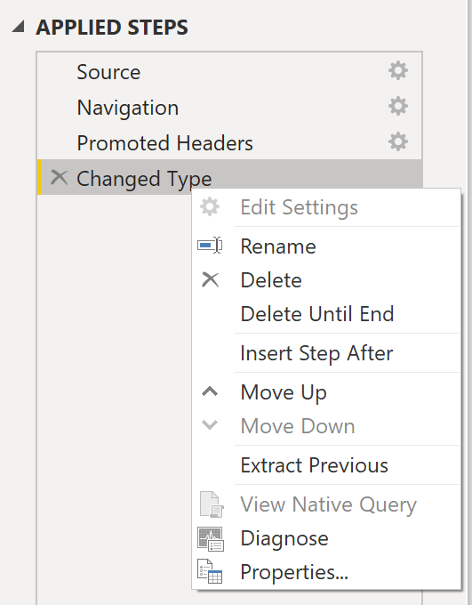](https://learn.microsoft.com/en-us/training/modules/get-data/media/8-view-native-query-ss.png#lightbox)

If the **View Native Query** option isn't available (not displayed in bold type), then query folding isn't possible for this step, and you'll have to work backward in the **Applied Steps** area until you reach the step in which **View Native Query** is available (displays in bold type). This process will reveal the native query that is used to transform the semantic model.

Native queries aren't possible for the following transformations:

* Adding an index column
* Merging and appending columns of different tables with two different sources
* Changing the data type of a column

A good guideline to remember is that if you can translate a transformation into a **Select** SQL statement, which includes operators and clauses such as GROUP BY, SORT BY, WHERE, UNION ALL, and JOIN, you can use query folding.

While query folding is one option to optimize performance when retrieving, importing, and preparing data, another option is query diagnostics.

##### Query diagnostics

Another tool that you can use to study query performance is *query diagnostics*. You can determine what bottlenecks may exist while loading and transforming your data, refreshing your data in Power Query, running SQL statements in Query Editor, and so on.

To access query diagnostics in Power Query Editor, go to **Tools** in the Home ribbon. When you're ready to begin transforming your data or making other edits in Power Query Editor, select **Start Diagnostics** in the **Session Diagnostics** section. When you're finished, make sure that you select **Stop Diagnostics**.

[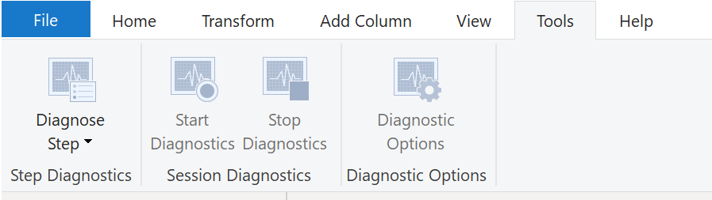](https://learn.microsoft.com/en-us/training/modules/get-data/media/8-navigating-query-diagnostics-ss.png#lightbox)

Selecting **Diagnose Step** shows you the length of time that it takes to run that step, as shown in the following image. This selection can tell you if a step takes longer to complete than others, which then serves as a starting point for further investigation.

[](https://learn.microsoft.com/en-us/training/modules/get-data/media/8-applying-query-diagnostics-ss.png#lightbox)

This tool is useful when you want to analyze performance on the Power Query side for tasks such as loading semantic models, running data refreshes, or running other transformative tasks.

#### Other techniques to optimize performance

Other ways to optimize query performance in Power BI include:

* **Process as much data as possible in the original data source.** Power Query and Power Query Editor allow you to process the data; however, the processing power that is required to complete this task might lower performance in other areas of your reports. Generally, a good practice is to process, as much as possible, in the native data source.
* **Use native SQL queries.** When using DirectQuery for SQL databases, such as the case for our scenario, make sure that you aren't pulling data from stored procedures or common table expressions (CTEs).
* **Separate date and time, if bound together.** If any of your tables have columns that combine date and time, make sure that you separate them into distinct columns before importing them into Power BI. This approach will increase compression abilities.

For more information, refer to [Query Folding Guidance](https://learn.microsoft.com/en-us/power-bi/guidance/power-query-folding/) and [Query Folding](https://learn.microsoft.com/en-us/power-query/power-query-folding/).

### Resolve data import errors

While importing data into Power BI, you may encounter errors resulting from factors such as:

* Power BI imports from numerous data sources.
* Each data source might have dozens (and sometimes hundreds) of different error messages. `
* Other components can cause errors, such as hard drives, networks, software services, and operating systems.
* Data often can't comply with any specific schema.

The following sections cover some of the more common error messages that you might encounter in Power BI.

#### Query timeout expired

Relational source systems often have many people who are concurrently using the same data in the same database. Some relational systems and their administrators seek to limit a user from monopolizing all hardware resources by setting a query timeout. These timeouts can be configured for any timespan, from as little as five seconds to as much as 30 minutes or more.

For instance, if you’re pulling data from your organization’s SQL Server, you might see the error shown in the following figure.

[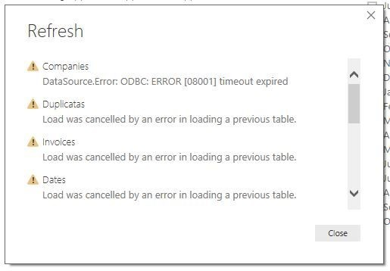](https://learn.microsoft.com/en-us/training/modules/get-data/media/9-data-import-query-timeout-ss.png#lightbox)

#### Power BI Query Error: Timeout expired

This error indicates that you’ve pulled too much data according to your organization’s policies. Administrators incorporate this policy to avoid slowing down a different application or suite of applications that might also be using that database.

You can resolve this error by pulling fewer columns or rows from a single table. While you're writing SQL statements, it might be a common practice to include groupings and aggregations. You can also join multiple tables in a single SQL statement. Additionally, you can perform complicated subqueries and nested queries in a single statement. These complexities add to the query processing requirements of the relational system and can greatly elongate the time of implementation.

If you need the rows, columns, and complexity, consider taking small chunks of data and then bringing them back together by using Power Query. For instance, you can combine half the columns in one query and the other half in a different query. Power Query can merge those two queries back together after you're finished.

#### We couldn't find any data formatted as a table

Occasionally, you may encounter the “We couldn’t find any data formatted as a table” error while importing data from Microsoft Excel. Fortunately, this error is self-explanatory. Power BI expects to find data formatted as a table from Excel. The error even tells you the resolution. Perform the following steps to resolve the issue:

1. Open your Excel workbook, and highlight the data that you want to import.
2. Press the **Ctrl-T** keyboard shortcut. The first row will likely be your column headers.
3. Verify that the column headers reflect how you want to name your columns. Then, try to import data from Excel again. This time, it should work.

[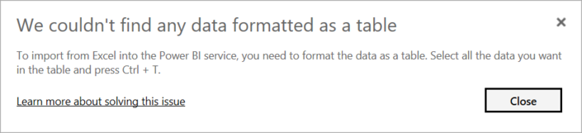](https://learn.microsoft.com/en-us/training/modules/get-data/media/9-format-as-table-excel-ss.png#lightbox)

#### Couldn't find file

While importing data from a file, you may get the "Couldn't find file" error.

[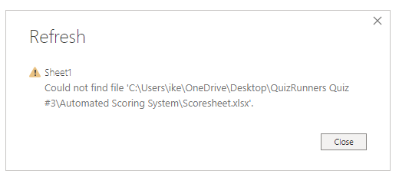](https://learn.microsoft.com/en-us/training/modules/get-data/media/9-file-location-ss.png#lightbox)

Usually, this error is caused by the file moving locations or the permissions to the file changing. If the cause is the former, you need to find the file and change the source settings.

1. Open Power Query by selecting the **Transform Data** button in Power BI.
2. Highlight the query that is creating the error.
3. On the left, under **Query Settings**, select the gear icon next to **Source**.

[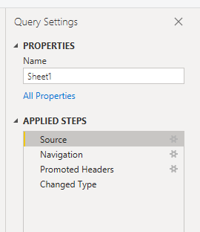](https://learn.microsoft.com/en-us/training/modules/get-data/media/9-query-changes-ss.png#lightbox)

1. Change the file location to the new location.

[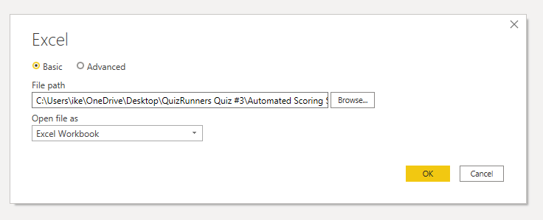](https://learn.microsoft.com/en-us/training/modules/get-data/media/9-file-location-new-location-ss.png#lightbox)

#### Data type errors

Sometimes, when you import data into Power BI, the columns appear blank. This situation happens because of an error in interpreting the data type in Power BI. The resolution to this error is unique to the data source. For instance, if you're importing data from SQL Server and see blank columns, you could try to convert to the correct data type in the query.

Instead of using this query:

SELECT CustomerPostalCode FROM Sales.Customers

Use this query:

SELECT CAST(CustomerPostalCode as varchar(10)) FROM Sales.Customers

By specifying the correct type at the data source, you eliminate many of these common data source errors.

You may encounter different types of errors in Power BI that are caused by the diverse data source systems where your data resides.

If you experience an error not covered, you can search [Microsoft documentation](https://learn.microsoft.com/en-us/power-query/dealing-with-errors) for the error message, and the resolution you need.

### Exercise - Prepare data in Power BI Desktop

This unit includes a lab to complete.

Use the free resources provided in the lab to complete the exercises in this unit. You will not be charged **for the lab environment**; however, you may need to bring your own subscription depending on the lab.

Microsoft provides this lab experience and related content for educational purposes. All presented information is owned by Microsoft and intended solely for learning about the covered products and services in this Microsoft Learn module.

[Launch lab](https://learn.microsoft.com/en-us/training/modules/get-data/lab-prepare)

**The estimated time to complete the exercise is 30 minutes.**

 Note

A virtual machine containing the client tools you need is provided, along with the exercise instructions. Use the button above to launch the virtual machine.

*A limited number of concurrent sessions are available - if the hosted environment is unavailable, try again later.*

Alternatively, you can use these [**setup instructions**](https://microsoftlearning.github.io/PL-300-Microsoft-Power-BI-Data-Analyst/Instructions/Labs/00-setup.html) to create your own lab environment, then follow these [**exercise instructions**](https://microsoftlearning.github.io/PL-300-Microsoft-Power-BI-Data-Analyst/Instructions/Labs/01-prepare-data-with-power-query-in-power-bi-desktop.html).

Get Data in Power BI Desktop

#### Lab story

This lab is designed to introduce you to Power BI Desktop application and how to connect to data and how to use data preview techniques to understand the characteristics and quality of the source data. The learning objectives are:

* Open Power BI Desktop
* Connect to different data sources
* Preview source data with Power Query
* Use data profiling features in Power Query

**This lab should take approximately 30 minutes.**

Get started with Power BI Desktop

To complete this exercise, first open a web browser and enter the following URL to download the zip folder:

https://github.com/MicrosoftLearning/PL-300-Microsoft-Power-BI-Data-Analyst/raw/Main/Allfiles/Labs/01-prepare-data-with-power-query-in-power-bi-desktop/01-prepare-data.zip

Extract the folder to the **C:\Users\Student\Downloads\01-prepare-data** folder.

Open the **01-Starter-Sales Analysis.pbix** file.

* This starter file has been specially configured to help you complete the lab. The following report-level settings have been disabled in the starter file:
  + Data Load > Import relationships from data sources on first load
  + Data Load > Autodetect new relationships after data is loaded

Get data from SQL Server

This task teaches you how to connect to a SQL Server database and import tables, which create queries in Power Query.

1. On the **Home** ribbon tab, from inside the **Data** group, select **SQL Server**.

[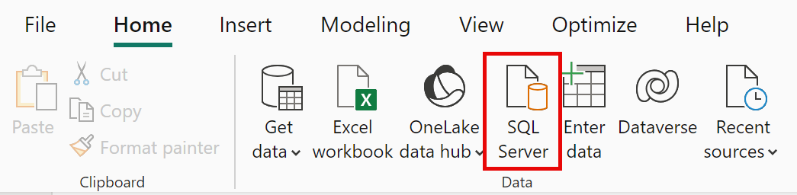](https://microsoftlearning.github.io/PL-300-Microsoft-Power-BI-Data-Analyst/Instructions/Labs/Linked_image_Files/01-prepare-data-with-power-query-in-power-bi-desktop_image11.png)

1. In the **SQL Server Database** window, in the **Server** box, enter **localhost** and leave **Database** blank, then select **OK**.

***Note****: In this lab, you’ll connect to the SQL Server database by using****localhost****because gateway data sources can’t resolve****localhost****. This isn’t a recommended practice when creating your own solutions.*

1. If prompted for credentials, select **Windows > Use my current credentials**, and then **Connect**.
2. Select **OK** if you receive a warning that an encrypted connection cannot be established.
3. In the **Navigator** pane, expand the **AdventureWorksDW2020** database.

***Note****: The****AdventureWorksDW2020****database is based on the****AdventureWorksDW2017****sample database. It has been modified to support the learning objectives of the course labs.*

1. Select the **DimEmployee** table, and notice the preview of the table data.

[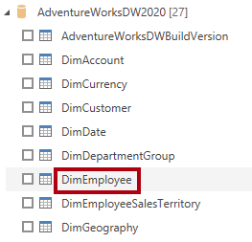](https://microsoftlearning.github.io/PL-300-Microsoft-Power-BI-Data-Analyst/Instructions/Labs/Linked_image_Files/01-prepare-data-with-power-query-in-power-bi-desktop_image18.png)

***Note****: The preview data allows you to see the columns and a sample of rows.*

1. To import the table data, **select the checkbox** next to the following tables:
   * DimEmployee
   * DimEmployeeSalesTerritory
   * DimProduct
   * DimReseller
   * DimSalesTerritory
   * FactResellerSales
2. Complete this task by selecting **Transform Data**, which will open Power Query Editor - leave this open for the next task.

You’ve now connected to six tables from a SQL Server database.

**Preview Data in Power Query Editor**

This task introduces the Power Query Editor and allows you to review and profile the data. This helps you determine how to clean and transform the data later. You’ll also review both dimension tables prefixed with “Dim” and fact tables prefixed with “Fact”.

1. In the **Power Query Editor** window, at the left, notice the **Queries** pane. The **Queries** pane contains one query for each table you checked.

[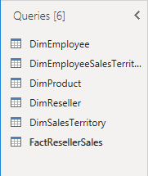](https://microsoftlearning.github.io/PL-300-Microsoft-Power-BI-Data-Analyst/Instructions/Labs/Linked_image_Files/01-prepare-data-with-power-query-in-power-bi-desktop_image20.png)

1. Select the first query—**DimEmployee**.

*The****DimEmployee****table in the SQL Server database stores one row for each employee. A subset of the rows from this table represents the salespeople, which will be relevant to the model you’ll develop.*

1. At the bottom left corner of the status bar, some table statistics are provided—the table has 33 columns, and 296 rows.

[](https://microsoftlearning.github.io/PL-300-Microsoft-Power-BI-Data-Analyst/Instructions/Labs/Linked_image_Files/01-prepare-data-with-power-query-in-power-bi-desktop_image22.png)

1. In the data preview pane, scroll horizontally to review all columns. Notice that the last five columns contain **Table** or **Value** links.

*These five columns represent relationships to other tables in the database. They can be used to join tables together. You’ll join tables in the****Load Transformed Data in Power BI Desktop****lab.*

1. To assess column quality, on the **View** ribbon tab, from inside the **Data Preview** group, check **Column Quality**. The column quality feature allows you to easily determine the percentage of valid, error, or empty values found in columns.

[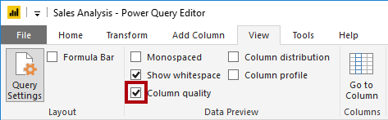](https://microsoftlearning.github.io/PL-300-Microsoft-Power-BI-Data-Analyst/Instructions/Labs/Linked_image_Files/01-prepare-data-with-power-query-in-power-bi-desktop_image23.png)

1. Notice that the **Position** column has 94% empty (null) rows.

[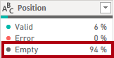](https://microsoftlearning.github.io/PL-300-Microsoft-Power-BI-Data-Analyst/Instructions/Labs/Linked_image_Files/01-prepare-data-with-power-query-in-power-bi-desktop_image24.png)

1. To assess column distribution, on the **View** ribbon tab, from inside the **Data Preview** group, check **Column Distribution**.
2. Review the **Position** column again, and notice that there are four distinct values, and one unique value.
3. Review the column distribution for the **EmployeeKey** column—there are 296 distinct values, and 296 unique values.

[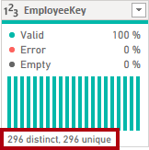](https://microsoftlearning.github.io/PL-300-Microsoft-Power-BI-Data-Analyst/Instructions/Labs/Linked_image_Files/01-prepare-data-with-power-query-in-power-bi-desktop_image26.png)

***Note****: When the distinct and unique counts are the same, it means the column contains unique values. When modeling, it’s important that some model tables have unique columns. These unique columns can be used to create one-to-many relationships, which you’ll do in the****Model Data in Power BI Desktop****lab.*

1. In the **Queries** pane, select the **DimProduct** query.

*The****DimProduct****table contains one row per product sold by the company.*

1. In the **Queries** pane, select the **DimReseller** query.

*The****DimReseller****table contains one row per reseller. Resellers sell, distribute, or value add to the Adventure Works products.*

1. To view column values, on the **View** ribbon tab, from inside the **Data Preview** group, check **Column Profile**.
2. Select the **BusinessType** column header, and notice the new pane beneath the data preview pane. Review the column statistics and value distribution in the data preview pane.

*Notice the data quality issue: there are two labels for warehouse (****Warehouse****, and the misspelled****Ware House****).*

[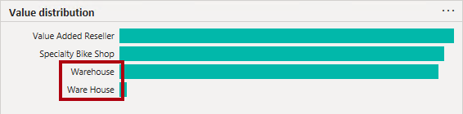](https://microsoftlearning.github.io/PL-300-Microsoft-Power-BI-Data-Analyst/Instructions/Labs/Linked_image_Files/01-prepare-data-with-power-query-in-power-bi-desktop_image31.png)

1. Hover the cursor over the **Ware House** bar, and notice that there are five rows with this value.
2. In the **Queries** pane, select the **DimSalesTerritory** query.

*The****DimSalesTerritory****table contains one row per sales region, including****Corporate HQ****(headquarters). Regions are assigned to a country, and countries are assigned to groups. In the****Model Data in Power BI Desktop****lab, you’ll create a hierarchy to support analysis at region, country, or group level.*

1. In the **Queries** pane, select the **FactResellerSales** query.

*The****FactResellerSales****table contains one row per sales order line—a sales order contains one or more line items.*

1. Review the column quality for the **TotalProductCost** column, and notice that 8% of the rows are empty.

*Missing****TotalProductCost****column values is a data quality issue.*

**Get data from a CSV file**

In this task, you’ll create a new query based on CSV files.

1. To add a new query, in the **Power Query Editor** window, on the **Home** ribbon tab, from inside the **New Query** group, select the **New Source** down-arrow, and then select **Text/CSV**.
2. Navigate to the **01-prepare-data > ResellerSalesTargets.csv** file. Select **Open**.
3. In the **ResellerSalesTargets.csv** window, review the preview data. Select **OK**.
4. In the **Queries** pane, notice the addition of the **ResellerSalesTargets** query.

*The****ResellerSalesTargets****CSV file contains one row per salesperson, per year. Each row records 12 monthly sales targets (expressed in thousands). The business year for the Adventure Works company commences on July 1.*

1. Notice that no column contains empty values. When there isn’t a monthly sales target, a hyphen character is stored instead.
2. Review the icons in each column header, to the left of the column name. The icons represent the column data type. **123** is whole number, and **ABC** is text.

[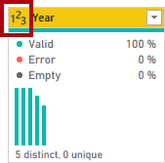](https://microsoftlearning.github.io/PL-300-Microsoft-Power-BI-Data-Analyst/Instructions/Labs/Linked_image_Files/01-prepare-data-with-power-query-in-power-bi-desktop_image38.png)

1. Repeat the steps to create a query based on the **ColorFormats.csv** file.

*The****ColorFormats****CSV file contains one row per product color. Each row records the HEX codes to format background and font colors.*

You should now have two new queries, **ResellerSalesTargets** and **ColorFormats**.

[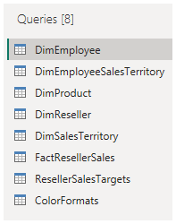](https://microsoftlearning.github.io/PL-300-Microsoft-Power-BI-Data-Analyst/Instructions/Labs/Linked_image_Files/01-all-queries-loaded.png)

Lab complete

### [Knowledge Check](https://learn.microsoft.com/en-us/training/modules/get-data/10-check)

### Summary

In this module, you learned about pulling data from many different data sources and into Power BI. You can pull data from files, relational databases, Azure Analysis Services, cloud-based applications, websites, and more. Retrieving data from different data sources requires treating each data source differently. For instance, Microsoft Excel data should be pulled in from an Excel table. Relational databases often have query timeouts. You can connect to SQL Server Analysis Services with Connect live, which allows you to see data changes in real-time.

It's important to select the correct storage mode for your data. Do you require that visuals interact quickly but don’t mind possibly refreshing the data when the underlying data source changes? If so, select Import to import data into Power BI. If you prefer to see updates to data as soon as they happen at the cost of interactivity performance, then choose Direct Query for your data instead.

In addition, you learned how to solve performance problems and data import errors. You learned that Power BI gives you tooling to identify where performance problems may exist. Data import errors can be alarming at first, but you can see that the resolution is easily implemented.

## Clean, transform, and load data in Power BI

### Introduction

Consider the scenario where you have imported data into Power BI from several different sources and, when you examine the data, it is not prepared for analysis. What could make the data unprepared for analysis?

When examining the data, you discover several issues, including:

* A column called **Employment status** only contains numerals.
* Several columns contain errors.
* Some columns contain null values.
* The customer ID in some columns appears as if it was duplicated repeatedly.
* A single address column has combined street address, city, state, and zip code.

You start working with the data, but every time you create visuals on reports, you get bad data, incorrect results, and simple reports about sales totals are wrong.

Dirty data can be overwhelming and, though you might feel frustrated, you decide to get to work and figure out how to make this semantic model as pristine as possible.

Fortunately, Power BI and Power Query offer you a powerful environment to clean and prepare the data. Clean data has the following advantages:

* Measures and columns produce more accurate results when they perform aggregations and calculations.
* Tables are organized, where users can find the data in an intuitive manner.
* Duplicates are removed, making data navigation simpler. It will also produce columns that can be used in slicers and filters.
* A complicated column can be split into two, simpler columns. Multiple columns can be combined into one column for readability.
* Codes and integers can be replaced with human readable values.

In this module, you will learn how to:

* Resolve inconsistencies, unexpected or null values, and data quality issues.
* Apply user-friendly value replacements.
* Profile data so you can learn more about a specific column before using it.
* Evaluate and transform column data types.
* Apply data shape transformations to table structures.
* Combine queries.
* Apply user-friendly naming conventions to columns and queries.
* Edit M code in the Advanced Editor.

### Shape the initial data

Power Query Editor in Power BI Desktop allows you to shape (transform) your imported data. You can accomplish actions such as renaming columns or tables, changing text to numbers, removing rows, setting the first row as headers, and much more. It is important to shape your data to ensure that it meets your needs and is suitable for use in reports.

You have loaded raw sales data from two sources into a Power BI model. Some of the data came from a .csv file that was created manually in Microsoft Excel by the Sales team. The other data was loaded through a connection to your organization's Enterprise Resource Planning (ERP) system. Now, when you look at the data in Power BI Desktop, you notice that it's in disarray; some data that you don't need and some data that you do need are in the wrong format.

You need to use Power Query Editor to clean up and shape this data before you can start building reports.

[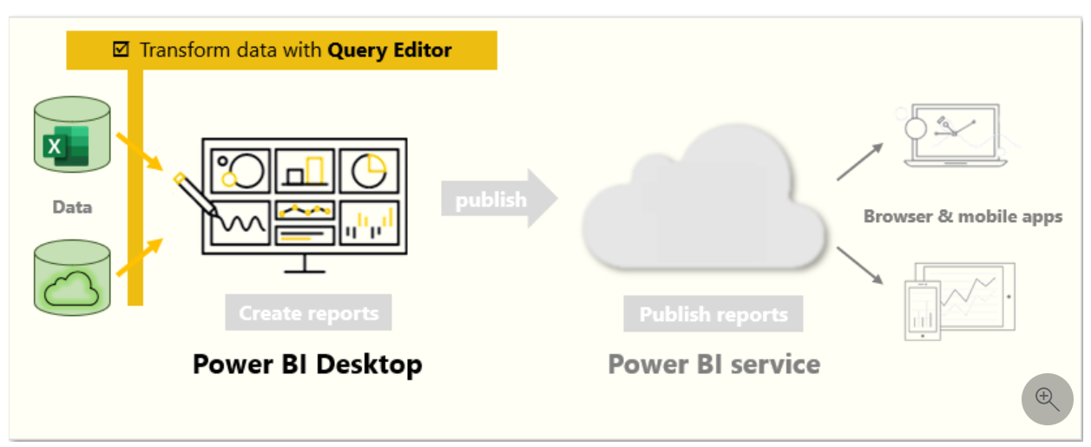](https://learn.microsoft.com/en-us/training/modules/clean-data-power-bi/media/02-shape-data-query-editor-overview-ss.png#lightbox)

#### Get started with Power Query Editor

To start shaping your data, open Power Query Editor by selecting the **Transform data** option on the **Home** tab of Power BI Desktop.

[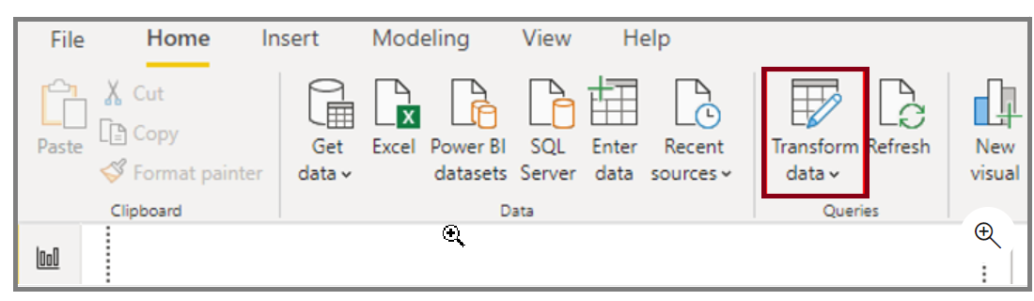](https://learn.microsoft.com/en-us/training/modules/clean-data-power-bi/media/02-open-query-editor-transform-button-ssm.png#lightbox)

In Power Query Editor, the data in your selected query displays in the middle of the screen and, on the left side, the **Queries** pane lists the available queries (tables).

When you work in Power Query Editor, all steps that you take to shape your data are recorded. Then, each time the query connects to the data source, it automatically applies your steps, so your data is always shaped the way that you specified. Power Query Editor only makes changes to a particular view of your data, so you can feel confident about changes that are being made to your original data source. You can see a list of your steps on the right side of the screen, in the **Query Settings** pane, along with the query's properties.

The Power Query Editor ribbon contains many buttons you can use to select, view, and shape your data.

To learn more about the available features and functions, see [The query ribbon](https://learn.microsoft.com/en-us/power-query/power-query-quickstart-using-power-bi#the-query-ribbon).

Note

In Power Query Editor, the right-click context menus and **Transform** tab in the ribbon provide many of the same options.

#### Identify column headers and names

The first step in shaping your initial data is to identify the column headers and names within the data and then evaluate where they are located to ensure that they are in the right place.

In the following screenshot, the source data in the csv file for SalesTarget (sample not provided) had a target categorized by products and a subcategory split by months, both of which are organized into columns.

[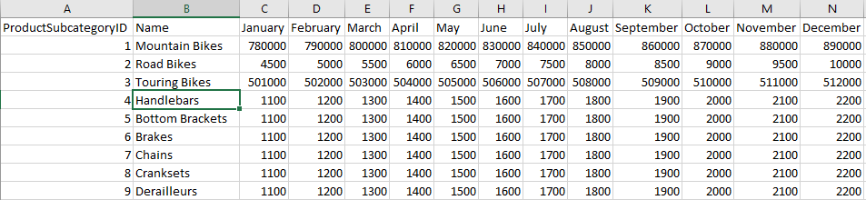](https://learn.microsoft.com/en-us/training/modules/clean-data-power-bi/media/02-identify-columns-ss.png#lightbox)

However, you notice that the data did not import as expected.

[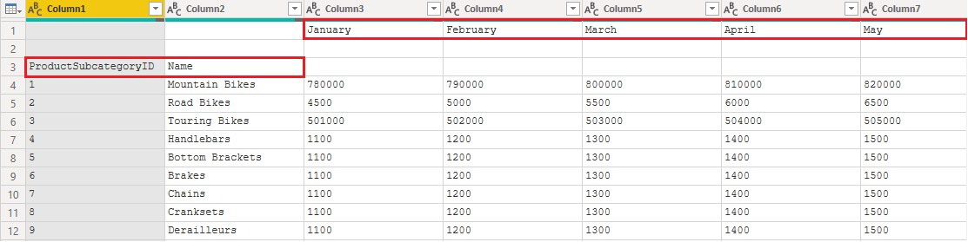](https://learn.microsoft.com/en-us/training/modules/clean-data-power-bi/media/02-identify-headers-names-ssm.png#lightbox)

Consequently, the data is difficult to read. A problem has occurred with the data in its current state because column headers are in different rows (marked in red), and several columns have undescriptive names, such as **Column1**, **Column2**, and so on.

When you have identified where the column headers and names are located, you can make changes to reorganize the data.

#### Promote headers

When a table is created in Power BI Desktop, Power Query Editor assumes that all data belongs in table rows. However, a data source might have a first row that contains column names, which is what happened in the previous SalesTarget example. To correct this inaccuracy, you need to promote the first table row into column headers.

You can promote headers in two ways: by selecting the **Use First Row as Headers** option on the **Home** tab or by selecting the drop-down button next to **Column1** and then selecting **Use First Row as Headers**.

[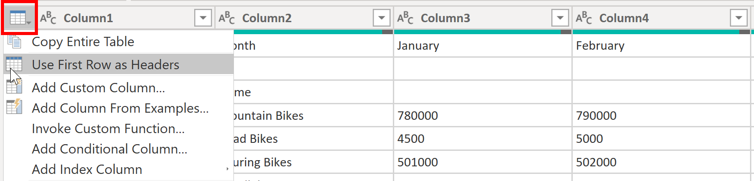](https://learn.microsoft.com/en-us/training/modules/clean-data-power-bi/media/02-use-first-row-headers-ssm.png#lightbox)

The following image illustrates how the **Use First Row as Headers** feature impacts the data:

[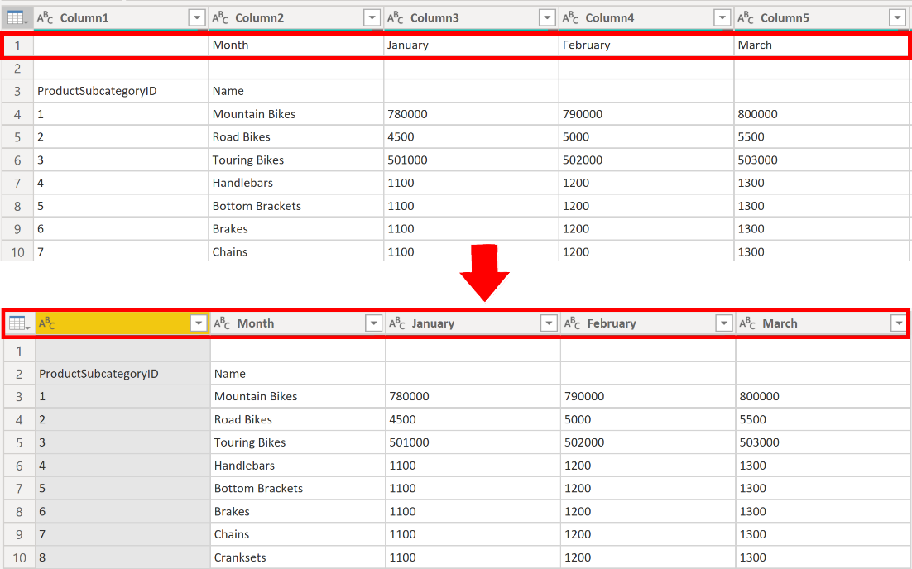](https://learn.microsoft.com/en-us/training/modules/clean-data-power-bi/media/02-use-first-row-headers-result-ssm.png#lightbox)

#### Rename columns

The next step in shaping your data is to examine the column headers. You might discover that one or more columns have the wrong headers, a header has a spelling error, or the header naming convention is not consistent or user-friendly.

Refer to the previous screenshot, which shows the impact of the **Use First Row as Headers** feature. Notice that the column that contains the subcategory **Name** data now has **Month** as its column header. This column header is incorrect, so it needs to be renamed.

You can rename column headers in two ways. One approach is to right-click the header, select **Rename**, edit the name, and then press **Enter**. Alternatively, you can double-click the column header and overwrite the name with the correct name.

You can also work around this issue by removing (skipping) the first two rows and then renaming the columns to the correct name.

#### Remove top rows

When shaping your data, you might need to remove some of the top rows, for example, if they are blank or if they contain data that you do not need in your reports.

Continuing with the SalesTarget example, notice that the first row is blank (it has no data) and the second row has data that is no longer required.

[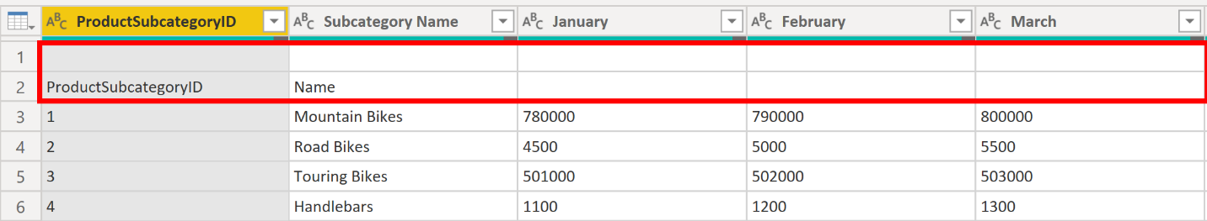](https://learn.microsoft.com/en-us/training/modules/clean-data-power-bi/media/02-remove-top-rows-ssm.png#lightbox)

To remove these excess rows, select **Remove Rows** > **Remove Top Rows** on the **Home** tab.

[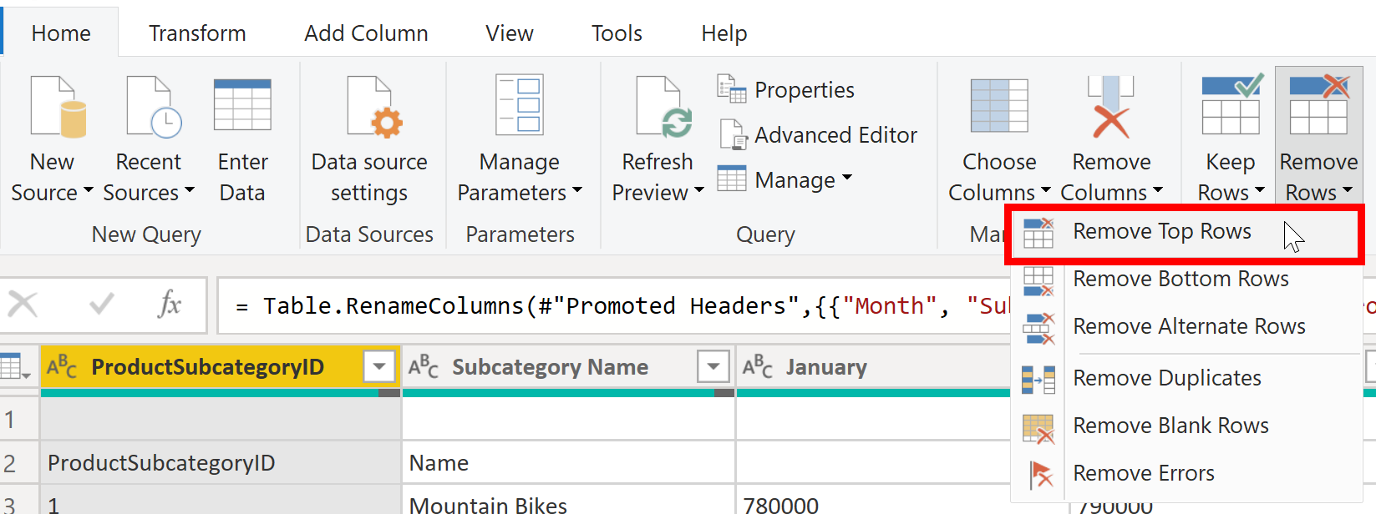](https://learn.microsoft.com/en-us/training/modules/clean-data-power-bi/media/02-remove-top-rows-feature-ssm.png#lightbox)

#### Remove columns

A key step in the data shaping process is to remove unnecessary columns. It is much better to remove columns as early as possible. One way to remove columns would be to limit the column when you get data from data source. For instance, if you are extracting data from a relational database by using SQL, you would want to limit the column that you extract by using a column list in the SELECT statement.

Removing columns at an early stage in the process rather than later is best, especially when you have established relationships between your tables. Removing unnecessary columns will help you to focus on the data that you need and help improve the overall performance of your Power BI Desktop semantic models and reports.

Examine each column and ask yourself if you really need the data that it contains. If you don't plan on using that data in a report, the column adds no value to your semantic model. Therefore, the column should be removed. You can always add the column later, if your requirements change over time.

You can remove columns in two ways. The first method is to select the columns that you want to remove and then, on the **Home** tab, select **Remove Columns**.

[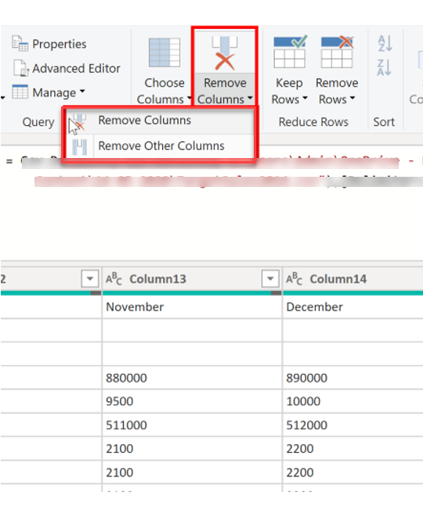](https://learn.microsoft.com/en-us/training/modules/clean-data-power-bi/media/02-remove-columns-ssm.png#lightbox)

Alternatively, you can select the columns that you want to keep and then, on the **Home** tab, select **Remove Columns** > **Remove Other Columns**.

[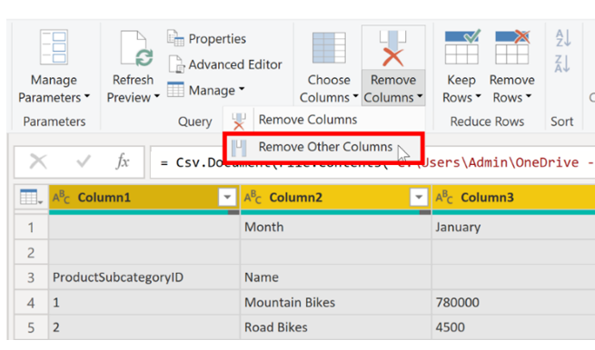](https://learn.microsoft.com/en-us/training/modules/clean-data-power-bi/media/02-remove-other-columsn-ssm.png#lightbox)

#### Unpivot columns

Unpivoting is a useful feature of Power BI. You can use this feature with data from any data source, but you would most often use it when importing data from Excel. The following example shows a sample Excel document with sales data.

[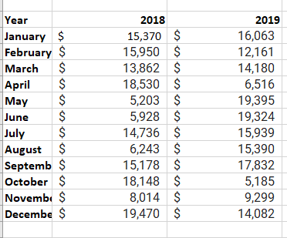](https://learn.microsoft.com/en-us/training/modules/clean-data-power-bi/media/02-excel-data-multiple-columns-ss.png#lightbox)

Though the data might initially make sense, it would be difficult to create a total of all sales combined from 2018 and 2019. Your goal would then be to use this data in Power BI with three columns: **Month**, **Year**, and **SalesAmount**.

When you import the data into Power Query, it will look like the following image.

[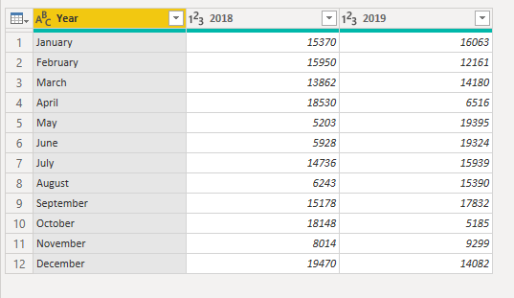](https://learn.microsoft.com/en-us/training/modules/clean-data-power-bi/media/02-original-data-ss.png#lightbox)

Next, rename the first column to **Month**. This column was mislabeled because that header in Excel was labeling the 2018 and 2019 columns. Highlight the 2018 and 2019 columns, select the **Transform** tab in Power Query, and then select **Unpivot**.

[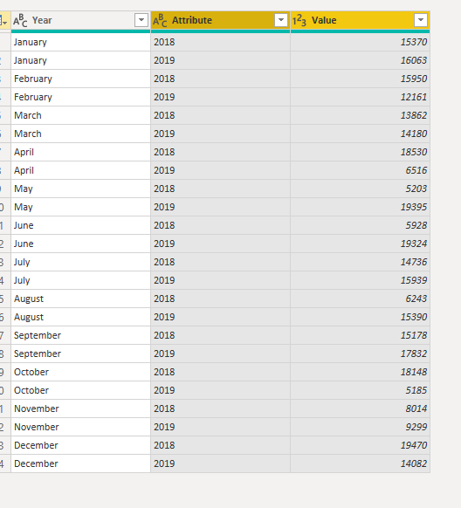](https://learn.microsoft.com/en-us/training/modules/clean-data-power-bi/media/02-unpivot-ss.png#lightbox)

You can rename the **Attribute** column to **Year** and the **Value** column to **SalesAmount**.

Unpivoting streamlines the process of creating DAX measures on the data later. By completing this process, you have now created a simpler way of slicing the data with the **Year** and **Month** columns.

#### Pivot columns

If the data that you are shaping is flat (in other words, it has lot of detail but is not organized or grouped in any way), the lack of structure can complicate your ability to identify patterns in the data.

You can use the **Pivot Column** feature to convert your flat data into a table that contains an aggregate value for each unique value in a column. For example, you might want to use this feature to summarize data by using different math functions such as **Count**, **Minimum**, **Maximum**, **Median**, **Average**, or **Sum**.

In the SalesTarget example, you can pivot the columns to get the quantity of product subcategories in each product category.

On the **Transform** tab, select **Transform > Pivot Columns**.

[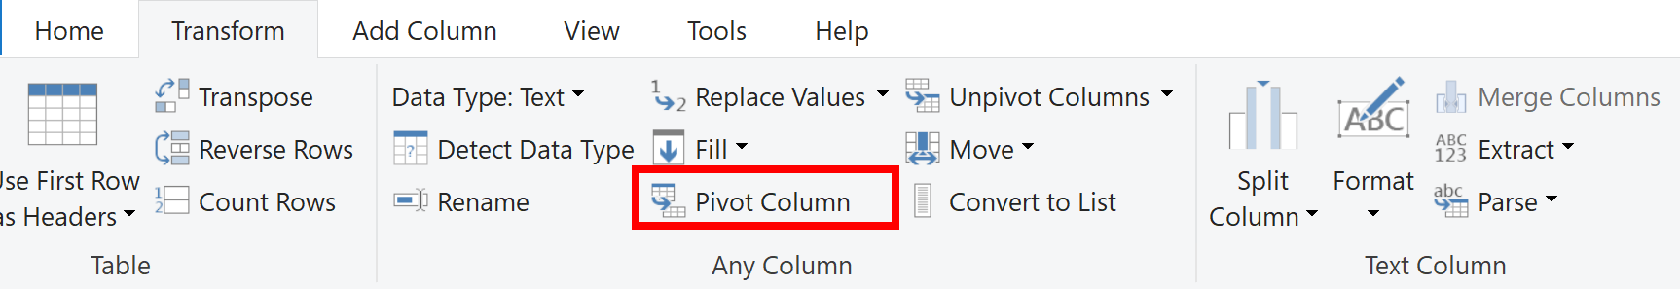](https://learn.microsoft.com/en-us/training/modules/clean-data-power-bi/media/02-pivot-column-ssm.png#lightbox)

On the **Pivot Column** window that displays, select a column from the **Values Column** list, such as **Subcategory name**. Expand the advanced options and select an option from the **Aggregate Value Function** list, such as **Count (All)**, and then select **OK**.

[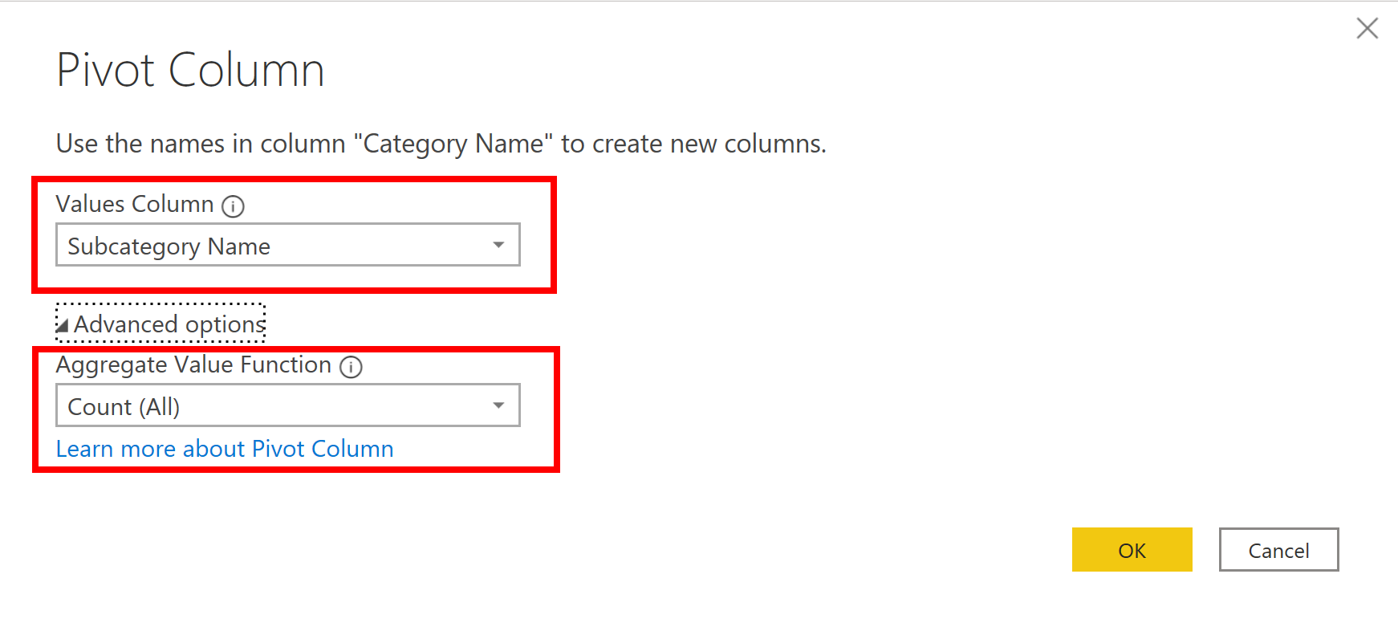](https://learn.microsoft.com/en-us/training/modules/clean-data-power-bi/media/02-aggregate-value-function-ssm.png#lightbox)

The following image illustrates how the **Pivot Column** feature changes the way that the data is organized.

[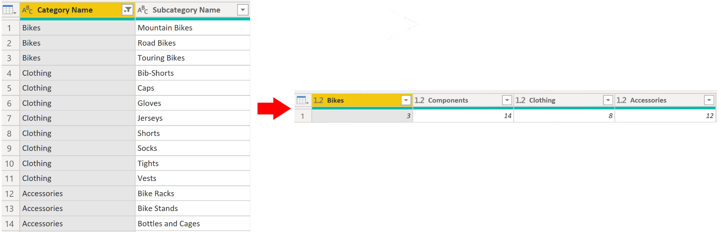](https://learn.microsoft.com/en-us/training/modules/clean-data-power-bi/media/02-pivot-column-feature-display-data-ssm.png#lightbox)

Power Query Editor records all steps that you take to shape your data, and the list of steps are shown in the **Query Settings** pane. If you have made all the required changes, select **Close & Apply** to close Power Query Editor and apply your changes to your semantic model. However, before you select **Close & Apply**, you can take further steps to clean up and transform your data in Power Query Editor. These additional steps are covered later in this module.

### Simplify the data structure

When you import data from multiple sources into Power BI Desktop, the data retains its predefined table and column names. You might want to change some of these names so that they are in a consistent format, easier to work with, and more meaningful to a user. You can use Power Query Editor in Power BI Desktop to make these name changes and simplify your data structure.

To continue with the previous scenario where you shaped the initial data in your model, you need to take further action to simplify the structure of the sales data and get it ready for developing reports for the Sales team. You have already renamed the columns, but now you need to examine the names of the queries (tables) to determine if any improvements can be made. You also need to review the contents of the columns and replace any values that require correction.

#### Rename a query

It's good practice to change uncommon or unhelpful query names to names that are more obvious or that the user is more familiar with. For instance, if you import a product fact table into Power BI Desktop and the query name displays as *FactProductTable*, you might want to change it to a more user-friendly name, such as *Products*. Similarly, if you import a view, the view might have a name that contains a prefix of *v*, such as *vProduct*. People might find this name unclear and confusing, so you might want to remove the prefix.

In this example, you have examined the name of the TargetSales query and realize that this name is unhelpful because you'll have a query with this name for every year. To avoid confusion, you want to add the year to the query name.

In Power Query Editor, in the **Queries** pane to the left of your data, select the query that you want to rename. Right-click the query and select **Rename**. Edit the current name or type a new name, and then press **Enter**.

[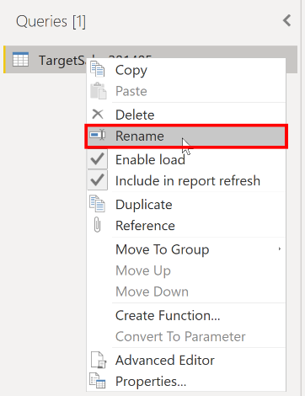](https://learn.microsoft.com/en-us/training/modules/clean-data-power-bi/media/03-rename-query-ssm.png#lightbox)

#### Replace values

You can use the **Replace Values** feature in Power Query Editor to replace any value with another value in a selected column.

In this example, you notice that, in the **Attribute** column, the month December is misspelled. You need to correct this spelling mistake. Select the column that contains the value that you want to replace (**Attribute** in this case), and then select **Replace Values** on the **Transform** tab.

[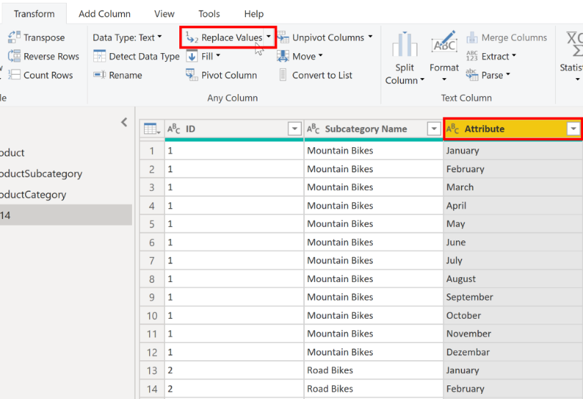](https://learn.microsoft.com/en-us/training/modules/clean-data-power-bi/media/03-replace-value-ssm.png#lightbox)

In the **Value to Find** box, enter the name of the value that you want to replace, and then in the **Replace With** box, enter the correct value name and then select **OK**. In Power Query, you can't select one cell and change one value, like you might have done in Excel.

[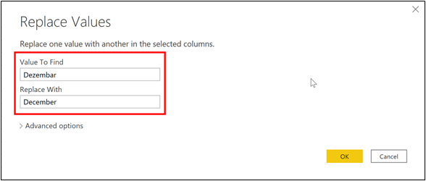](https://learn.microsoft.com/en-us/training/modules/clean-data-power-bi/media/03-value-find-ssm.png#lightbox)

You can review the list of steps that you took to restructure and correct your data in the **Query Settings** pane. When you have completed all steps that you want to take, you can select **Close & Apply** to close Power Query Editor and apply your changes to your data model. However, you can take further action to clean and transform your data.

#### Replace null values

Occasionally, you might find that your data sources contain null values. For example, a freight amount on a sales order might have a null value if it's synonymous with zero. If the value stays null, the averages will not calculate correctly. One solution would be to change the nulls to zero, which will produce the more accurate freight average. In this instance, using the same steps that you followed previously will help you replace the null values with zero.

[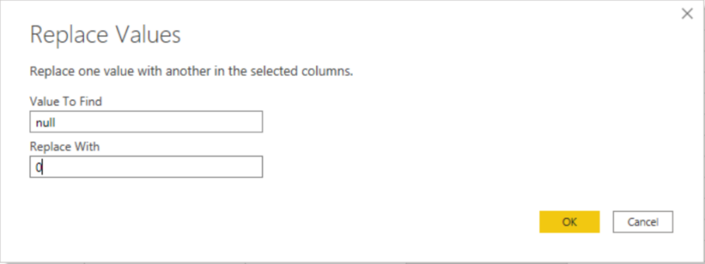](https://learn.microsoft.com/en-us/training/modules/clean-data-power-bi/media/03-replace-null-zero-ss.png#lightbox)

#### Remove duplicates

You can also remove duplicates from columns to only keep unique names in a selected column by using the **Remove Duplicates** feature in Power Query.

In this example, notice that the **Category Name** column contains duplicates for each category. As a result, you want to create a table with unique categories and use it in your semantic model. You can achieve this action by selecting a column, right-clicking on the header of the column, and then selecting the **Remove Duplicates** option.

You might consider copying the table before removing the duplicates. The **Copy** option is at the top of the context menu, as shown in the following screenshot. Copying the table before removing duplicates will give you a comparison of the tables and will let you use both tables, if needed.

[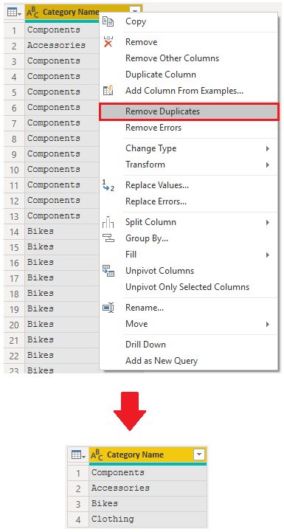](https://learn.microsoft.com/en-us/training/modules/clean-data-power-bi/media/03-remove-duplicates-ssm.png#lightbox)

#### Best practices for naming tables, columns, and values

Naming conventions for tables, columns, and values have no fixed rules; however, we recommend that you use the language and abbreviations that are commonly used within your organization and that everyone agrees on and considers them as common terminology.

A best practice is to give your tables, columns, and measures descriptive business terms and replace underscores ("_") with spaces. Be consistent with abbreviations, prefixes, and words like "number" and "ID." Excessively short abbreviations can cause confusion if they are not commonly used within the organization.

Also, by removing prefixes or suffixes that you might use in table names and instead naming them in a simple format, you will help avoid confusion.

When replacing values, try to imagine how those values will appear on the report. Values that are too long might be difficult to read and fit on a visual. Values that are too short might be difficult to interpret. Avoiding acronyms in values is also a good idea, provided that the text will fit on the visual.

### Evaluate and change column data types

When you import a table from any data source, Power BI Desktop automatically starts scanning the first 1,000 rows (default setting) and tries to detect the type of data in the columns. Some situations might occur where Power BI Desktop doesn't detect the correct data type. Where incorrect data types occur, you'll experience performance issues.

You have a higher chance of getting data type errors when you're dealing with flat files, such as comma-separated values (.CSV) files and Excel workbooks (.XLSX), because data was entered manually into the worksheets and mistakes were made. Conversely, in databases, the data types are predefined when tables or views are created.

A best practice is to evaluate the column data types in Power Query Editor before you load the data into a Power BI semantic model. If you determine that a data type is incorrect, you can change it. You might also want to apply a format to the values in a column and change the summarization default for a column.

To continue with the scenario where you're cleaning and transforming sales data in preparation for reporting, you now need to evaluate the columns to ensure that they have the correct data type. You need to correct any errors that you identify.

You evaluate the **OrderDate** column. As expected, it contains numeric data, but Power BI Desktop has incorrectly set the column data type to Text. To report on this column, you need to change the data type from Text to Date.

[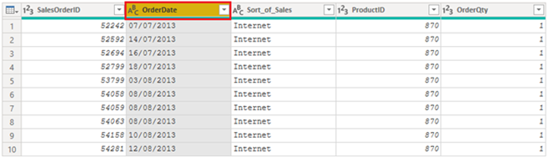](https://learn.microsoft.com/en-us/training/modules/clean-data-power-bi/media/04-column-data-type-setas-text-ssm.png#lightbox)

#### Implications of incorrect data types

The following information provides insight into problems that can arise when Power BI doesn't detect the correct data type.

Incorrect data types will prevent you from creating certain calculations, deriving hierarchies, or creating proper relationships with other tables. For example, if you try to calculate the Quantity of Orders YTD, you'll get the following error stating that the **OrderDate** column data type isn't Date, which is required in time-based calculations.

Quantity of Orders YTD = TOTALYTD(SUM('Sales'[OrderQty]), 'Sales'[OrderDate])

[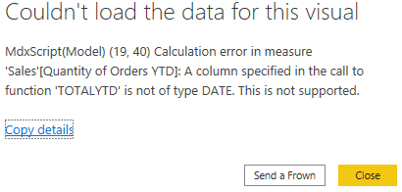](https://learn.microsoft.com/en-us/training/modules/clean-data-power-bi/media/04-error-calculated-measure-ss.png#lightbox)

Another issue with having an incorrect data type applied on a date field is the inability to create a date hierarchy, which would allow you to analyze your data on a yearly, monthly, or weekly basis. The following screenshot shows that the SalesDate field isn't recognized as type Date and will only be presented as a list of dates in the Table visual. However, It's a best practice to use a date table and turn off the auto date/time to get rid of the auto generated hierarchy. For more information about this process, see [Auto generated data type](https://learn.microsoft.com/en-us/power-bi/guidance/auto-date-time/) documentation.

[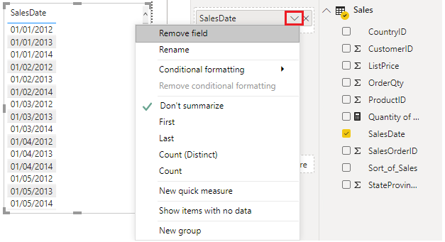](https://learn.microsoft.com/en-us/training/modules/clean-data-power-bi/media/04-additions-sales-date-options-ssm.png#lightbox)

#### Change the column data type

You can change the data type of a column in two places: in Power Query Editor and in the Power BI Desktop Report view by using the column tools. It is best to change the data type in the Power Query Editor before you load the data.

##### Change the column data type in Power Query Editor

In Power Query Editor, you can change the column data type in two ways. One way is to select the column that has the issue, select **Data Type** in the **Transform** tab, and then select the correct data type from the list.

[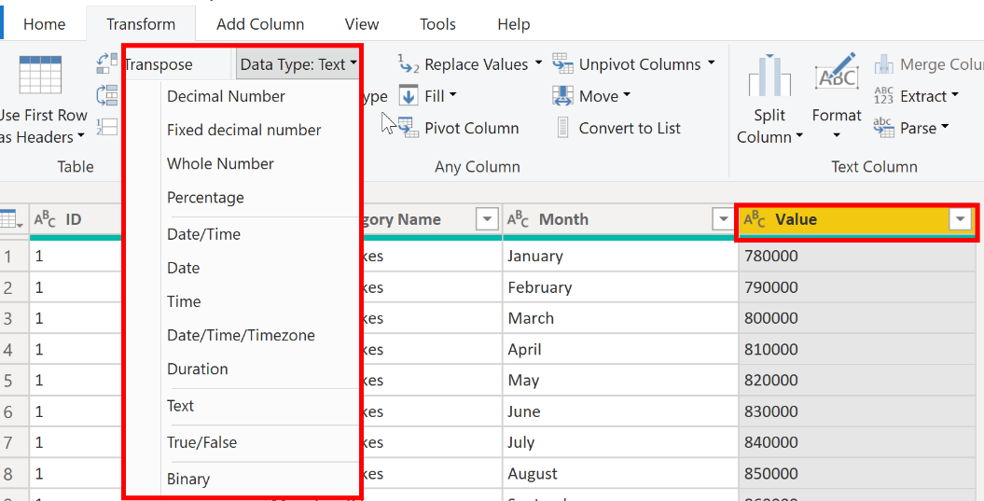](https://learn.microsoft.com/en-us/training/modules/clean-data-power-bi/media/04-select-data-type-ssm.png#lightbox)

Another method is to select the data type icon next to the column header and then select the correct data type from the list.

[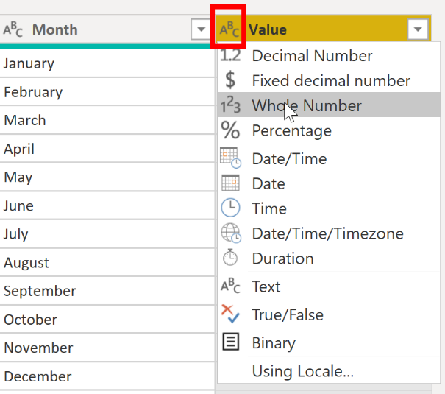](https://learn.microsoft.com/en-us/training/modules/clean-data-power-bi/media/04-select-data-type-from-list-ssm.png#lightbox)

As with any other changes that you make in Power Query Editor, the change that you make to the column data type is saved as a programmed step. This step is called **Changed Type** and it will be iterated every time the data is refreshed.

After you have completed all steps to clean and transform your data, select **Close & Apply** to close Power Query Editor and apply your changes to your semantic model. At this stage, your data should be in great shape for analysis and reporting.

For more information, see [Data types in Power BI Desktop](https://learn.microsoft.com/en-us/power-bi/connect-data/desktop-data-types/).

### Combine multiple tables into a single table

The ability to combine queries is powerful because it allows you to append or merge different tables or queries together. You can combine tables into a single table in the following circumstances:

* Too many tables exist, making it difficult to navigate an overly complicated semantic model.
* Several tables have a similar role.
* A table has only a column or two that can fit into a different table.
* You want to use several columns from different tables in a custom column.

You can combine the tables in two different ways: merging and appending.

Assume that you're developing Power BI reports for the Sales and HR teams. They have asked you to create a contact information report that contains the contact information and location of every employee, supplier, and customer. The data is in the HR.Employees, Production.Suppliers, and the Sales.Customers tables, as shown in the following image.

[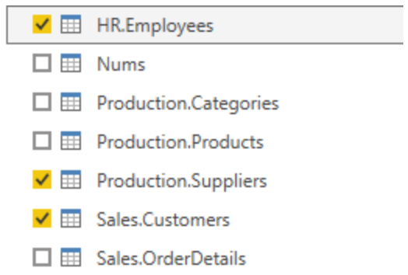](https://learn.microsoft.com/en-us/training/modules/clean-data-power-bi/media/05-choosing-tables-combine-ss.png#lightbox)

However, this data comes from multiple tables, so the dilemma is determining how you can merge the data in these multiple tables and create one source-of-truth table to create a report from. The inherent functionality of Power BI allows you to combine and merge queries into a single table.

#### Append queries

When you append queries, you'll be adding rows of data to another table or query. For example, you could have two tables, one with 300 rows and another with 100 rows, and when you append queries, you'll end up with 400 rows. When you merge queries, you'll be adding columns from one table (or query) into another. To merge two tables, you must have a column that is the key between the two tables.

For the previously mentioned scenario, you'll append the HR.Employees table with the Production.Suppliers and Sales.Customers tables so that you have one master list of contact information. Because you want to create one table that has all contact information for employees, suppliers, and customers, when you combine the queries, the pertinent columns that you require in your combined table must be named the same in your original data tables to see one consolidated view.

Before you begin combining queries, you can remove extraneous columns that you don't need for this task from your tables. To complete this task, format each table to have only four columns with your pertinent information, and rename them so they all have the same column headers: ID, company, name, and phone. The following images are snippets of the reformatted Sales.Customers, Production.Suppliers, and HR.Employees tables.

[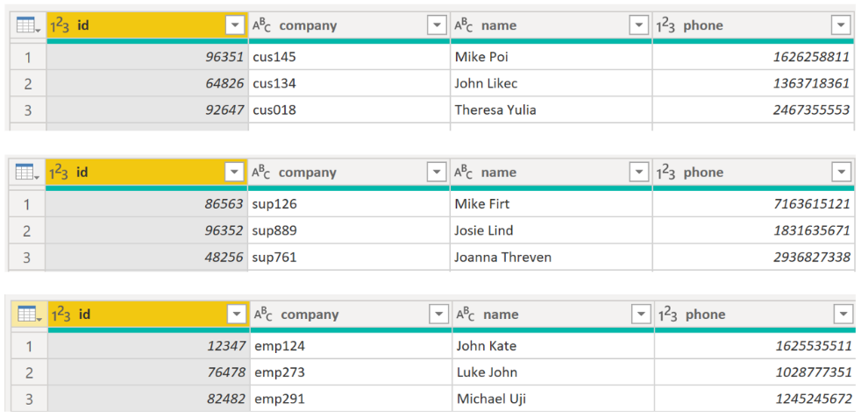](https://learn.microsoft.com/en-us/training/modules/clean-data-power-bi/media/05-reformatting-appending-ss.png#lightbox)

After you have finished reformatting, you can combine the queries. On the **Home** tab on the Power Query Editor ribbon, select the drop-down list for **Append Queries**. You can select **Append Queries as New**, which means that the output of appending will result in a new query or table, or you can select **Append Queries**, which will add the rows from an existing table into another.

Your next task is to create a new master table, so you need to select **Append Queries as New**. This selection will bring you to a window where you can add the tables that you want to append from **Available Tables** to **Tables to Append**, as shown in the following image.

[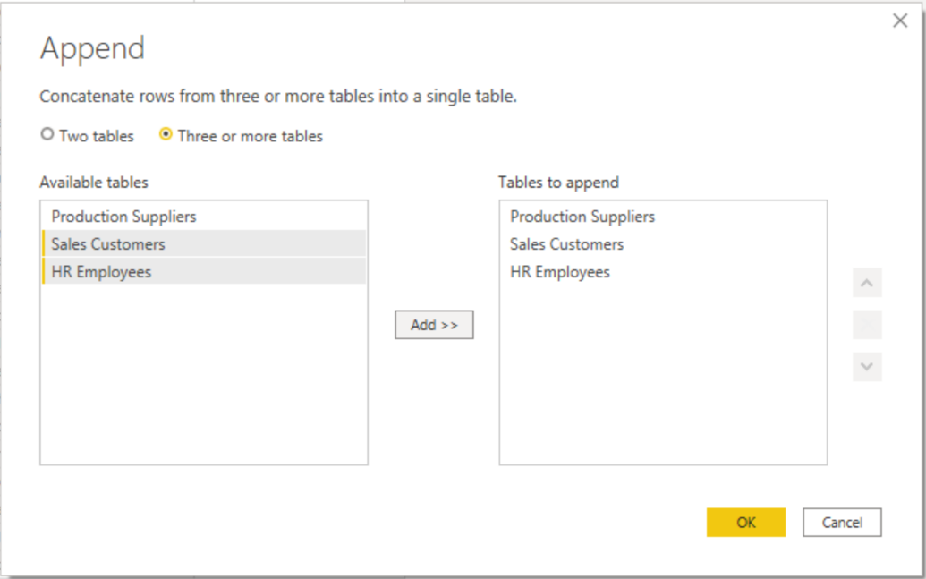](https://learn.microsoft.com/en-us/training/modules/clean-data-power-bi/media/05-append-new-window-ss.png#lightbox)

After you have added the tables that you want to append, select **OK**. You'll be routed to a new query that contains all rows from all three of your tables, as shown in the following image.

[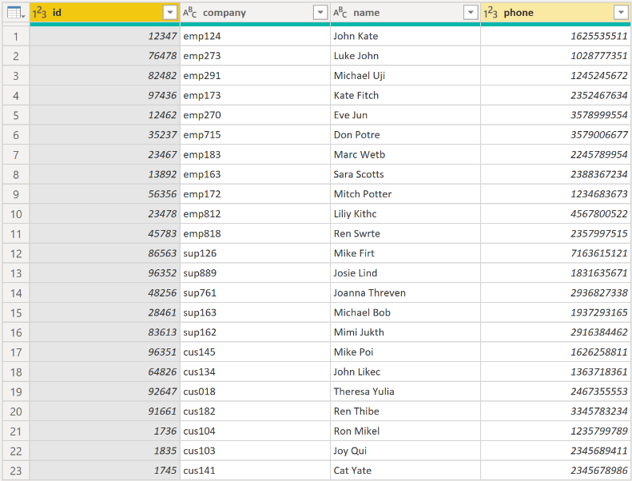](https://learn.microsoft.com/en-us/training/modules/clean-data-power-bi/media/05-appending-new-final-ss.png#lightbox)

You have now succeeded in creating a master table that contains the information for the employees, suppliers, and customers. You can exit Power Query Editor and build any report elements surrounding this master table.

However, if you wanted to merge tables instead of appending the data from one table to another, the process would be different.

#### Merge queries

When you merge queries, you're combining the data from multiple tables into one based on a column that is common between the tables. This process is similar to the JOIN clause in SQL. Consider a scenario where the Sales team now wants you to consolidate orders and their corresponding details (which are currently in two tables) into a single table. You can accomplish this task by merging the two tables, Orders and OrderDetails, as shown in the following image. The column that is shared between these two tables is **OrderID**.

[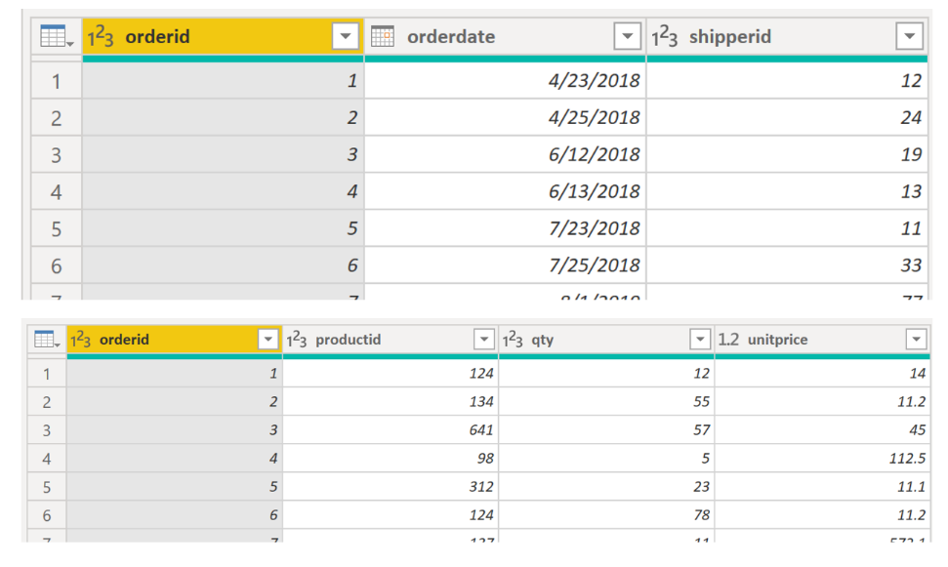](https://learn.microsoft.com/en-us/training/modules/clean-data-power-bi/media/05-merging-tables-example-ss.png#lightbox)

Go to **Home** on the Power Query Editor ribbon and select the **Merge Queries** drop-down menu, where you can select **Merge Queries as New**. This selection will open a new window, where you can choose the tables that you want to merge from the drop-down list, and then select the column that is matching between the tables, which in this case is **orderid**.

[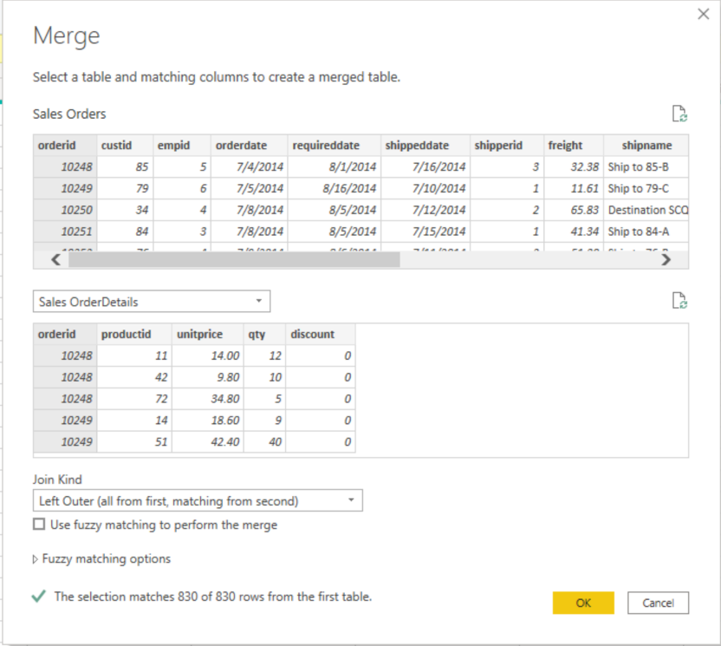](https://learn.microsoft.com/en-us/training/modules/clean-data-power-bi/media/05-merge-queries-new-ss.png#lightbox)

You can also choose how to join the two tables together, a process that is also similar to JOIN statements in SQL. These join options include:

* **Left Outer** - Displays all rows from the first table and only the matching rows from the second.
* **Full Outer** - Displays all rows from both tables.
* **Inner** - Displays the matched rows between the two tables.

For this scenario, you'll choose to use a **Left Outer** join. Select **OK**, which will route you to a new window where you can view your merged query.

[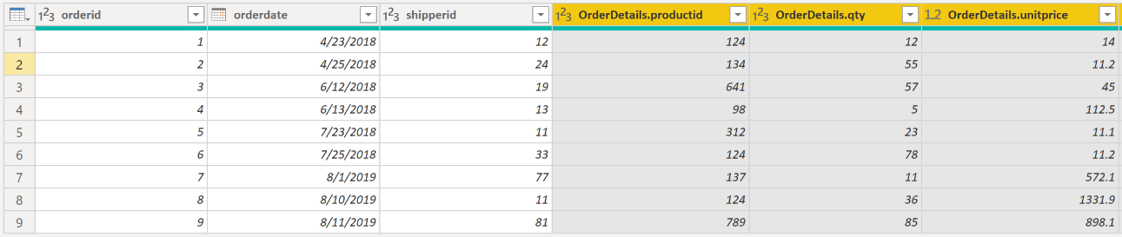](https://learn.microsoft.com/en-us/training/modules/clean-data-power-bi/media/05-merge-queries-final-view-ss.png#lightbox)

Now, you can merge two queries or tables in different ways so that you can view your data in the most appropriate way for your business requirements.

For more information on this topic, see the [Shape and Combine Data in Power BI](https://learn.microsoft.com/en-us/power-bi/connect-data/desktop-shape-and-combine-data/) documentation.

### Profile data in Power BI

Profiling data is about studying the nuances of the data: determining anomalies, examining and developing the underlying data structures, and querying data statistics such as row counts, value distributions, minimum and maximum values, averages, and so on. This concept is important because it allows you to shape and organize the data so that interacting with the data and identifying the distribution of the data is uncomplicated, therefore helping to make your task of working with the data on the front end to develop report elements near effortless.

Assume that you are developing reports for the Sales team at your organization. You are uncertain how the data is structured and contained within the tables, so you want to profile the data behind the scenes before you begin developing the visuals. Power BI has inherent functionality that makes these tasks user-friendly and straightforward.

#### Examine data structures

Before you begin examining the data in Power Query Editor, you should first learn about the underlying data structures that data is organized in. You can view the current semantic model under the **Model** tab on Power BI Desktop.

[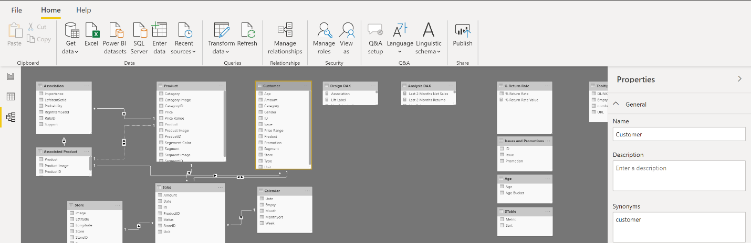](https://learn.microsoft.com/en-us/training/modules/clean-data-power-bi/media/06-data-model-ribbon-ss.png#lightbox)

On the **Model** tab, you can edit specific column and table properties by selecting a table or columns, and you can transform the data by using the **Transform Data** button, which takes you to Power Query Editor. Additionally, you can manage, create, edit, and delete relationships between different tables by using **Manage Relationships**, which is located on the ribbon.

#### Find data anomalies and data statistics

After you have created a connection to a data source and have selected **Transform Data**, you are brought to Power Query Editor, where you can determine if anomalies exist within your data. Data anomalies are outliers within your data. Determining what those anomalies are can help you identify what the normal distribution of your data looks like and whether specific data points exist that you need to investigate further. Power Query Editor determines data anomalies by using the **Column Distribution** feature.

Select **View** on the ribbon, and under **Data Preview**, you can choose from a few options. To understand data anomalies and statistics, select the **Column Distribution**, **Column Quality**, and **Column Profile** options. The following figure shows the statistics that appear.

**Column quality** and **Column distribution** are shown in the graphs above the columns of data. **Column quality** shows you the percentages of data that is valid, in error, and empty. In an ideal situation, you want 100 percent of the data to be valid.

[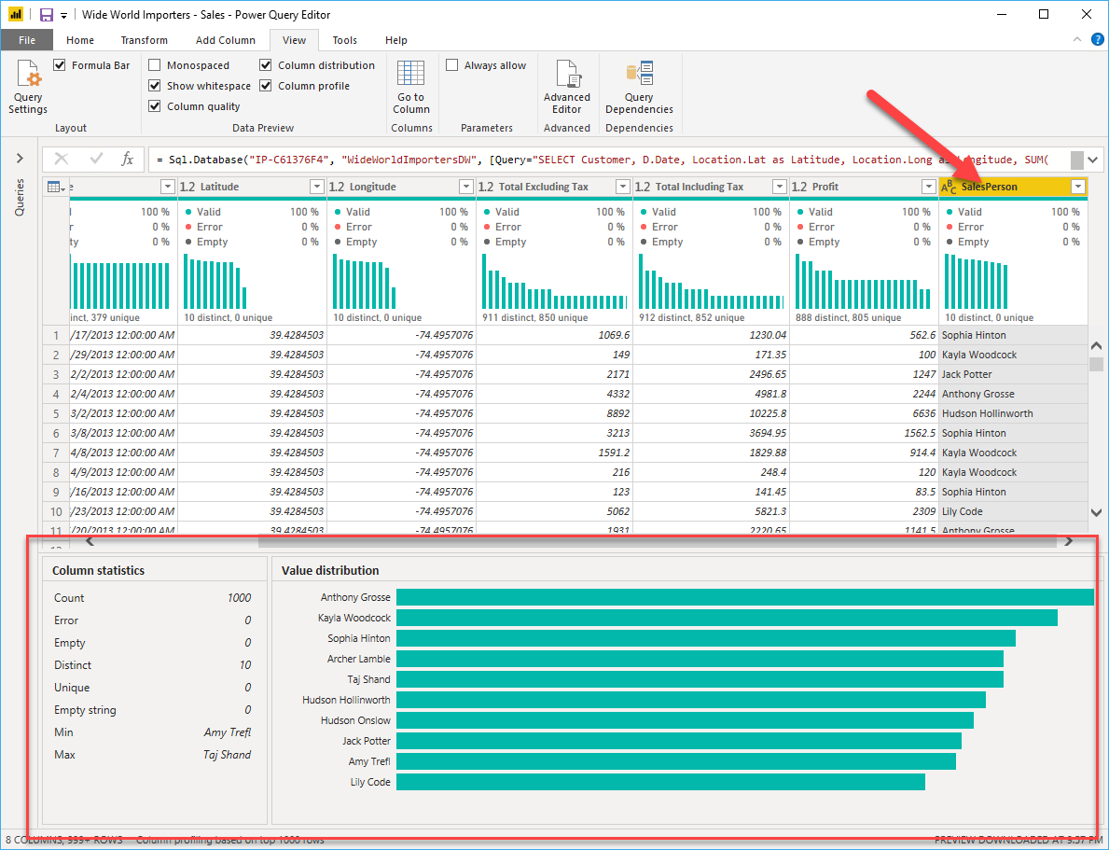](https://learn.microsoft.com/en-us/training/modules/clean-data-power-bi/media/06-column-statistics-ssm.png#lightbox)

 Note

By default, Power Query examines the first 1000 rows of your data set. To change this, select the profiling status in the status bar and select **Column profiling based on entire data set**.

**Column distribution** shows you the distribution of the data within the column and the counts of distinct and unique values, both of which can tell you details about the data counts. Distinct values are all the different values in a column, including duplicates and null values, while unique values do not include duplicates or nulls. Therefore, **distinct** in this table tells you the total count of how many values are present, while **unique** tells you how many of those values only appear once.

**Column profile** gives you a more in-depth look into the statistics within the columns for the first 1,000 rows of data. This column provides several different values, including the count of rows, which is important when verifying whether the importing of your data was successful. For example, if your original database had 100 rows, you could use this row count to verify that 100 rows were, in fact, imported correctly. Additionally, this row count will show how many rows that Power BI has deemed as being outliers, empty rows and strings, and the min and max, which will tell you the smallest and largest value in a column, respectively. This distinction is particularly important in the case of numeric data because it will immediately notify you if you have a maximum value that is beyond what your business identifies as a "maximum." This value calls to your attention these values, which means that you can then focus your efforts when delving deeper into the data. In the case where data was in the text column, as seen in the previous image, the minimum value is the first value and the maximum value is the last value when in alphabetical order.

Additionally, the **Value distribution** graph tells you the counts for each distinct value in that specific column. When looking at the graph in the previous image, notice that the value distribution indicates that "Anthony Gross" appears the greatest number of times within the **SalesPerson** column and that "Lily Code" appears the least number of times. This information is particularly important because it identifies outliers. If a value appears far more than other values in a column, the **Value distribution** feature allows you to pinpoint a place to begin your investigation into why this is so.

On a numeric column, **Column Statistics** will also include how many zeroes and null values exist, along with the average value in the column, the standard deviation of the values in the column, and how many even and odd values are in the column. These statistics give you an idea of the distribution of data within the column and are important because they summarize the data in the column and serve as a starting point to determine what the outliers are.

For example, while looking through invoice data, you notice that the **Value distribution** graph shows that a few salespeople in the **SalesPerson** column appear the same number of times within the data. Additionally, you notice the same situation has occurred in the **Profit** column and in a few other tables as well. During your investigation, you discover that the data you were using was bad data and needed to be refreshed, so you immediately complete the refresh. Without viewing this graph, you might not have seen this error so quickly and, for this reason, value distribution is essential.

After you have completed your edits in Power Query Editor and are ready to begin building visuals, return to **Home** on the Power Query Editor ribbon. Select **Close & Apply**, which will return you to Power BI Desktop and any column edits/transformations will also be applied.

You have now determined the elements that make up profiling data in Power BI, which include loading data in Power BI, interrogating column properties to gain clarity about and make further edits to the type and format of data in columns, find data anomalies, and view data statistics in Power Query Editor. With this knowledge, you can include in your toolkit the ability to study your data in an efficient and effective manner.

### Use Advanced Editor to modify M code

Each time you shape data in Power Query, you create a step in the Power Query process. Those steps can be reordered, deleted, and modified where it makes sense. Each cleaning step that you made was likely created by using the graphical interface, but Power Query uses the M language behind the scenes. The combined steps are available to read by using the Power Query Advanced Editor. The M language is always available to be read and modified directly.  It is not required that you use M code to take advantage of Power Query. You will rarely need to write M code, but it can still prove useful. Because each step in Power Query is written in M code, even if the UI created it for you, you can use those steps to learn M code and customize it to suit your needs.

After creating steps to clean data, select the **View** ribbon of Power Query and then select **Advanced Editor**.

[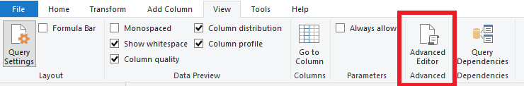](https://learn.microsoft.com/en-us/training/modules/clean-data-power-bi/media/08-view-ribbon-advanced-button-ssm.png#lightbox)

The following screen should appear.

[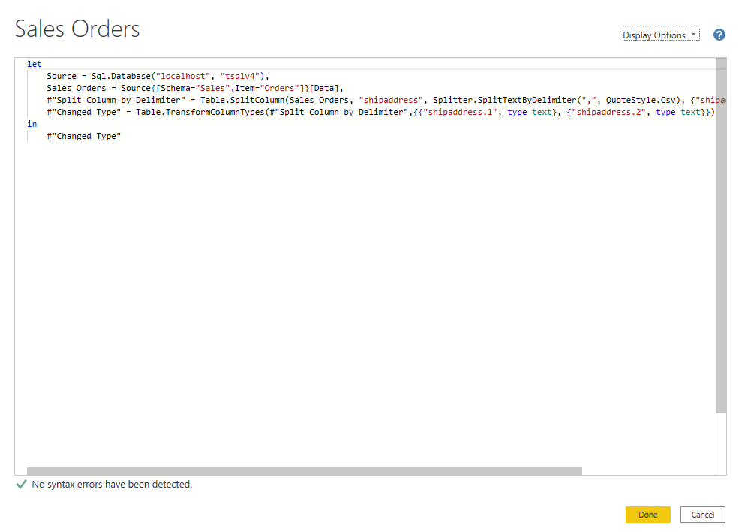](https://learn.microsoft.com/en-us/training/modules/clean-data-power-bi/media/08-m-code.png#lightbox)

Each Power Query step will roughly align with one or two lines of M code. You don't have to be an expert in M code to be able to read it. You can even experiment with changing it. For instance, if you need to change the name of a database, you could do it right in the code and then select **Done**.

You might notice that M code is written top-down. Later steps in the process can refer to previous steps by the variable name to the left of the equal sign. Be careful about reordering these steps because it could ruin the statement dependencies. Write to a query formula step by using the **in** statement. Generally, the last query step is used as the **in final data set** result.

### Exercise - Load data in Power BI Desktop

This unit includes a lab to complete.

Use the free resources provided in the lab to complete the exercises in this unit. You will not be charged **for the lab environment**; however, you may need to bring your own subscription depending on the lab.

Microsoft provides this lab experience and related content for educational purposes. All presented information is owned by Microsoft and intended solely for learning about the covered products and services in this Microsoft Learn module.

Launch lab

#### Access your environment

Before you start this lab (unless you are continuing from a previous lab), select **Launch lab** above.

You are automatically logged in to your lab environment as data-ai\student.

You can now begin your work on this lab.

 Tip

To dock the lab environment so that it fills the window, select the PC icon at the top and then select **Fit Window to Machine**.

[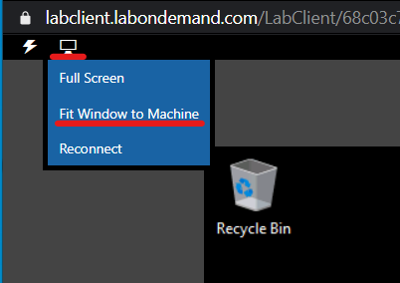](https://learn.microsoft.com/en-us/training/modules/includes/fit-window.png#lightbox)

**The estimated time to complete the lab is 45 minutes.**

 Note

A virtual machine containing the client tools you need is provide, along with the exercise instructions. Use the button above to launch the virtual machine.

*A limited number of concurrent sessions are available - if the hosted environment is unavailable, try again later.*

Alternatively, you can use these [**setup instructions**](https://microsoftlearning.github.io/PL-300-Microsoft-Power-BI-Data-Analyst/Instructions/Labs/00-setup.html) to create your own lab environment, then follow these [**exercise instructions**](https://microsoftlearning.github.io/PL-300-Microsoft-Power-BI-Data-Analyst/Instructions/Labs/02-load-data-with-power-query-in-power-bi-desktop.html).

#### Load Transformed Data in Power BI Desktop

Lab story

In this lab, you’ll use data cleansing and transformation techniques to start shaping your data model. You’ll then apply the queries to load each as a table to the data model.

In this lab you learn how to:

* Apply various transformations
* Load queries to the data model

**This lab should take approximately 45 minutes.**

#### Get started

To complete this exercise, first open a web browser and enter the following URL to download the zip folder:

<https://github.com/MicrosoftLearning/PL-300-Microsoft-Power-BI-Data-Analyst/raw/Main/Allfiles/Labs/02-load-data-with-power-query-in-power-bi-desktop/02-load-data.zip>

Extract the folder to the **C:\Users\Student\Downloads\02-load-data** folder.

Open the **02-Starter-Sales Analysis.pbix** file.

***Note****: You can dismiss the sign-in by selecting****Cancel****. Close any other informational windows. Select****Apply Later****, if prompted to apply changes.*

#### Configure the Salesperson query

In this task, you’ll use Power Query Editor to configure the **Salesperson** query.

Important:

*When instructed to rename columns, it’s important that you rename them exactly as described.*

1. To open the **Power Query Editor** window, on the **Home** ribbon tab, from inside the **Queries** group, select the **Transform Data** icon.

[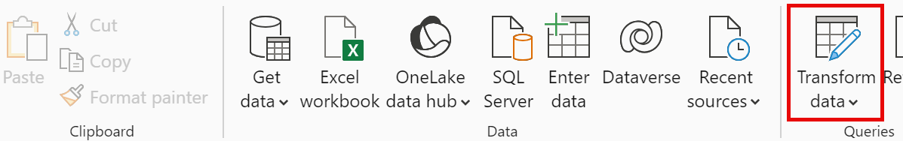](https://microsoftlearning.github.io/PL-300-Microsoft-Power-BI-Data-Analyst/Instructions/Labs/Linked_image_Files/02-load-data-with-power-query-in-power-bi-desktop_image10.png)

1. In the **Power Query Editor** window, in the **Queries** pane, select the **DimEmployee** query.

[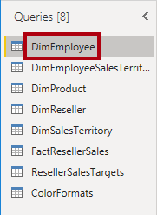](https://microsoftlearning.github.io/PL-300-Microsoft-Power-BI-Data-Analyst/Instructions/Labs/Linked_image_Files/02-load-data-with-power-query-in-power-bi-desktop_image11.png)

Note:

If you receive a warning message asking to specify how to connect, select **Edit Credentials**, connect using current credentials, and select **OK** to use an unencrypted connection.

1. To rename the query, in the **Query Settings** pane (located at the right), in the **Name** box, replace the text with **Salesperson**, and then press **Enter**. Then verify the name has been updated in **Queries** pane.

*The query name determines the model table name. It’s recommended to define concise and user-friendly names.*

1. To locate a specific column, on the **Home** ribbon tab, select the **Manage Columns** down-arrow, select the **Choose Columns** down-arrow, and then select **Go to Column**.

*Go to Column is a useful feature with many columns. Otherwise, you can horizontally scroll find columns.*

[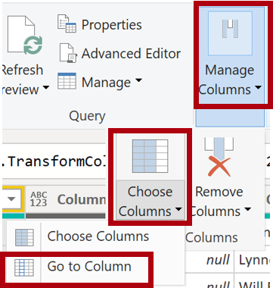](https://microsoftlearning.github.io/PL-300-Microsoft-Power-BI-Data-Analyst/Instructions/Labs/Linked_image_Files/02-load-data-with-power-query-in-power-bi-desktop_image13.png)

1. In the **Go to Column** window, to order the list by column name, select the **AZ** sort button, and then select **Name** and **SalesPersonFlag**. Click **OK**.

[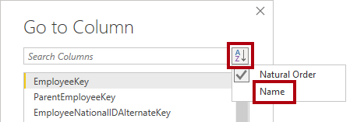](https://microsoftlearning.github.io/PL-300-Microsoft-Power-BI-Data-Analyst/Instructions/Labs/Linked_image_Files/02-load-data-with-power-query-in-power-bi-desktop_image14.png)

1. Locate the **SalesPersonFlag** column, then filter the column to select only Salespeople (that is, **TRUE**), and click **OK**.
2. In the **Query Settings** pane, in the **Applied Steps** list, notice the addition of the **Filtered Rows** step.

*Each transformation you create results in another step logic. It’s possible to edit or delete steps. It’s also possible to select a step to preview the query results at that stage of the query transformation.*

[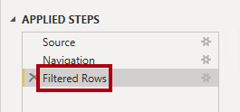](https://microsoftlearning.github.io/PL-300-Microsoft-Power-BI-Data-Analyst/Instructions/Labs/Linked_image_Files/02-load-data-with-power-query-in-power-bi-desktop_image17.png)

1. To remove columns, on the **Home** ribbon tab, select the **Manage Columns** group, select the **Choose Columns** icon.
2. In the **Choose Columns** window, to uncheck all columns, uncheck the **(Select All Columns)** item.
3. To include columns, check the following six columns:
   * EmployeeKey
   * EmployeeNationalIDAlternateKey
   * FirstName
   * LastName
   * Title
   * EmailAddress
4. In the **Applied Steps** list, notice the addition of another query step.

[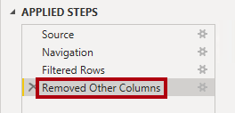](https://microsoftlearning.github.io/PL-300-Microsoft-Power-BI-Data-Analyst/Instructions/Labs/Linked_image_Files/02-load-data-with-power-query-in-power-bi-desktop_image21.png)

1. To create a single name column, first select the **FirstName** column header. While pressing the **Ctrl** key, select the **LastName** column.

[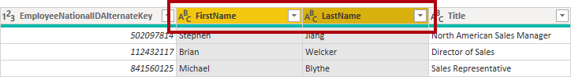](https://microsoftlearning.github.io/PL-300-Microsoft-Power-BI-Data-Analyst/Instructions/Labs/Linked_image_Files/02-load-data-with-power-query-in-power-bi-desktop_image22.png)

1. Right-click either of the select column headers, and then in the context menu, select **Merge Columns**.

*Many common transformations can be applied by right-clicking the column header, and then choosing them from the context menu. Note, however, more transformations are available in the ribbon.*

1. In the **Merge Columns** window, in the **Separator** dropdown list, select **Space**.
2. In the **New Column Name** box, replace the text with **Salesperson**.
3. To rename the **EmployeeNationalIDAlternateKey** column, double-click the **EmployeeNationalIDAlternateKey** column header and replace the text with **EmployeeID**, and then press **Enter**.
4. Use the previous steps to rename the **EmailAddress** column to **UPN**.

*UPN is an acronym for User Principal Name.*

**At the bottom-left, in the status bar, verify that the query has 5 columns and 18 rows.**

#### Configure the SalespersonRegion query

In this task, you’ll configure the **SalespersonRegion** query.

1. In the **Queries** pane, select the **DimEmployeeSalesTerritory** query.
2. In the **Query Settings** pane, rename the query to **SalespersonRegion**.
3. To remove the last two columns, first select the **DimEmployee** column header.
4. While pressing the **Ctrl** key, select the **DimSalesTerritory** column header.
5. Right-click either of the select column headers, and then in the context menu, select **Remove Columns**.

**In the status bar, verify that the query has 2 columns and 39 rows.**

#### Configure the Product query

In this task, you’ll configure the **Product** query.

Important:

*When detailed instructions have already been provided, lab steps will provide more concise instructions. If you need the detailed instructions, you can refer back to the steps of previous tasks.*

1. Select the **DimProduct** query and rename the query to **Product**.
2. Locate the **FinishedGoodsFlag** column, and then filter the column to retrieve products that are finished goods (that is, TRUE).
3. Remove all columns, **except** the following:
   * ProductKey
   * EnglishProductName
   * StandardCost
   * Color
   * DimProductSubcategory
4. Notice that the **DimProductSubcategory** column represents a related table (it contains **Value** links).
5. In the **DimProductSubcategory** column header, at the right of the column name, select the expand button.

[](https://microsoftlearning.github.io/PL-300-Microsoft-Power-BI-Data-Analyst/Instructions/Labs/Linked_image_Files/02-load-data-with-power-query-in-power-bi-desktop_image31.png)

1. See the full list of columns, then select the **Select All Columns** box to unselect all columns.
2. Select **EnglishProductSubcategoryName** and **DimProductCategory**, and uncheck the **Use Original Column Name as Prefix** checkbox before selecting **OK**.

*By selecting these two columns, a transformation will be applied to join to the****DimProductSubcategory****table, and then include these columns. The****DimProductCategory****column is, in fact, another related table in the data source.*

*Query column names must always be unique. If left checked, this checkbox would prefix each column with the expanded column name (in this case****DimProductSubcategory****). Because it’s known that the selected column names don’t collide with column names in the****Product****query, the option is deselected.*

1. Notice that the transformation resulted in the addition of two columns, and that the **DimProductSubcategory** column has been removed.
2. Expand the **DimProductCategory** column, and then introduce only the **EnglishProductCategoryName** column.
3. Rename the following four columns:
   * **EnglishProductName** to **Product**
   * **StandardCost** to **Standard Cost** (include a space)
   * **EnglishProductSubcategoryName** to **Subcategory**
   * **EnglishProductCategoryName** to **Category**

**In the status bar, verify that the query has 6 columns and 397 rows.**

#### Configure the Reseller query

In this task, you’ll configure the **Reseller** query.

1. Select the **DimReseller** query and rename to **Reseller**.
2. Remove all columns, **except** the following:
   * ResellerKey
   * BusinessType
   * ResellerName
   * DimGeography
3. Expand the **DimGeography** column, to include **only** the following three columns:
   * City
   * StateProvinceName
   * EnglishCountryRegionName
4. On the **Business Type** column header, select the down-arrow, and then review the distinct column values, and notice both values **Warehouse** and **Ware House**.
5. Right-click the **Business Type** column header, and then select **Replace Values**.
6. In the **Replace Values** window, configure the following values:
   * In the **Value to Find** box, enter **Ware House**
   * In the **Replace With** box, enter **Warehouse**

[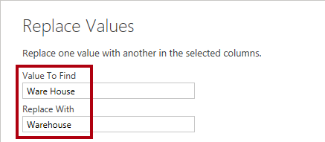](https://microsoftlearning.github.io/PL-300-Microsoft-Power-BI-Data-Analyst/Instructions/Labs/Linked_image_Files/02-load-data-with-power-query-in-power-bi-desktop_image40.png)

1. Rename the following four columns:
   * **BusinessType** to **Business Type** (include a space)
   * **ResellerName** to **Reseller**
   * **StateProvinceName** to **State-Province**
   * **EnglishCountryRegionName** to **Country-Region**

**In the status bar, verify that the query has 6 columns and 701 rows.**

#### Configure the Region query

In this task, you’ll configure the **Region** query.

1. Select the **DimSalesTerritory** query and rename the query to **Region**.
2. Apply a filter to the **SalesTerritoryAlternateKey** column to remove the value 0 (zero).

*This will remove one row.*

1. Remove all columns, **except** the following:
   * SalesTerritoryKey
   * SalesTerritoryRegion
   * SalesTerritoryCountry
   * SalesTerritoryGroup
2. Rename the following three columns:
   * **SalesTerritoryRegion** to **Region**
   * **SalesTerritoryCountry** to **Country**
   * **SalesTerritoryGroup** to **Group**

**In the status bar, verify that the query has 4 columns and 10 rows.**

#### Configure the Sales query

In this task, you’ll configure the **Sales** query.

1. Select the **FactResellerSales** query and rename it to **Sales**.
2. Remove all columns, **except** the following:
   * SalesOrderNumber
   * OrderDate
   * ProductKey
   * ResellerKey
   * EmployeeKey
   * SalesTerritoryKey
   * OrderQuantity
   * UnitPrice
   * TotalProductCost
   * SalesAmount
   * DimProduct

Note:

*You may recall in the****Prepare Data in Power BI Desktop****lab that a small percentage of****FactResellerSales****rows had missing****TotalProductCost****values. The****DimProduct****column has been included to retrieve the product standard cost column to assist fixing the missing values.*

1. Expand the **DimProduct** column, uncheck all columns, and then include only the **StandardCost** column.
2. To create a custom column, on the **Add Column** ribbon tab, from inside the **General** group, select **Custom Column**.

[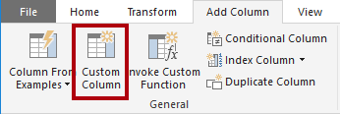](https://microsoftlearning.github.io/PL-300-Microsoft-Power-BI-Data-Analyst/Instructions/Labs/Linked_image_Files/02-load-data-with-power-query-in-power-bi-desktop_image47.png)

1. In the **Custom Column** window, in the **New Column Name** box, replace the text with **Cost**.
2. In the **Custom Column Formula** box, enter the following expression (after the equals symbol), then save the new column:

` if [TotalProductCost] = null then [OrderQuantity] * [StandardCost] else [TotalProductCost] `

***Note****: You can copy the expression from the****Snippets.txt****file in the 02-load-data folder.*

*This expression tests if the****TotalProductCost****value is missing. If missing, it produces a value by multiplying the****OrderQuantity****value by the****StandardCost****value; otherwise, it uses the existing****TotalProductCost****value.*

1. Remove the following two columns:
   * TotalProductCost
   * StandardCost
2. Rename the following three columns:
   * **OrderQuantity** to **Quantity**
   * **UnitPrice** to **Unit Price** (include a space)
   * **SalesAmount** to **Sales**
3. To modify the column data type, in the **Quantity** column header, at the left of the column name, select the **1.2** icon, and then select **Whole Number**.

*Configuring the correct data type is important. When the column contains numeric value, it’s also important to choose the correct type if you expect to perform mathematic calculations.*

[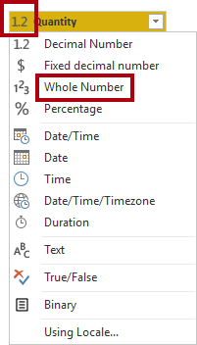](https://microsoftlearning.github.io/PL-300-Microsoft-Power-BI-Data-Analyst/Instructions/Labs/Linked_image_Files/02-load-data-with-power-query-in-power-bi-desktop_image50.png)

1. Modify the following three column data types to **Fixed Decimal Number**.

*The fixed decimal number data type allows for 19 digits, and allows for more precision to avoid rounding errors. It’s important to use the fixed decimal number type for financial values, or rates (like exchange rates).*

* + Unit Price
  + Sales
  + Cost

**In the status bar, verify that the query has 10 columns and 999+ rows.** *A maximum of 1000 rows will be loaded as preview data for each query.*

#### Configure the Targets query

In this task, you’ll configure the **Targets** query.

1. Select the **ResellerSalesTargets** query and rename to **Targets**.

**Note:** If you receive a warning message asking to specify how to connect, select **Edit Credentials**, and use anonymous access.

1. To unpivot the 12 month columns (**M01**-**M12**), first multi-select the **Year** and **EmployeeID** column headers.
2. Right-click either of the select column headers, and then in the context menu, select **Unpivot Other Columns**.
3. Notice that the column names now appear in the **Attribute** column, and the values appear in the **Value** column.
4. Apply a filter to the **Value** column to remove hyphen (-) values.

*You may recall that the hyphen character was used in the source CSV file to represent zero (0).*

1. Rename the following two columns:
   * **Attribute** to **MonthNumber** (there’s no space)
   * **Value** to **Target**
2. To prepare the **MonthNumber** column values, right-click the **MonthNumber** column header, and then select **Replace Values**.

*You’ll now apply transformations to produce a date column. The date will be derived from the****Year****and****MonthNumber****columns. You’ll create the column by using the****Columns From Examples****feature.*

1. In the **Replace Values** window, in the **Value To Find** box, enter **M** and leave the **Replace with** empty.
2. Modify the **MonthNumber** column data type to **Whole Number**.
3. On the **Add Column** ribbon tab, from inside the **General** group, select The **Column From Examples** icon.

[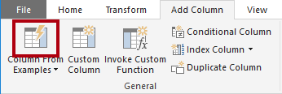](https://microsoftlearning.github.io/PL-300-Microsoft-Power-BI-Data-Analyst/Instructions/Labs/Linked_image_Files/02-load-data-with-power-query-in-power-bi-desktop_image59.png)

1. Notice that the first row is for year **2017** and month number **7**.
2. In the **Column1** column, in the first grid cell, commence entering **7/1/2017**, and then press **Enter**.

***Note****: The virtual machine uses US regional settings, so this date is in fact July 1, 2017. Other regional settings may require a****0****before the date.*

1. Notice that the grid cells update with predicted values.

*The feature has accurately predicted that you’re combining values from the****Year****and****MonthNumber****columns.*

1. Notice also the formula presented above the query grid.

[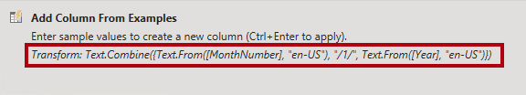](https://microsoftlearning.github.io/PL-300-Microsoft-Power-BI-Data-Analyst/Instructions/Labs/Linked_image_Files/02-load-data-with-power-query-in-power-bi-desktop_image60.png)

1. To rename the new column, double-click the **Merged** column header and rename the column as **TargetMonth**.
2. Remove the following columns:
   * Year
   * MonthNumber
3. Modify the following column data types:
   * **Target** as fixed decimal number
   * **TargetMonth** as date
4. To multiply the **Target** values by 1000, select the **Target** column header, and then on the **Transform** ribbon tab, from inside the **Number Column** group, select **Standard**, and then select **Multiply**.

*You may recall that the target values were stored as thousands.*

[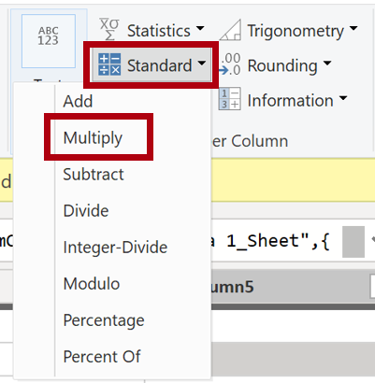](https://microsoftlearning.github.io/PL-300-Microsoft-Power-BI-Data-Analyst/Instructions/Labs/Linked_image_Files/02-load-data-with-power-query-in-power-bi-desktop_image63.png)

1. In the **Multiply** window, in the **Value** box, enter **1000**, and select **OK**.

**In the status bar, verify that the query has 3 columns and 809 rows.**

#### Configure the ColorFormats query

In this task, you’ll configure the **ColorFormats** query.

1. Select the **ColorFormats** query and notice that the first row contains the column names.
2. On the **Home** ribbon tab, from inside the **Transform** group, select **Use First Row as Headers**.

[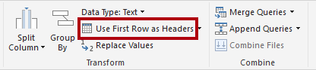](https://microsoftlearning.github.io/PL-300-Microsoft-Power-BI-Data-Analyst/Instructions/Labs/Linked_image_Files/02-load-data-with-power-query-in-power-bi-desktop_image68.png)

**In the status bar, verify that the query has 3 columns and 10 rows.**

#### Update the Product query

In this task, you’ll update the **Product** query by merging the **ColorFormats** query.

1. Select the **Product** query.
2. To merge the **ColorFormats** query, on the **Home** ribbon tab, select the **Combine** down-arrow, then select **Merge Queries**.

*Merging queries allows integrating data, in this case from different data sources (SQL Server and a CSV file).*

[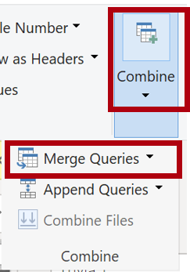](https://microsoftlearning.github.io/PL-300-Microsoft-Power-BI-Data-Analyst/Instructions/Labs/Linked_image_Files/02-load-data-with-power-query-in-power-bi-desktop_image71.png)

1. In the **Merge** window, in the **Product** query grid, select the **Color** column header.

[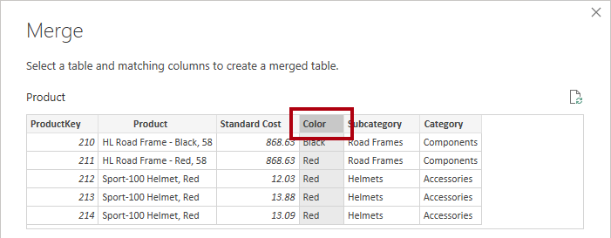](https://microsoftlearning.github.io/PL-300-Microsoft-Power-BI-Data-Analyst/Instructions/Labs/Linked_image_Files/02-load-data-with-power-query-in-power-bi-desktop_image72.png)

1. Beneath the **Product** query grid, in the dropdown list, select the **ColorFormats** query.

[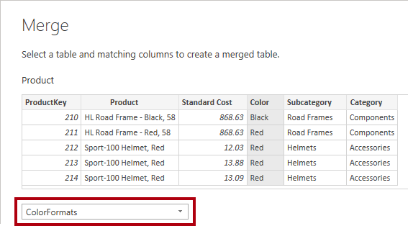](https://microsoftlearning.github.io/PL-300-Microsoft-Power-BI-Data-Analyst/Instructions/Labs/Linked_image_Files/02-load-data-with-power-query-in-power-bi-desktop_image73.png)

1. In the **ColorFormats** query grid, select the **Color** column header.
2. When the **Privacy Levels** window opens, for each of the two data sources, in the corresponding dropdown list, select **Organizational**, then **Save**.

*Privacy levels can be configured for data source to determine whether data can be shared between sources. Setting each data source as****Organizational****allows them to share data, if necessary. Private data sources can never be shared with other data sources. It doesn’t mean that Private data can’t be shared; it means that the Power Query engine can’t share data between the sources.*

[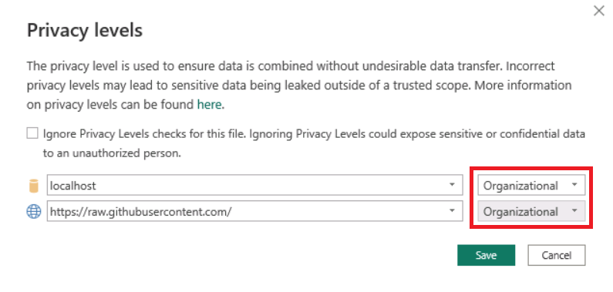](https://microsoftlearning.github.io/PL-300-Microsoft-Power-BI-Data-Analyst/Instructions/Labs/Linked_image_Files/02-load-data-with-power-query-in-power-bi-desktop_image74.png)

1. In the **Merge** window, use the default **Join Kind** - maintaining the selection of Left Outer and select **OK**.
2. Expand the **ColorFormats** column to include the following two columns:
   * Background Color Format
   * Font Color Format

**In the status bar, verify that the query now has 8 columns and 397 rows.**

#### Update the ColorFormats query

In this task, you’ll update the **ColorFormats** to disable its load.

1. Select the **ColorFormats** query.
2. In the **Query Settings** pane, select the **All Properties** link.

[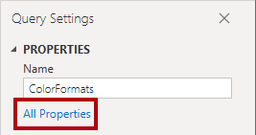](https://microsoftlearning.github.io/PL-300-Microsoft-Power-BI-Data-Analyst/Instructions/Labs/Linked_image_Files/02-load-data-with-power-query-in-power-bi-desktop_image80.png)

1. In the **Query Properties** window, uncheck the **Enable Load To Report** checkbox.

*Disabling the load means it will not load as a table to the data model. This is done because the query was merged with the****Product****query, which is enabled to load to the data model.*

[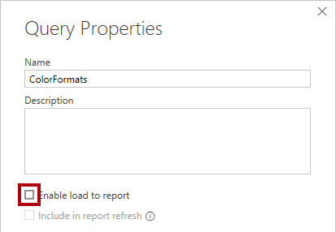](https://microsoftlearning.github.io/PL-300-Microsoft-Power-BI-Data-Analyst/Instructions/Labs/Linked_image_Files/02-load-data-with-power-query-in-power-bi-desktop_image81.png)

Review final product

1. In Power Query Editor, verify that you have **8 queries**, correctly named as follows:
   * Salesperson
   * SalespersonRegion
   * Product
   * Reseller
   * Region
   * Sales
   * Targets
   * ColorFormats (which won’t load to the data model)
2. Select **Close & Apply** to load the data to the model, and close Power Query Editor window.

[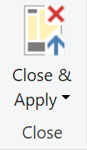](https://microsoftlearning.github.io/PL-300-Microsoft-Power-BI-Data-Analyst/Instructions/Labs/Linked_image_Files/02-load-data-with-power-query-in-power-bi-desktop_image83.png)

1. You can now see the canvas in Power BI Desktop, with Filters, Visualizations, and Data panes on the right. In the Data pane, notice the **7 tables** loaded to the data model.

[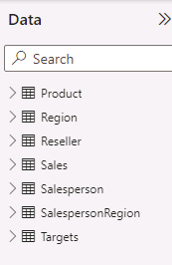](https://microsoftlearning.github.io/PL-300-Microsoft-Power-BI-Data-Analyst/Instructions/Labs/Linked_image_Files/02-load-data-with-power-query-in-power-bi-desktop_image84.png)

Lab complete

### [Check your knowledge](https://learn.microsoft.com/en-us/training/modules/clean-data-power-bi/9-check)

### Summary

This module explained how you can take data that is difficult to read, build calculations on, and discover and make it simpler for report authors and others to use. Additionally, you learned how to combine queries so that they were fewer in number, which makes data navigation more streamlined. You also replaced renamed columns into a human readable form and reviewed good naming conventions for objects in Power BI.

## Choose a Power BI model framework

### Introduction

For over two decades, Microsoft continues to make deep investments in enterprise business intelligence (BI). Azure Analysis Services (AAS) and SQL Server Analysis Services (SSAS) are based on mature BI data modeling technology used by countless enterprises. The same technology is also at the heart of Power BI data models.

Power BI offers you a choice when designing your model. You can use Power BI Desktop to develop your model, and you can develop it by using different frameworks. These frameworks help to deliver fast performance, near real-time results, or both.

This module introduces the frameworks, their benefits and limitations, and features to help optimize your models. Lastly, it provides you with guidance to help you choose the right framework and features for your project.

#### Learning objectives

By the end of this module, you’ll be able to:

* Describe Power BI model fundamentals.
* Determine when to develop an import model.
* Determine when to develop a DirectQuery model.
* Determine when to develop a composite model.
* Choose an appropriate Power BI model framework.

### Describe Power BI model fundamentals

This unit introduces Power BI model terms. It’s important that you understand these terms in order to choose the appropriate model framework for your project. This unit describes the following terms:

* Data model
* Power BI dataset
* Analytic query
* Tabular model
* Star schema design
* Table storage mode
* Model framework

#### Data model

A Power BI data model is a query-able data resource that’s optimized for analytics. Reports can query data models by using one of two analytic languages: Data Analysis Expressions (DAX) or Multidimensional Expressions (MDX). Power BI uses DAX, while paginated reports can use either DAX or MDX. The Analyze in Excel features uses MDX.

 Tip

A data model is also described as semantic model, especially in enterprise scenarios. Commonly, in the context of a data discussion and in this module, a data model is simply referred to as a model.

#### Power BI dataset

You develop a Power BI model in Power BI Desktop, and once published to a workspace in the Power BI service, it’s then known as a dataset. A dataset is a Power BI artifact that’s a source of data for visualizations in Power BI reports and dashboards.

 Note

Not all datasets originate from models developed in Power BI Desktop. Some datasets represent connections to external-hosted models in AAS or SSAS. Others can represent real-time data structures, including push datasets, streaming datasets, or hybrid datasets. This module is concerned only with models developed in Power BI Desktop.

#### Analytic query

Power BI reports and dashboards must query a dataset. When Power BI visualizes dataset data, it prepares and sends an analytic query. An analytic query produces a query result from a model that’s easy for a person to understand, especially when visualized.

An analytic query has three phases that are executed in this order:

1. Filter
2. Group
3. Summarize

**Filtering** (sometimes known as slicing) narrows down on a subset of the model data. Filter values aren’t visible in the query result. Most analytic queries apply filters because it’s common to filter by a time period, and usually other attributes. Filtering happens in different ways. In a Power BI report, you can set filters at report, page, or visual level. Report layouts often include slicer visuals to filter visuals on the report page. When the model enforces row-level security (RLS), it applies filters to model tables to restrict access to specific data. Measures, which summarize model data, can also apply filters.

**Grouping** (sometimes known as dicing) divides query result into groups. Each group is also a filter, but unlike the filtering phase, filter values are visible in the query result. For example, grouping by customer filters each group by customer.

**Summarization** produces a single value result. Typically, a report visual summarizes a numeric field by using an aggregate function. Aggregate functions include sum, count, minimum, maximum, and others. You can achieve simple summarization by aggregating a column, or you can achieve complex summarization by creating a measure using a DAX formula.

Consider an example: A Power BI report page includes a slicer to filter by a single year. There’s also a column chart visual that shows quarterly sales for the filtered year.

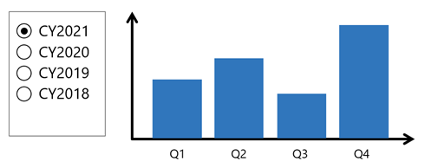

In this example, the slicer **filters** the visual by calendar year 2021. The column chart **groups** by quarters (of the filtered year). Each column is a group that represents a visible filter. The column heights represent the **summarized** sales values for each quarter of the filtered year.

#### Tabular model

A Power BI model is a tabular model. A tabular model comprises one or more tables of columns. It can also include relationships, hierarchies, and calculations.

#### Star schema design

To produce an optimized and easy-to-use tabular model, we recommend you produce a star schema design. Star schema design is a mature modeling approach widely adopted by relational data warehouses. It requires you to classify model tables as either dimension or fact.

Dimension tables describe business entities; the things you model. Entities can include products, people, places, and concepts including time itself. Fact tables store observations or events, and can be, for example, sales orders, stock balances, exchange rates, or temperature readings. A fact table contains dimension key columns that relate to dimension tables, and numeric measure columns. A fact table forms the center of a star, and the related dimension tables form the points of the star.

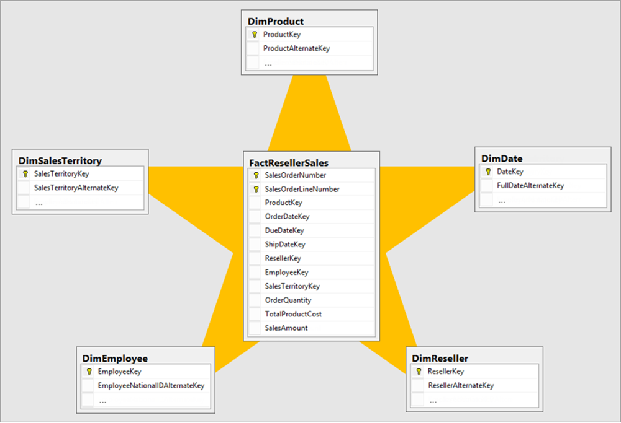

In an analytic query, dimensions table columns filter or group. Fact table columns are summarized.

For more information, see [Understand star schema and the importance for Power BI](https://learn.microsoft.com/en-us/power-bi/guidance/star-schema).

#### Table storage mode

Each Power BI model table (except calculated tables) has a storage mode property. The storage mode property can be either **Import**, **DirectQuery**, or **Dual**, and it determines whether table data is stored in the model.

* **Import** – Queries retrieve data that’s stored, or cached, in the model.
* **DirectQuery** – Queries pass through to the data source.
* **Dual** – Queries retrieve stored data or pass through to the data source. Power BI determines the most efficient plan, striving to use cached data whenever possible.

#### Model framework

Table storage mode settings determine the model framework, which can be either import, DirectQuery, or composite. The following units in this module describe each of these frameworks and provides guidance on their use.

* An import model comprises tables that have their storage mode property set to **Import**.
* A DirectQuery model comprises tables that have their storage mode property set to **DirectQuery**, and they belong to the same source group. Source group is described later in this module.
* A composite model comprises more than one source group.

### Determine when to develop an import model

An import model comprises tables that have their storage mode property set to **Import**. It includes calculated tables, which you define with a DAX formula, too.

#### Import model benefits

Import models are the most frequently developed model framework because there are many benefits. Import models:

* Support all Power BI data source types, including databases, files, feeds, web pages, dataflows, and more.
* Can integrate source data. For example, one table sources its data from a relational database while a related table sources its data from a web page.
* Support all DAX and Power Query (M) functionality.
* Support calculated tables.
* Deliver the best query performance. That’s because the data cached in the model is optimized for analytic queries (filter, group, and summarize) and the model is stored entirely in memory.

In short, import models offer you the most options and design flexibility, and they deliver fast performance. For this reason, Power BI Desktop defaults to use import storage mode when you “Get data.”



#### Import model limitations

Despite the many compelling benefits, there are limitations of import models that you must bear in mind. Limitations are related to **model size** and **data refresh**.

##### Model size

Power BI imposes dataset size restrictions, which limit the size of a model. When you publish the model to a shared capacity, there’s a 1-GB limit per dataset. When this size limit is exceeded, the dataset will fail to refresh. When you publish the model to a dedicated capacity (also known as Premium capacities), it can grow beyond 10-GB, providing you enable the [Large dataset storage format setting](https://learn.microsoft.com/en-us/power-bi/enterprise/service-premium-large-models) for the capacity.

You should always strive to reduce the amount of data stored in tables. This strategy helps to reduce the duration of model refreshes and speed up model queries. There are numerous data reduction techniques that you can apply, including:

* Remove unnecessary columns
* Remove unnecessary rows
* Group by and summarize to raise the grain of fact tables
* Optimize column data types with a preference for numeric data
* Preference for custom columns in Power Query instead of calculated columns in the model
* Disable Power Query query load
* Disable auto date/time
* Use DirectQuery table storage, as described in later units of this module.

For more information, see [Data reduction techniques for Import modeling](https://learn.microsoft.com/en-us/power-bi/guidance/import-modeling-data-reduction).

 Note

The 1-GB per dataset limit refers to the compressed size of the Power BI model, not the volume of data being collected from the source system.

##### Data refresh

Imported data must be periodically refreshed. Dataset data is only as current as the last successful data refresh. To keep data current, you set up scheduled data refresh, or report consumers can perform an on-demand refresh.

Power BI imposes limits on how often scheduled refresh operations can occur. It’s up to eight times per day in a shared capacity, and up to 48 times per day in a dedicated capacity.

You should determine whether this degree of latency is tolerable. It often depends on the velocity (or volatility) of the data, and the urgency to keep users informed about the current state of data. When scheduled refresh limits aren’t acceptable, consider using DirectQuery storage tables, or creating a hybrid table. Or take a different approach, and create a real-time dataset instead.

 Tip

Hybrid tables are described in [**unit 4**](https://learn.microsoft.com/en-us/training/modules/choose-power-bi-model-framework/5-determine-when-to-develop-composite-model). For information about real-time datasets, work through the [**Monitor data in real-time with Power BI**](https://learn.microsoft.com/en-us/training/modules/monitor-data-real-time-power-bi/) module.

You must also consider refresh workload and duration. By default, to refresh a table, Power BI removes all data and reloads it again. These operations can place an unacceptable burden on source systems, especially for large fact tables. To reduce this burden, you can set up the incremental refresh feature. Incremental refresh automates the creation and management of time-period partitions and intelligently update only those partitions that require refresh.

When your data source supports incremental refresh, it can result in faster and more reliable refreshes, and reduced resource consumption of Power BI and source systems.

Advanced data modelers can customize their own partitioning strategy. Automation scripts can create, manage, and refresh table partitions. For more information, see [Power BI usage scenarios: Advanced data model management](https://learn.microsoft.com/en-us/power-bi/guidance/powerbi-implementation-planning-usage-scenario-advanced-data-model-management). This usage scenario describes using the XMLA endpoint available with Power BI Premium.

### Determine when to develop a DirectQuery model

A DirectQuery model comprises tables that have their storage mode property set to **DirectQuery**, and they belong to the same source group.

A source group is a set of tables that connect to the same data source. There are two types:

* **Import** – Represents all import storage mode tables including calculated tables. There can only be one import source group in a model.
* **DirectQuery** – Represents all DirectQuery storage mode tables that relate to a specific data source.

 Note

An import model and a DirectQuery model only comprise a single source group. When there’s more than one source group, the model framework is known as a composite model. Composite models are described in [**Unit 5**](https://learn.microsoft.com/en-us/training/modules/choose-power-bi-model-framework/5-determine-when-to-develop-composite-model).

#### DirectQuery model benefits

There are several benefits to developing a DirectQuery model.

##### Model large or fast-changing data sources

A DirectQuery model is a great framework choice when your source data exhibits volume and/or velocity characteristics. Because DirectQuery tables don’t require refresh, they’re well suited to large data stores, like a data warehouse. It’s impractical and inefficient, if not impossible, to import an entire data warehouse into a model. When the source data changes rapidly and users need to see current data, a DirectQuery model can deliver near real-time query results.

When a report queries a DirectQuery model, Power BI passes those queries to the underlying data source.

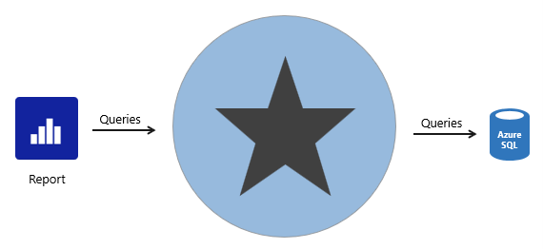

##### Enforce source RLS

DirectQuery is also useful when the source database enforces row-level security (RLS). Instead of replicating RLS rules in your Power BI model, the source data base can enforce its rules. This approach works only for some relational databases, and it involves setting up single sign-on for the dataset data source. For more information, see [Azure SQL Database with DirectQuery](https://learn.microsoft.com/en-us/power-bi/connect-data/service-azure-sql-database-with-direct-connect).

##### Data sovereignty restrictions

If your organization has security policies that restrict data leaving their premises, then it isn’t possible to import data. A DirectQuery model that connects to an on-premises data source may be appropriate. (You can also consider installing [Power BI Report Server](https://learn.microsoft.com/en-us/power-bi/report-server/get-started) for on-premises reporting.)

##### Create specialized datasets

Typically, DirectQuery mode supports relational database sources. That’s because Power BI must translate analytic queries to native queries understood by the data source.

However, there’s one powerful exception. You can connect to a Power BI dataset (or Azure Analysis Services model) and convert it to a DirectQuery local model. A local model is a relative term that describes a model’s relationship to another model. In this case, the original dataset is a remote model, and the new dataset is the local model. These models are chained, which is term used to describe related models. You can chain up to three models in this way.

This capability to chain models supports the potential to personalize and/or extend a remote model. The simplest thing you can do is rename objects, like tables or columns, or add measures to the local model. You can also extend the model with calculated columns or calculated tables, or add new import or DirectQuery tables. However, these extensions result in the creation of new source groups, which means the model becomes a composite model. That scenario is described in [Unit 5](https://learn.microsoft.com/en-us/training/modules/choose-power-bi-model-framework/5-determine-when-to-develop-composite-model).

For more information, see [Using DirectQuery for Power BI datasets and Azure Analysis Services](https://learn.microsoft.com/en-us/power-bi/connect-data/desktop-directquery-datasets-azure-analysis-services).

#### DirectQuery model limitations

There are many limitations related to DirectQuery models that you must bear in mind. Here are the main limitations:

* Not all data sources are supported. Typically, only major relational database systems are supported. Power BI datasets and Azure Analysis Services models are supported too.
* All Power Query (M) transformations are not possible, because these queries must translate to native queries that are understood by source systems. So, for example, it’s not possible to use pivot or unpivot transformations.
* Analytic query performance can be slow, especially if source systems aren’t optimized (with indexes or materialized views), or there are insufficient resources for the analytic workload.
* Analytic queries can impact on source system performance. It could result in a slower experience for all workloads, including OLTP operations.

#### Boost DirectQuery model performance

When there’s a justification to develop a DirectQuery model, you can mitigate some limitations in two ways.

##### Data source optimizations

You can optimize the source database to ensure the expected analytic query workload performs well. Specifically, you can create indexes and materialized views, and ensure the database has sufficient resources for all workloads.

 Tip

We recommend that you always work in collaboration with the database owner. It’s important that they understand the additional workload a DirectQuery model can place on their database.

##### DirectQuery user-defined aggregation tables

You can add user-defined aggregation tables to a DirectQuery model. User-defined aggregation tables are special model tables that are hidden (from users, calculations, and RLS). They work best when they satisfy higher-grain analytic queries over large fact tables. When you set the aggregation table to use DirectQuery storage mode, it can query a materialized view in the data source. You can also set an aggregation table to use import storage mode or enable automatic aggregations, and these options are described in Unit 4.

For more information, see [DirectQuery model guidance in Power BI Desktop](https://learn.microsoft.com/en-us/power-bi/guidance/directquery-model-guidance).

### Determine when to develop a composite model

A composite model comprises more than one source group. Typically, there’s always the import source group and a DirectQuery source group.

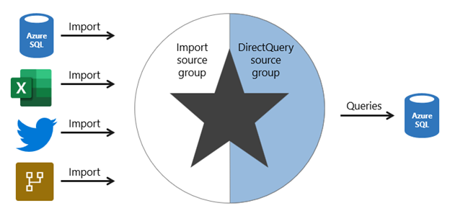

 Note

Generally, the benefits and limitations associated with import and DirectQuery storage modes apply to composite models.

#### Composite model benefits

There are several benefits to developing a composite model.

Composite models provide you with design flexibility. You can choose to integrate data using different storage modes, striking the right balance between imported data and pass-through data. Commonly, enterprise models benefit from using DirectQuery tables on large data sources and by boosting query performance with imported tables. Power BI features that support this scenario are described later in this unit.

Composite models can also boost the performance of a DirectQuery model by providing Power BI with opportunity to satisfy some analytic queries from imported data. Querying cached data almost always performs better than pass-through queries.

Lastly, when your model includes DirectQuery tables to a remote model, like a Power BI dataset, you can extend your model with new calculated columns and tables. It results in a specialized model based on a core model. For more information, see [Power BI usage scenarios: Customizable managed self-service BI](https://learn.microsoft.com/en-us/power-bi/guidance/powerbi-implementation-planning-usage-scenario-customizable-managed-self-service-bi).

#### Composite model limitations

There are several limitations related to composite models.

* Import (or dual, as described later) storage mode tables still require periodic refresh. Imported data can become out of sync with DirectQuery sourced data, so it’s important to refresh it periodically.
* When an analytic query must combine imported and DirectQuery data, Power BI must consolidate source group query results, which can impact performance. To help avoid this situation for higher-grain queries, you can add import aggregation tables to your model (or enable automatic aggregations) and set related dimension tables to use dual storage mode. This scenario is described later in this unit.
* When chaining models (DirectQuery to Power BI datasets), modifications made to upstream models can break downstream models. Be sure to assess the impact of modifications by performing [dataset impact analysis](https://learn.microsoft.com/en-us/power-bi/collaborate-share/service-dataset-impact-analysis) first.
* Relationships between tables from different source groups are known as limited relationships. A model relationship is considered limited when there's no guaranteed "one" side (The "one" side means the column contains unique values; the "many" side means the column can contain duplicate values.) This can occur in two situations. The first is when the relationship uses a many-to-many cardinality type, even if one or both columns contain unique values. The second is when the relationship spans different source groups, which only happens in composite models. Limited relationships may result in different evaluations of model queries and calculations. For more information, see [Relationship evaluation](https://learn.microsoft.com/en-us/power-bi/transform-model/desktop-relationships-understand).

#### Boost DirectQuery model performance with import data

When there’s a justification to develop a DirectQuery model, you can mitigate some limitations by using specific Power BI features that involve import tables.

##### Import aggregation tables

You can add import storage mode user-defined aggregation tables or enable automatic aggregations. This way, Power BI directs higher-grain fact queries to a cached aggregation. To boost query performance further, ensure that related dimension tables are set to use dual storage mode.

Automatic aggregations are a Premium feature. For more information, see [Automatic aggregations](https://learn.microsoft.com/en-us/power-bi/enterprise/aggregations-auto).

##### Dual storage mode

A dual storage mode table is set to use both import and DirectQuery storage modes. At query time, Power BI determines the most efficient mode to use. Whenever possible, Power BI attempts to satisfy analytic queries by using cached data.

Dual storage mode tables work well with import aggregation tables. They allow Power BI to satisfy higher-grain queries entirely from cached data.

Slicer visuals and filter card lists, which are often based on dimension table columns, render more quickly because they’re queried from cached data.

#### Deliver real-time data from an import model

When you set up an import table with incremental refresh, you can enable the **Get the latest data in real-time with DirectQuery** option.

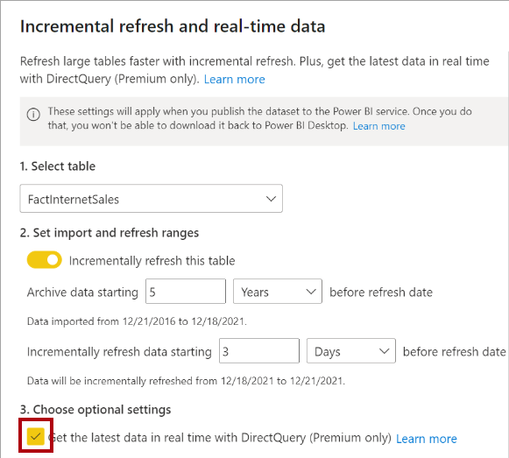

By enabling this option, Power BI automatically creates a table partition that uses DirectQuery storage mode. In this case, the table becomes a hybrid table, meaning it has import partitions to store older data, and a single DirectQuery partition for current data.

When Power BI queries a hybrid table, the query uses the cache for older data, and passes through to the data source to retrieve current data.

This option is only available with a Premium license.

For more information, see [Configure incremental refresh and real-time data](https://learn.microsoft.com/en-us/power-bi/connect-data/incremental-refresh-configure).

### Choose a model framework

Here’s some general guidance about choosing the appropriate model framework for your project. It especially applies to enterprise solutions, where data volumes are large, query throughput is high, and fast responsiveness is important.

Most importantly, choose the import model framework whenever possible. This framework offers you the most options, design flexibility, and delivers fast performance. Be sure to apply data reduction techniques to ensure that Power BI loads the least amount of data possible.

Choose the DirectQuery model framework when your data source stores large volumes of data and/or your report needs to deliver near real-time data.

Choose the composite model framework to:

* Boost the query performance of a DirectQuery model.
* Deliver near real-time query results from an import model.
* Extend a Power BI dataset (or AAS model) with additional data.

You can boost the query performance of a DirectQuery model by using aggregation tables, which can use import or DirectQuery storage mode. When using import aggregation tables, be sure to set related dimension tables to use dual storage mode. That way, Power BI can satisfy higher-grain queries entirely from cache.

You can deliver near real-time query results from in import model by creating a hybrid table. In this case, Power BI adds a DirectQuery partition for the current period.

Lastly, you can create specialized models by chaining to a core model by using DirectQuery. This type of development is typically done by a business analyst who extends core models, which IT delivers and supports.

 Important

Plan carefully. In Power BI Desktop, it’s always possible to convert a DirectQuery table to an import table. But it’s not possible to convert an import table to a DirectQuery table.

### [Knowledge check](https://learn.microsoft.com/en-us/training/modules/choose-power-bi-model-framework/7-knowledge-check)

### Summary

You can develop your Power BI model based on three different frameworks: import, DirectQuery, and composite. Each framework has its own benefits and limitations, and features to help you optimize your model.

Ultimately, you should strive to develop a model that efficiently delivers fast performance with low latency, even for high volume data sources.

# Model data with Power BI

## Design a semantic model in Power BI

### Introduction

Creating a great semantic model is one of the most important tasks that a data analyst can perform in Microsoft Power BI. By doing this job well, you help make it easier for people to understand your data, which will make building valuable Power BI reports easier for them and for you.

The pages in this module are instructional only, no data files are provided. You have a chance to work with real data in the labs.

A good semantic model offers the following benefits:

* Data exploration is faster.
* Aggregations are simpler to build.
* Reports are more accurate.
* Writing reports takes less time.
* Reports are easier to maintain in the future.

Providing set rules for what makes a good semantic model is difficult because all data is different, and the usage of that data varies. Generally, a smaller semantic model is better because it performs faster and will be simpler to use. However, defining what a smaller semantic model entails is equally as problematic because it's a heuristic and subjective concept.

Typically, a smaller semantic model is composed of fewer tables and fewer columns in each table that the user can see. If you import all necessary tables from a sales database, but the total table count is 30 tables, the user will not find that intuitive. Collapsing those tables into five tables make the semantic model more intuitive to the user, whereas if the user opens a table and finds 100 columns, they might find it overwhelming. Removing unneeded columns to provide a more manageable number increases the likelihood that the user reads all column names. To summarize, you should aim for simplicity when designing your semantic models.

The following image is an example semantic model. The boxes contain tables of data, where each line item within the box is a column. The lines that connect the boxes represent relationships between the tables. These relationships can be complex, even in such a simplistic model. The semantic model can become easily disorganized, and the total table count in the model can gradually increase. Keeping your semantic model simple, comprehensive, and accurate requires constant effort.

[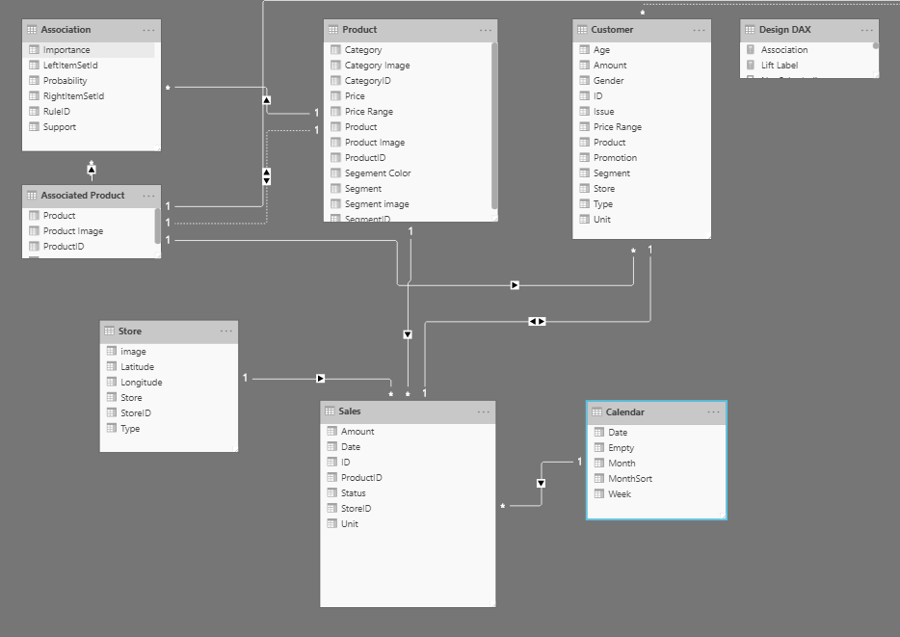](https://learn.microsoft.com/en-us/training/modules/design-model-power-bi/media/01-example-data-model-01-ss.png#lightbox)

Relationships are defined between tables through primary and foreign keys. Primary keys are column(s) that identify each unique, non-null data row. For instance, if you have a Customers table, you could have an index that identifies each unique customer. The first row has an ID of 1, the second row an ID of 2, and so on. Each row is assigned a unique value, which can be referred to by this simple value: the primary key. This process becomes important when you are referencing rows in a different table, which is what foreign keys do. Relationships between tables are formed when you have primary and foreign keys in common between different tables.

Power BI allows relationships to be built from tables with different data sources, a powerful function that enables you to pull one table from Microsoft Excel and another from a relational database. You would then create the relationship between those two tables and treat them as a unified semantic model.

Now that you have learned about the relationships that make up the data schema, you are able to explore a specific type of schema design, the star schema, which is optimized for high performance and usability.

#### Star schemas

You can design a star schema to simplify your data. It's not the only way to simplify your data, but it is a popular method; therefore, every Power BI data analyst should understand it. In a star schema, each table within your semantic model is defined as a dimension or a fact table, as shown in the following visual.

[](https://learn.microsoft.com/en-us/training/modules/design-model-power-bi/media/01-star-schema-example-01-ss.png#lightbox)

**Fact tables** contain observational or event data values: sales orders, product counts, prices, transactional dates and times, and quantities. Fact tables can contain several repeated values. For example, one product can appear multiple times in multiple rows, for different customers on different dates. These values can be aggregated to create visuals. For instance, a visual of the total sales orders is an aggregation of all sales orders in the fact table. With fact tables, it is common to see columns that are filled with numbers and dates. The numbers can be units of measurement, such as sale amount, or they can be keys, such as a customer ID. The dates represent time that is being recorded, like order date or shipped date.

**Dimension tables** contain the details about the data in fact tables: products, locations, employees, and order types. These tables are connected to the fact table through key columns. Dimension tables are used to filter and group the data in fact tables. The fact tables, on the other hand, contain the measurable data, such as sales and revenue, and each row represents a unique combination of values from the dimension tables. For the total sales orders visual, you could group the data so that you see total sales orders by product, in which product is data in the dimension table.

Fact tables are much larger than dimension tables because numerous events occur in fact tables, such as individual sales. Dimension tables are typically smaller because you are limited to the number of items that you can filter and group on. For instance, a year contains only so many months, and the United States are composed of only a certain number of states.

Considering this information about fact tables and dimension tables, you might wonder how you can build this visual in Power BI.

The pertinent data resides in two tables, Employee and Sales, as shown in the following semantic model. Because the Sales table contains the sales order values, which can be aggregated, it is considered a fact table. The Employee table contains the specific employee name, which filters the sales orders, so it would be a dimension table. The common column between the two tables, which is the primary key in the Employee table, is **EmployeeID**, so you can establish a relationship between the two tables based on this column.

[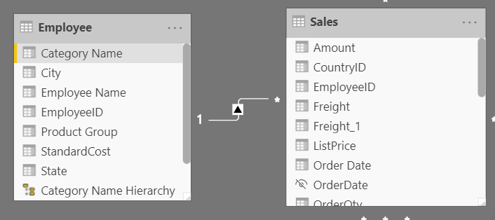](https://learn.microsoft.com/en-us/training/modules/design-model-power-bi/media/01-data-model-relationships-ss.png#lightbox)

When creating this relationship, you can build the visual according to the requirements, as shown in the following figure. If you did not establish this relationship, while keeping in mind the commonality between the two tables, you would have had more difficulty building your visual.

[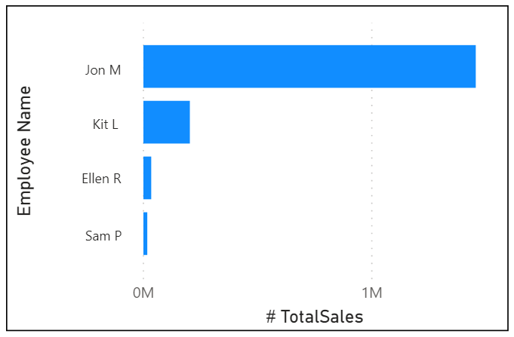](https://learn.microsoft.com/en-us/training/modules/design-model-power-bi/media/01-data-schema-example-04-ss.png#lightbox)

Star schemas and the underlying semantic model are the foundation of organized reports; the more time you spend creating these connections and design, the easier it will be to create and maintain reports.

### Work with tables

When users see fewer tables, they will enjoy using your semantic model considerably more. For example, suppose you've imported dozens of tables from many data sources and now the visual appears disorderly. In this case, you need to ensure that, before you begin working on building reports, your semantic model and table structure are simplified.

A simple table structure will:

* Be simple to navigate because of column and table properties that are specific and user-friendly.
* Have merged or appended tables to simplify the tables within your data structure.
* Have good-quality relationships between tables that make sense.

The following sections further explain how you might work with your tables to ensure a simple and readable table structure.

#### Configure semantic model and build relationships between tables

Assuming that you've already retrieved your data and cleaned it in Power Query, you can then go to the **Model** tab, where the semantic model is located. The following image shows how the relationship between the **Order** and **Sales** tables can be seen through the **OrderDate** column.

[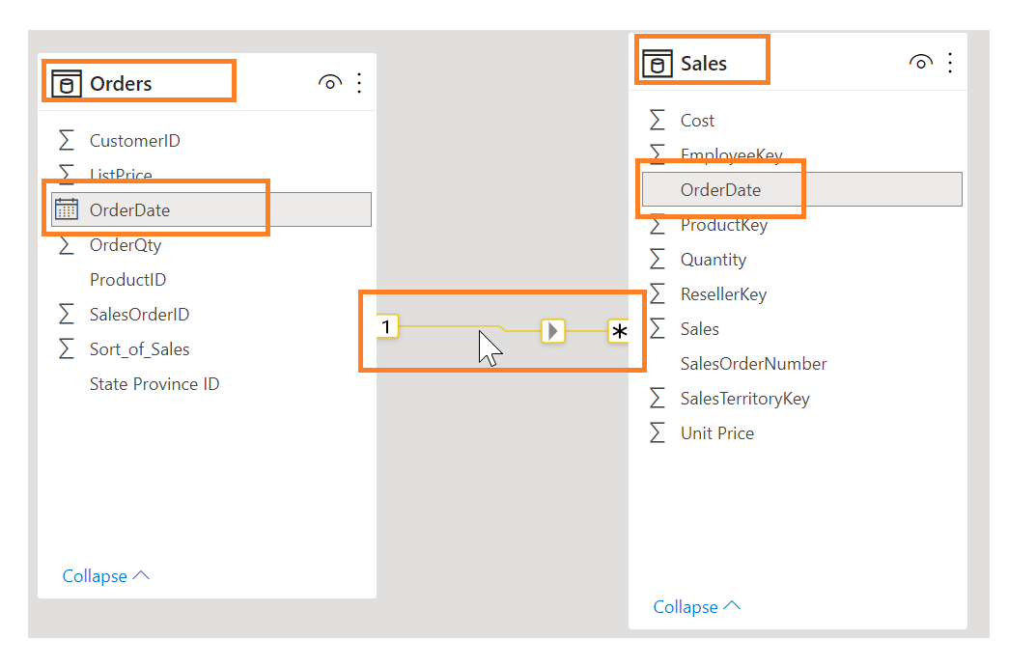](https://learn.microsoft.com/en-us/training/modules/design-model-power-bi/media/02-data-model-example-01-ssm.png#lightbox)

To manage these relationships, go to **Manage Relationships** on the ribbon, where the following window will appear.

[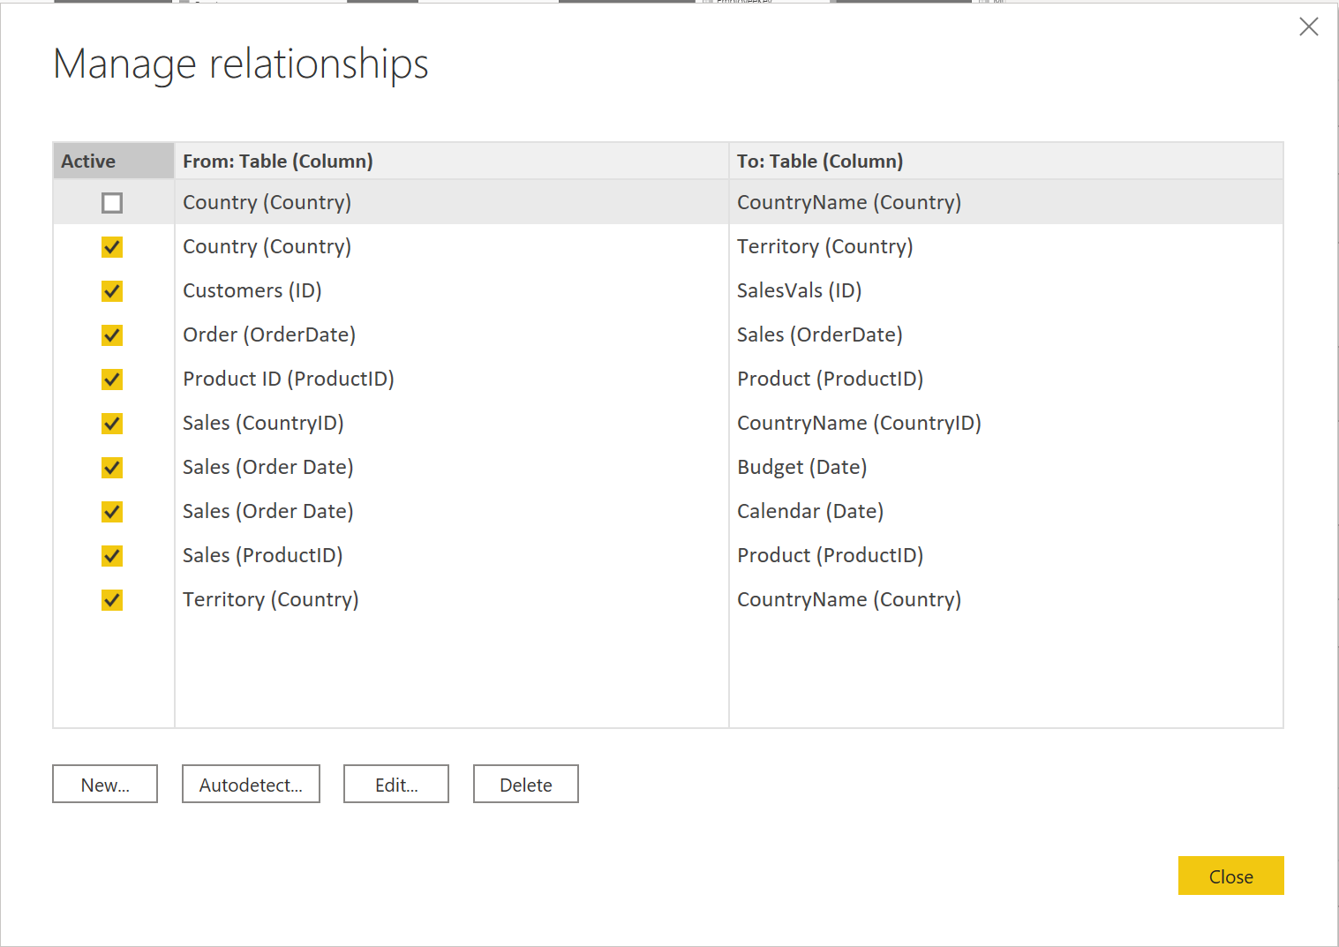](https://learn.microsoft.com/en-us/training/modules/design-model-power-bi/media/02-manage-relationships-window-02-ss.png#lightbox)

In this view, you can create, edit, and delete relationships between tables and also autodetect relationships that already exist. When you load your data into Power BI, the **Autodetect** feature will help you establish relationships between columns that are named similarly. Relationships can be inactive or active. Only one active relationship can exist between tables, which is discussed in a future module.

While the **Manage Relationships** feature allows you to configure relationships between tables, you can also configure table and column properties to ensure organization in your table structure.

#### Configure table and column properties

The **Model** view in Power BI desktop provides many options within the column properties that you can view or update. A simple method to get to this menu to update the tables and fields is by Ctrl+clicking or Shift+clicking items on this page.

[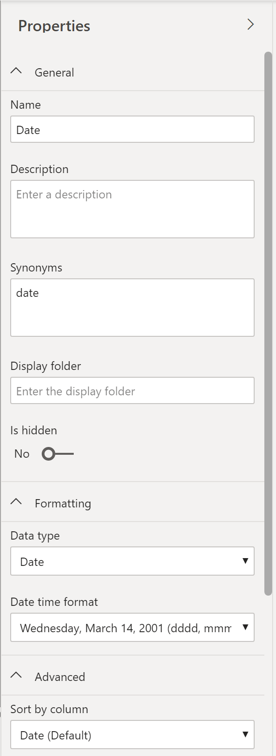](https://learn.microsoft.com/en-us/training/modules/design-model-power-bi/media/02-configure-properties-03-ss.png#lightbox)

Under the **General** tab, you can:

* Edit the name and description of the column.
* Add synonyms that can be used to identify the column when you are using the Q&A feature.
* Add a column into a folder to further organize the table structure.
* Hide or show the column.

Under the **Formatting** tab, you can:

* Change the data type.
* Format the date.

For instance, suppose that the dates in your column are formatted, as seen in the previous screenshot, in the form of "Wednesday, March 14, 2001". If you want to change the format so that the date was in the "mm/dd/yyyy" format, you would select the drop-down menu under **All date time formats** and then choose the appropriate date format, as shown in the following figure.

[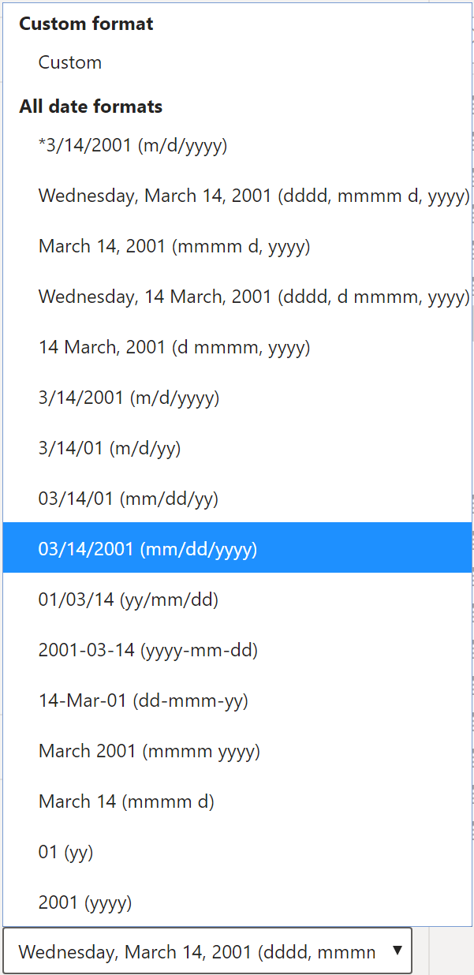](https://learn.microsoft.com/en-us/training/modules/design-model-power-bi/media/02-change-date-format-05-ss.png#lightbox)

After selecting the appropriate date format, return to the **Date** column, where you should see that the format has indeed changed, as shown in the following figure.

[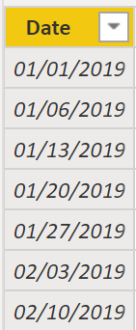](https://learn.microsoft.com/en-us/training/modules/design-model-power-bi/media/02-result-changing-format-06-ss.png#lightbox)

Under the **Advanced** tab, you can:

* Sort by a specific column.
* Assign a specific category to the data.
* Summarize the data.
* Determine if the column or table contains null values.

Additionally, Power BI has a new functionality to update these properties on many tables and fields by Ctrl+clicking or Shift+clicking items.

These examples are only some of the many types of transformations that you can make to simplify the table structure. This step is important to take before you begin making your visuals so that you don't have to go back and forth when making formatting changes. This process of formatting and configuring tables can also be done in Power Query.

### Create a date table

During report creation in Power BI, a common business requirement is to make calculations based on date and time. Organizations want to know how their business is doing over months, quarters, fiscal years, and so on. For this reason, it is crucial that these time-oriented values are formatted correctly. Power BI autodetects for date columns and tables; however, situations can occur where you will need to take extra steps to get the dates in the format that your organization requires.

For example, suppose that you are developing reports for the Sales team at your organization. The database contains tables for sales, orders, products, and more. You notice that many of these tables, including Sales and Orders, contain their own date columns, as shown by the **ShipDate** and **OrderDate** columns in the Sales and Orders tables. You are tasked with developing a table of the total sales and orders by year and month. How can you build a visual with multiple tables, each referencing their own date columns?

[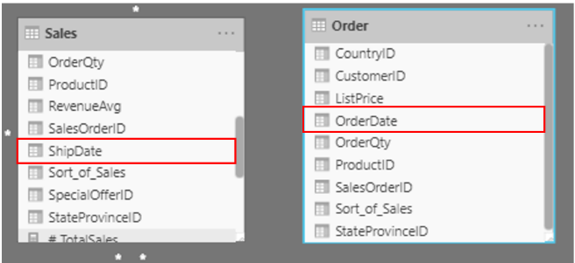](https://learn.microsoft.com/en-us/training/modules/design-model-power-bi/media/03-data-model-excerpt-ssm.png#lightbox)

To solve this problem, you can create a common date table that can be used by multiple tables. The following section explains how you can accomplish this task in Power BI.

#### Create a common date table

Ways that you can build a common date table are:

* Source data
* DAX
* Power Query

#### Source data

Occasionally, source databases and data warehouses already have their own date tables. If the administrator who designed the database did a thorough job, these tables can be used to perform the following tasks:

* Identify company holidays
* Separate calendar and fiscal year
* Identify weekends versus weekdays

Source data tables are mature and ready for immediate use. If you have a table as such, bring it into your semantic model and don't use any other methods that are outlined in this section. We recommend that you use a source date table because it is likely shared with other tools that you might be using in addition to Power BI.

If you do not have a source data table, you can use other ways to build a common date table.

#### DAX

You can use the Data Analysis Expression (DAX) functions CALENDARAUTO() or CALENDAR() to build your common date table. The CALENDAR() function returns a contiguous range of dates based on a start and end date that are entered as arguments in the function. Alternatively, the CALENDARAUTO() function returns a contiguous, complete range of dates that are automatically determined from your semantic model. The starting date is chosen as the earliest date that exists in your semantic model, and the ending date is the latest date that exists in your semantic model plus data that has been populated to the fiscal month that you can choose to include as an argument in the CALENDARAUTO() function. For the purposes of this example, the CALENDAR() function is used because you only want to see the data from May 31, 2011 (the first day that Sales began its tracking of this data) and forward for the next 10 years.

In Power BI Desktop, select **New Table**, and then enter in the following DAX formula:

DAX

Dates = CALENDAR(DATE(2011, 5, 31), DATE(2022, 12, 31))

[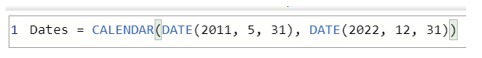](https://learn.microsoft.com/en-us/training/modules/design-model-power-bi/media/03-dax-function-calendar-auto-01-ss.png#lightbox)

Now, you have a column of dates that you can use. However, this column is slightly sparse. You also want to see columns for just the year, the month number, the week of the year, and the day of the week. You can accomplish this task by selecting **New Column** on the ribbon and entering the following DAX equation, which will retrieve the year from your Date table.

DAX

Year = YEAR(Dates[Date])

[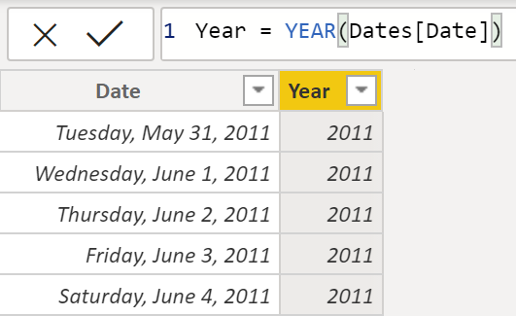](https://learn.microsoft.com/en-us/training/modules/design-model-power-bi/media/03-adding-columns-dax.png#lightbox)

You can perform the same process to retrieve the month number, week number, and day of the week:

DAX

MonthNum = MONTH(Dates[Date])

DAX

WeekNum = WEEKNUM(Dates[Date])

DAX

DayoftheWeek = FORMAT(Dates[Date], "DDDD")

When you have finished, your table will contain the columns that are shown in the following figure.

[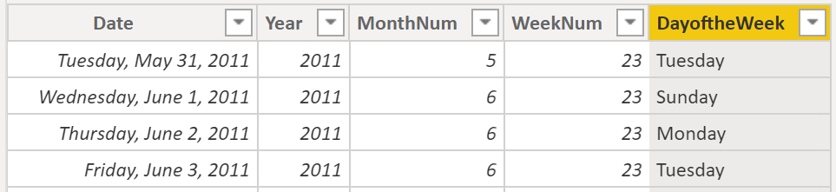](https://learn.microsoft.com/en-us/training/modules/design-model-power-bi/media/03-final-columns-dax-table-2-ss.png#lightbox)

You have now created a common date table by using DAX. This process only adds your new table to the semantic model; you will still need to establish relationships between your date table and the Sales and Order tables, and then mark your table as the official date table of your semantic model. However, before you complete those tasks, make sure that you consider another way of building a common date table: by using Power Query.

#### Power Query

You can use M-language, the development language that is used to build queries in Power Query, to define a common date table.

Select **Transform Data** in Power BI Desktop, which will direct you to Power Query. In the blank space of the left **Queries** pane, right-click to open the following drop-down menu, where you will select **New Query > Blank Query**.

[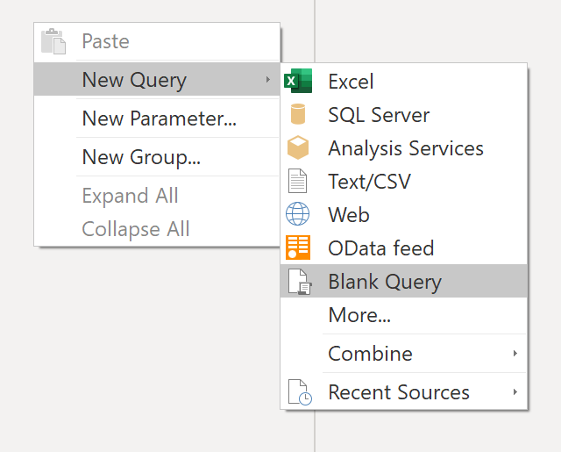](https://learn.microsoft.com/en-us/training/modules/design-model-power-bi/media/03-new-query-common-date-table-03-ss.png#lightbox)

In the resulting **New Query** view, enter the following M-formula to build a calendar table:

M

= List.Dates(#date(2011,05,31), 365*10, #duration(1,0,0,0))

[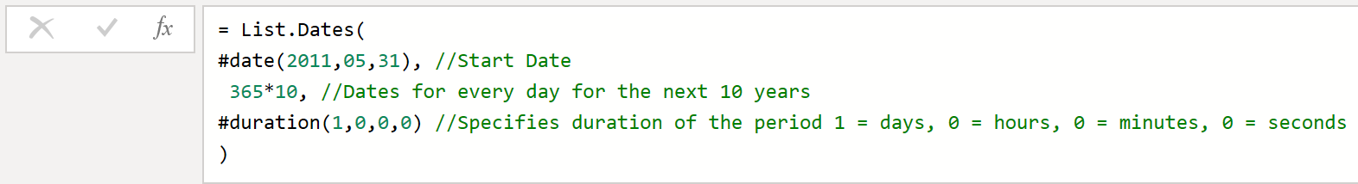](https://learn.microsoft.com/en-us/training/modules/design-model-power-bi/media/03-m-query-common-data-table-04-ss.png#lightbox)

For your sales data, you want the start date to reflect the earliest date that you have in your data: May 31, 2011. Additionally, you want to see dates for the next 10 years, including dates in the future. This approach ensures that, as new sales data flows in, you won't have to re-create this table. You can also change duration. In this case, you want a data point for every day, but you can also increment by hours, minutes, and seconds. The following figure shows the result.

[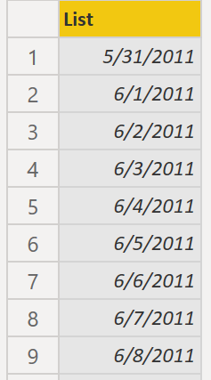](https://learn.microsoft.com/en-us/training/modules/design-model-power-bi/media/03-list-power-query-11-ss.png#lightbox)

After you have realized success in the process, you notice that you have a list of dates instead of a table of dates. To correct this error, go to the **Transform** tab on the ribbon and select **Convert > To Table**. As the name suggests, this feature will convert your list into a table. You can also rename the column to **DateCol**.

[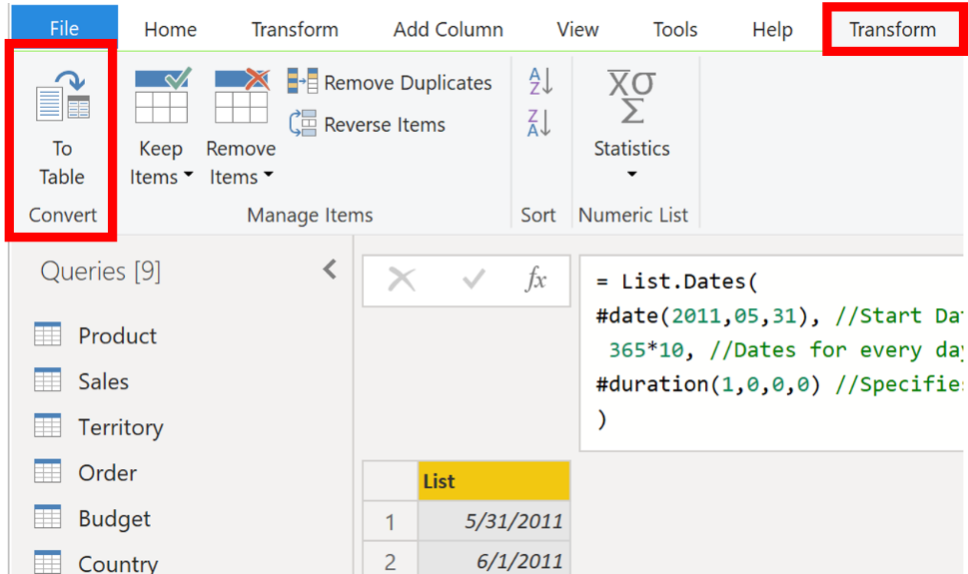](https://learn.microsoft.com/en-us/training/modules/design-model-power-bi/media/03-converting-list-table-05-ssm.png#lightbox)

Next, you want to add columns to your new table to see dates in terms of year, month, week, and day so that you can build a hierarchy in your visual. Your first task is to change the column type by selecting the icon next to the name of the column and, in the resulting drop-down menu, selecting the **Date** type.

[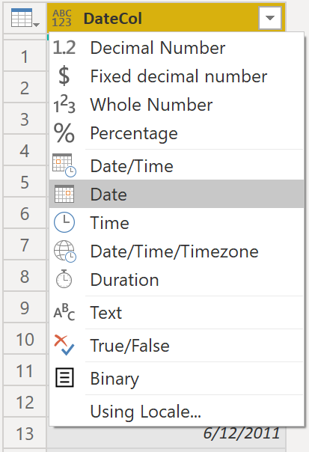](https://learn.microsoft.com/en-us/training/modules/design-model-power-bi/media/03-change-type-date-3-ss.png#lightbox)

After you have finished selecting the **Date** type, you can add columns for year, months, weeks, and days. Go to **Add Column**, select the drop-down menu under **Date**, and then select **Year**, as shown in the following figure.

[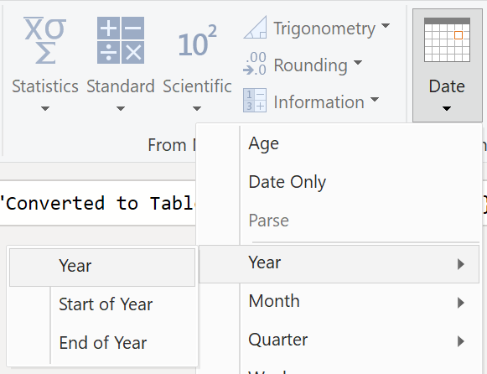](https://learn.microsoft.com/en-us/training/modules/design-model-power-bi/media/03-adding-columns-power-query-5-ss.png#lightbox)

Notice that Power BI has added a column of all years that are pulled from **DateCol**.

[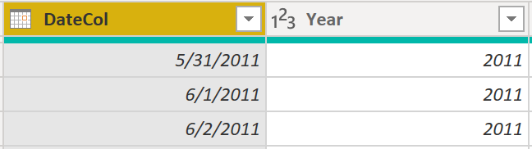](https://learn.microsoft.com/en-us/training/modules/design-model-power-bi/media/03-adding-columns-table-power-query-6-ss.png#lightbox)

Complete the same process for months, weeks, and days. After you have finished this process, the table will contain the columns that are shown in the following figure.

[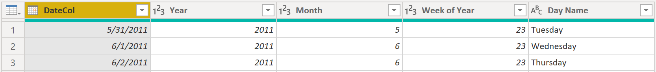](https://learn.microsoft.com/en-us/training/modules/design-model-power-bi/media/03-final-columns-using-power-query-7-ss.png#lightbox)

You have now successfully used Power Query to build a common date table.

The previous steps show how to get the table into the semantic model. Now, you need to mark your table as the official date table so that Power BI can recognize it for all future values and ensure that formatting is correct.

#### Mark as the official date table

Your first task in marking your table as the official date table is to find the new table on the **Fields** pane. Right-click the name of the table and then select **Mark as date table**, as shown in the following figure.

[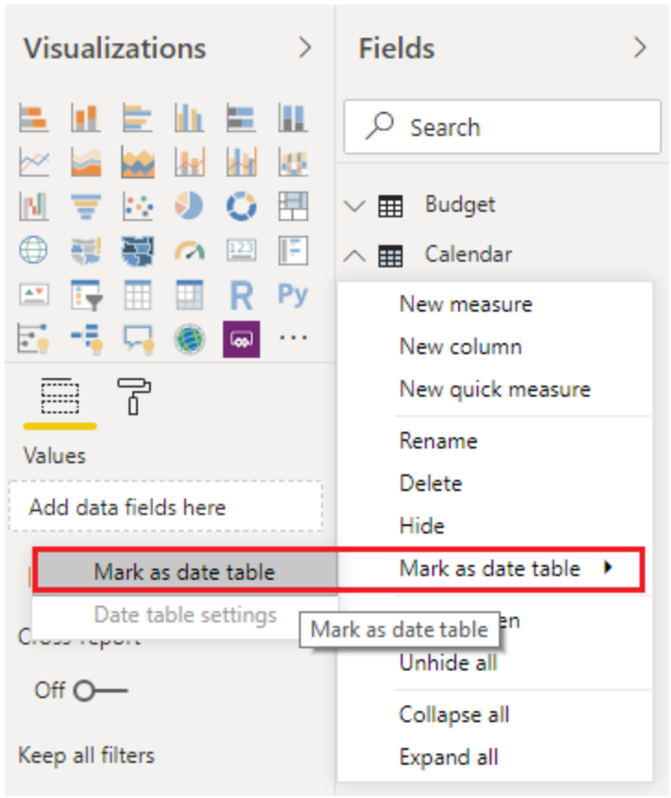](https://learn.microsoft.com/en-us/training/modules/design-model-power-bi/media/03-mark-date-table-06-ss.png#lightbox)

By marking your table as a date table, Power BI performs validations to ensure that the data contains zero null values, is unique, and contains continuous date values over a period. You can also choose specific columns in your table to mark as the date, which can be useful when you have many columns within your table. Right-click the table, select **Mark as date table**, and then select **Date table settings.** The following window will appear, where you can choose which column should be marked as **Date**.

[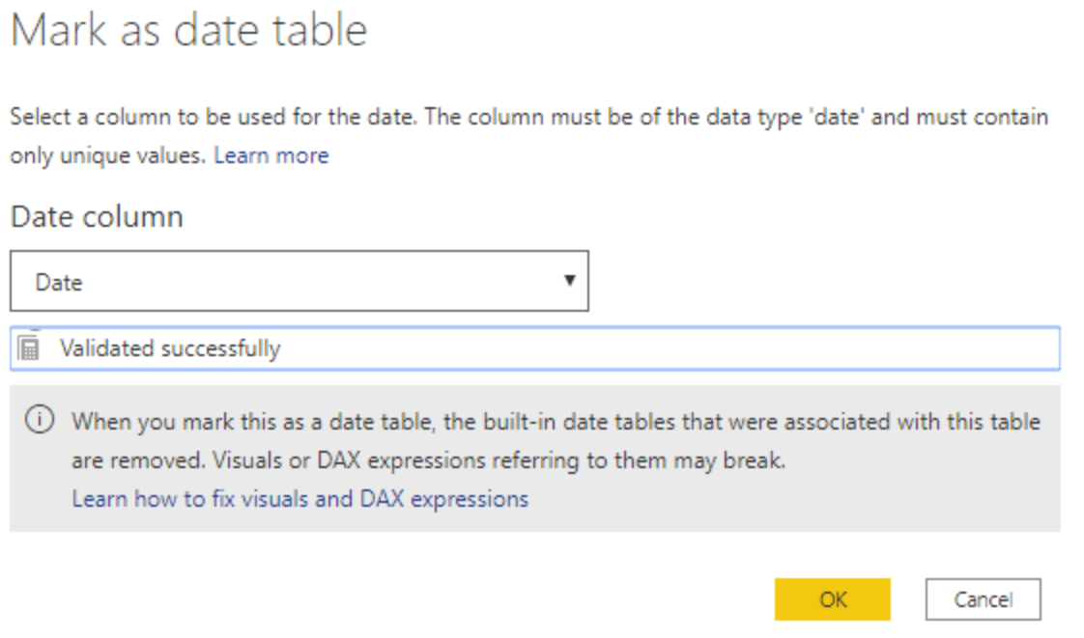](https://learn.microsoft.com/en-us/training/modules/design-model-power-bi/media/03-mark-date-table-07-ss.png#lightbox)

Selecting **Mark as date table** will remove autogenerated hierarchies from the **Date** field in the table that you marked as a date table. For other date fields, the auto hierarchy will still be present until you establish a relationship between that field and the date table or until you turn off the **Auto Date/Time** feature. You can manually add a hierarchy to your common date table by right-clicking the year, month, week, or day columns in the **Fields** pane and then selecting **New hierarchy.** This process is further discussed later in this module.

#### Build your visual

To build your visual between the Sales and Orders tables, you will need to establish a relationship between this new common date table and the Sales and Orders tables. As a result, you will be able to build visuals by using the new date table. To complete this task, go to **Model** tab **>** **Manage Relationships**, where you can create relationships between the common date table and the Orders and Sales tables by using the **OrderDate** column. The following screenshot shows an example of one such relationship.

[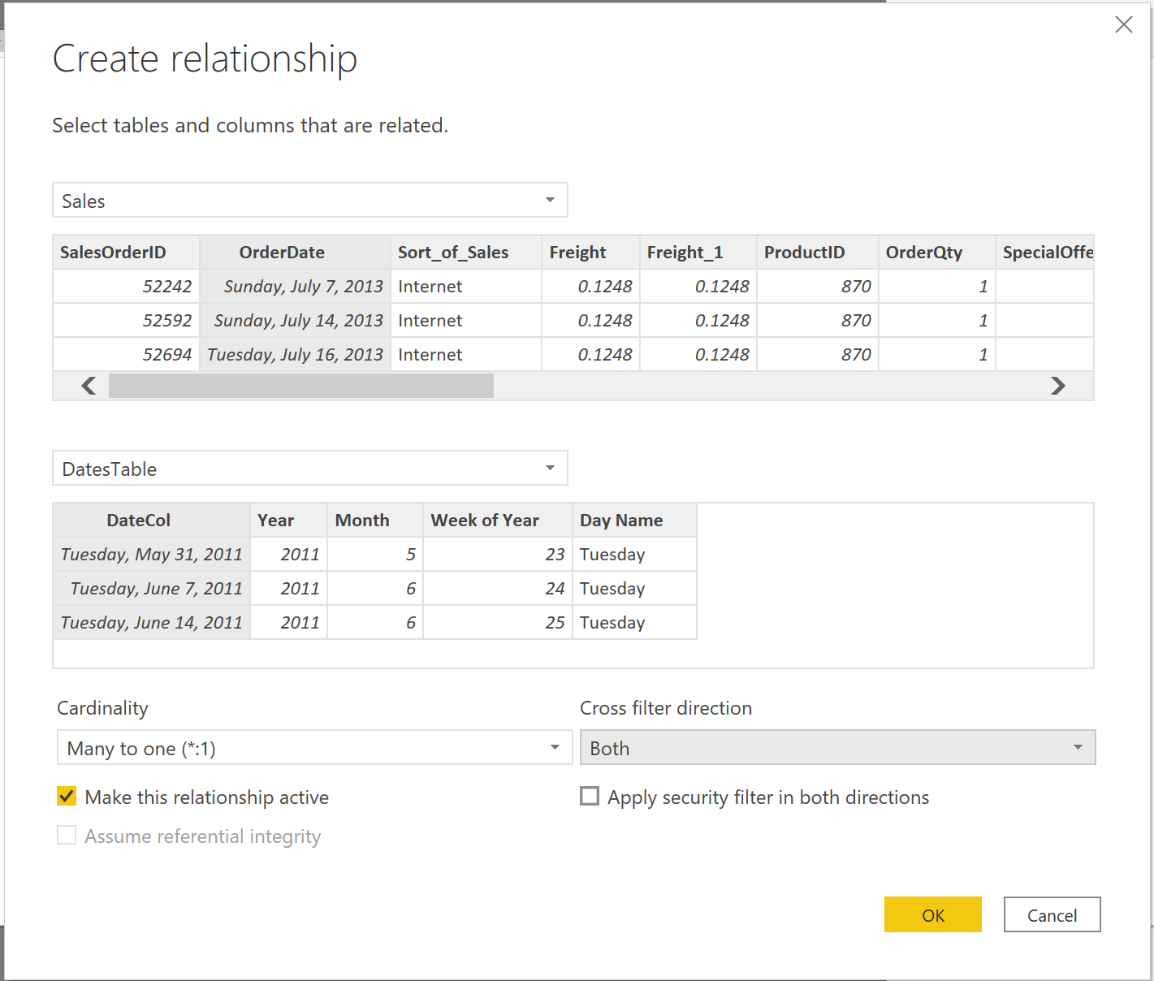](https://learn.microsoft.com/en-us/training/modules/design-model-power-bi/media/03-create-relationship-8-ss.png#lightbox)

After you have built the relationships, you can build your **Total Sales and Order Quantity by Time** visual with your common date table that you developed by using the DAX or Power Query method.

To determine the total sales, you need to add all sales because the **Amount** column in the Sales table only looks at the revenue for each sale, not the total sales revenue. You can complete this task by using the following measure calculation, which will be explained in later discussions. The calculation that you will use when building this measure is as follows:

DAX

#Total Sales = SUM(Sales[‘Amount’])

After you have finished, you can create a table by returning to the **Visualizations** tab and selecting the **Table** visual. You want to see the total orders and sales by year and month, so you only want to include the Year and Month columns from your date table, the **OrderQty** column, and the **#TotalSales** measure. When you learn about hierarchies, you can also build a hierarchy that will allow you drill down from years to months. For this example, you can view them side-by-side. You have now successfully created a visual with a common date table.

[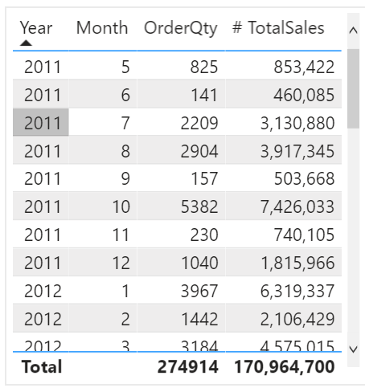](https://learn.microsoft.com/en-us/training/modules/design-model-power-bi/media/03-common-date-dax-5-ss.png#lightbox)

### Work with dimensions

When building a star schema, you will have dimension and fact tables. Fact tables contain information about events such as sales orders, shipping dates, resellers, and suppliers. Dimension tables store details about business entities, such as products or time, and are connected back to fact tables through a relationship.

You can use hierarchies as one source to help you find detail in dimension tables. These hierarchies form through natural segments in your data. For instance, you can have a hierarchy of dates in which your dates can be segmented into years, months, weeks, and days. Hierarchies are useful because they allow you to drill down into the specifics of your data instead of only seeing the data at a high level.

#### Hierarchies

When you are building visuals, Power BI automatically enters values of the date type as a hierarchy (if the table has not been marked as a date table).

[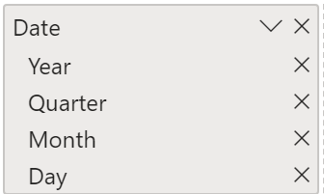](https://learn.microsoft.com/en-us/training/modules/design-model-power-bi/media/04-example-hierarchy-7-ss.png#lightbox)

In the preceding **Date** column, the date is shown in increasingly finer detail through year, quarters, months, and days. You can also manually create hierarchies.

For example, consider a situation where you want to create a stacked bar chart of **Total Sales by Category and Subcategory**. You can accomplish this task by creating a hierarchy in the **Product** table for categories and subcategories. To create a hierarchy, go to the **Fields** pane on Power BI and then right-click the column that you want the hierarchy for. Select **New hierarchy**, as shown in the following figure.

[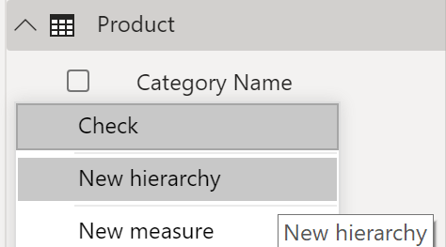](https://learn.microsoft.com/en-us/training/modules/design-model-power-bi/media/04-new-hierarchy-8-ss.png#lightbox)

Next, drag and drop the subcategory column into this new hierarchy that you've created. This column will be added as a sublevel on the hierarchy.

[](https://learn.microsoft.com/en-us/training/modules/design-model-power-bi/media/04-new-hierarchy-9-ss.png#lightbox)

Now, you can build the visual by selecting a stacked bar chart in the **Visualizations** pane. Add your **Category Name Hierarchy** in the **Axis** field and **Total Sales** in the **Values** field.

[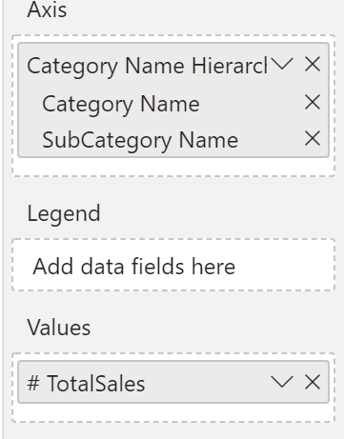](https://learn.microsoft.com/en-us/training/modules/design-model-power-bi/media/04-hierarchy-visual-7-ss.png#lightbox)

You can drill down on the visual to view both **Category** and **Subcategory**, depending on what you want to see. Hierarchies allow you to view increasing levels of data on a single view.

[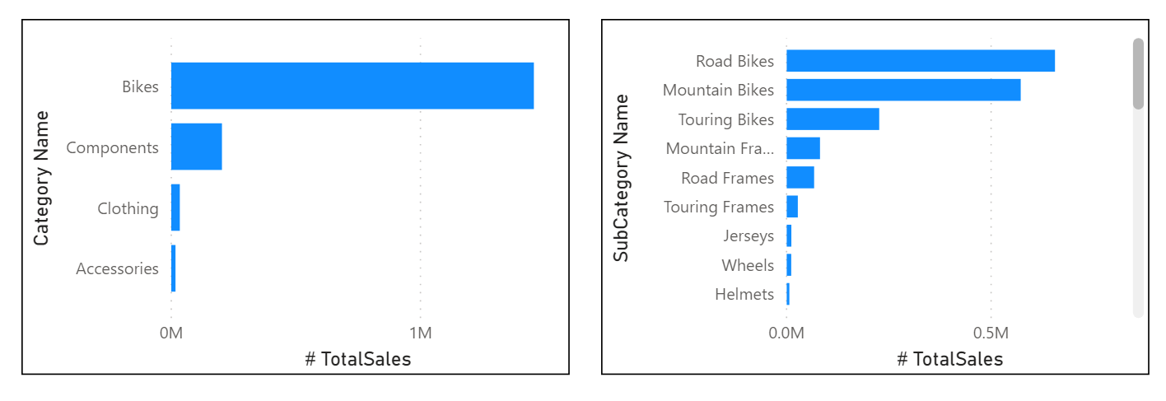](https://learn.microsoft.com/en-us/training/modules/design-model-power-bi/media/04-example-hierarchy-8-ss.png#lightbox)

Now that you have learned about hierarchies, you can take a step further and examine parent-child hierarchies and their role in multiple relationships between fact tables and dimension tables.

##### Parent-child hierarchy

In the following example, you have an Employee table within the database that tells you important information about the employees, their managers, and their IDs. When looking at this table, you notice that **Roy F** has been repeated multiple times in the **Manager** column. As the image shows, multiple employees can have the same manager, which indicates a hierarchy between managers and employees.

[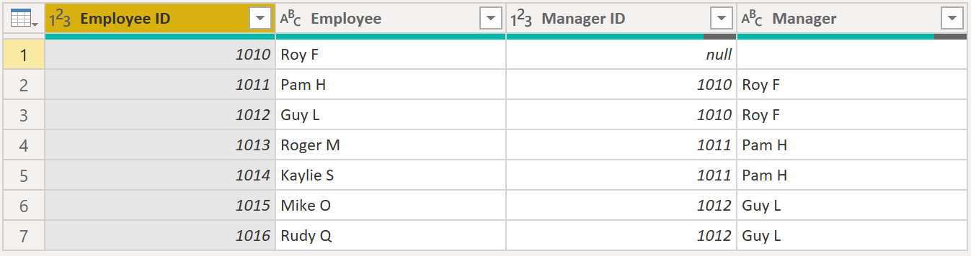](https://learn.microsoft.com/en-us/training/modules/design-model-power-bi/media/04-example-hierarchy-1-ss.png#lightbox)

The **Manager** column determines the hierarchy and is therefore the parent, while the "children" are the employees. For this example, you want to be able to see all levels of this hierarchy. Power BI does not default to showing you all levels of the hierarchy, so it is your responsibility to ensure that you see all levels of this hierarchy or "flatten" it so that you can see more data granularity.

##### Flatten parent-child hierarchy

The process of viewing multiple child levels based on a top-level parent is known as *flattening the hierarchy*. In this process, you are creating multiple columns in a table to show the hierarchical path of the parent to the child in the same record. You will use PATH(), a simple DAX function that returns a text version of the managerial path for each employee, and PATHITEM() to separate this path into each level of managerial hierarchy.

 Important

DAX has not been covered yet; however, it will be in another module. This function is included in this section because it's explaining hierarchies. If use of DAX in this capacity is confusing, refer to the DAX module and then return to this section afterward.

While on the table, go to the **Modeling** tab and select **New Column**. In the resulting formula bar, enter the following function, which creates the text path between the employee and manager. This action creates a calculated column in DAX.

DAX

Path = PATH(Employee[Employee ID], Employee[Manager ID])

[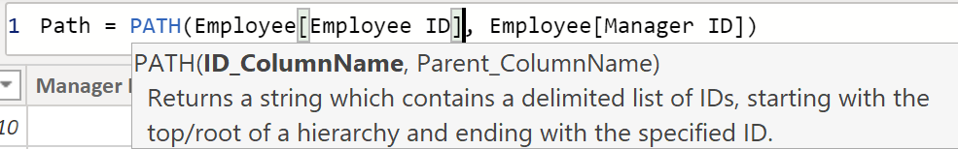](https://learn.microsoft.com/en-us/training/modules/design-model-power-bi/media/04-dax-measure-hierarchy-2-ss.png#lightbox)

The completed path between the employee and the manager appears in the new column, as shown in the following screenshot.

[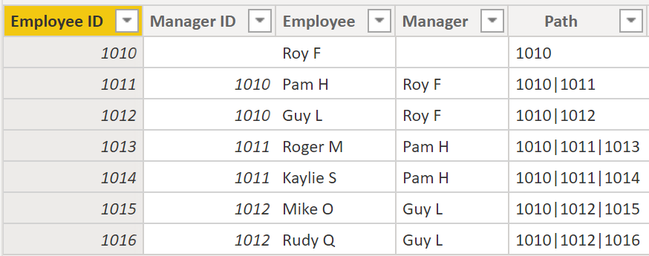](https://learn.microsoft.com/en-us/training/modules/design-model-power-bi/media/04-path-function-example-10-ss.png#lightbox)

If you look at Roger M, the path of IDs is **1010 | 1011 | 1013**, which means that one level above Roger M (ID 1013) is his manager, Pam H (ID 1011), and one level above Pam H is her manager Roy F (ID 1010). In this row, Roger M is on the bottom of the hierarchy, at the child level, and Roy F is at the top of the hierarchy and is at the parent level. This path is created for every employee. To flatten the hierarchy, you can separate each level by using the PATHITEM function.

To view all three levels of the hierarchy separately, you can create four columns in the same way that you did previously, by entering the following equations. You will use the PATHITEM function to retrieve the value that resides in the corresponding level of your hierarchy.

Level 1 = PATHITEM(Employee[Path],1)

Level 2 = PATHITEM(Employee[Path],2)

Level 3 = PATHITEM(Employee[Path],3)

[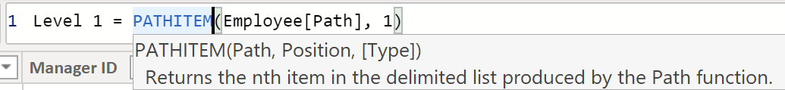](https://learn.microsoft.com/en-us/training/modules/design-model-power-bi/media/04-path-item-function-12-ss.png#lightbox)

After you have finished, notice that you now have each level of hierarchy within your table. Roy F is at the top of the hierarchy and, as you go through **Levels 2-3**, notice that the managers and employees map with each other.

[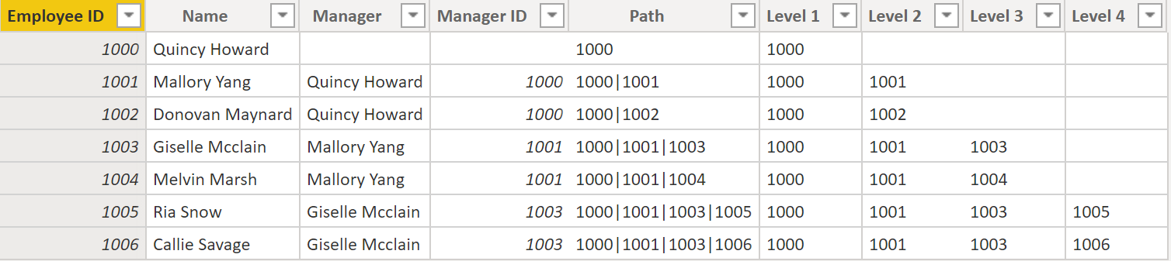](https://learn.microsoft.com/en-us/training/modules/design-model-power-bi/media/04-parent-child-hierarchy-table-06-ssm.png#lightbox)

Now, you can create a hierarchy on the **Fields** pane, as you did previously. Right-click **Level 1**, because this is the first hierarchy level, and then select **New Hierarchy.** Then, drag and drop **Level 2** and **Level 3** into this hierarchy.

[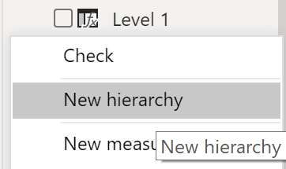](https://learn.microsoft.com/en-us/training/modules/design-model-power-bi/media/04-employee-level-hierarchy-14-ss.png#lightbox)

You have now successfully flattened a hierarchy so that you can view individual levels.

Previously, you've considered dimensions that have only one relationship with a fact table. However, situations do occur where your dimension table will have multiple relationships with a fact table.

#### Role-playing dimensions

Role-playing dimensions have multiple valid relationships with fact tables, meaning that the same dimension can be used to filter multiple columns or tables of data. As a result, you can filter data differently depending on what information you need to retrieve. This topic is complex, so it is only introduced in this section. Working with role-playing dimensions requires complex DAX functions that will be discussed in later sections.

[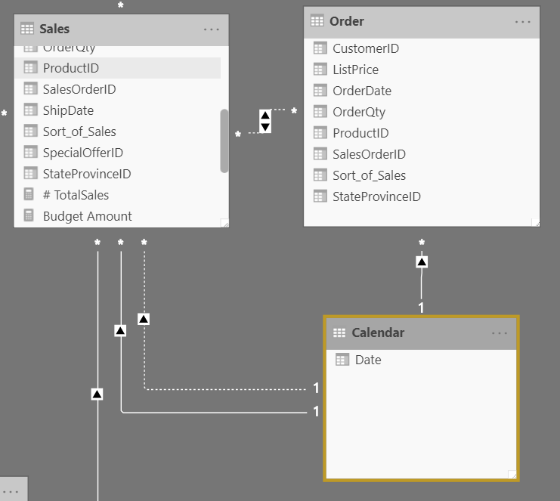](https://learn.microsoft.com/en-us/training/modules/design-model-power-bi/media/04-role-playing-dimension-05-ss.png#lightbox)

The preceding visual shows the Calendar, Sales, and Order tables. Calendar is the dimension table, while Sales and Order are fact tables. The dimension table has two relationships: one with Sales and one with Order. This example is of a role-playing dimension because the Calendar table can be used to group data in both Sales and Order. If you wanted to build a visual in which the Calendar table references the Order and the Sales tables, the Calendar table would act as a role-playing dimension.

### Define data granularity

Data granularity is the detail that is represented within your data, meaning that the more granularity your data has, the greater the level of detail within your data.

Data granularity is an important topic for all data analysts, regardless of the Power BI tools that you're using. Defining the correct data granularity can have a big impact on the performance and usability of your Power BI reports and visuals.

#### Data granularity defined

Consider a scenario where your company manages 1,000 refrigerated semi-trucks. Every few minutes, each truck uses a Microsoft Azure IoT application to record its current temperature. This temperature is important to your organization because, if the refrigeration were to malfunction, it could spoil the entire load, costing thousands of dollars. With so many trucks and so many sensors, extensive data is generated every day. Your report users don't want to sift through numerous records to find the ones that they are particularly interested in.

How can you change the granularity of the data to make the semantic model more usable?

In this scenario, you might want to import the data by using a daily average for each truck. That approach would reduce the records in the database to one record for each truck for each day. If you decide that the approach was acceptable enough for tracking costs and errors, then you could use that data granularity. Alternatively, you could select the last recorded temperature, or you could only import records that are above or below a normal range of temperatures. Any of these methods will reduce the total records that you import, while still bringing in data that is comprehensive and valuable.

For different scenarios, you could settle on data granularity that is defined weekly, monthly, or quarterly. Generally, the fewer the records that you are working with, the faster your reports and visuals will function. This approach translates to a faster refresh rate for the entire semantic model, which might mean that you can refresh more frequently.

However, that approach has a drawback. If your users want to drill into every single transaction, summarizing the granularity will prevent them from doing that, which can have a negative impact on the user experience. It is important to negotiate the level of data granularity with report users so they understand the implications of these choices.

#### Change data granularity to build a relationship between two tables

Data granularity can also have an impact when you're building relationships between tables in Power BI.

For example, consider that you're building reports for the Sales team at Tailwind Traders. You've been asked to build a matrix of total sales and budget over time by using the Calendar, Sales, and Budget tables. You notice that the lowest level of time-based detail that the Sales table goes into is by day, for instance 5/1/2020, 6/7/2020, and 6/18/2020. The Budget table only goes to the monthly level, for instance, the budget data is 5/2020 and 6/2020. These tables have different granularities that need to be reconciled before you can build a relationship between tables.

The following figure shows your current semantic model.

[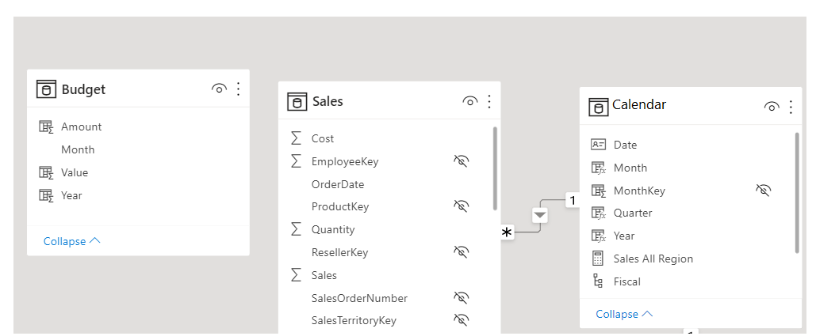](https://learn.microsoft.com/en-us/training/modules/design-model-power-bi/media/05-data-granularity-example-01-ss.png#lightbox)

As shown in the preceding figure, a relationship between Budget and Calendar is missing. Therefore, you need to create this relationship before you can build your visual. Notice that if you transform the **Year** and **Month** columns in the Calendar table into a new column, and do the same transformation in the Budget table, you can match the format of the **Date** column in the Calendar table. Then, you can establish a relationship between the two columns. To complete this task, you'll concatenate the **Year** and **Month** columns and then change the format.

[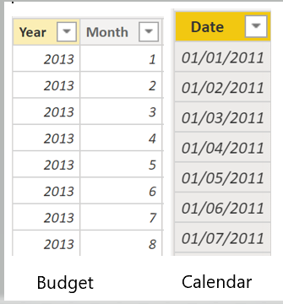](https://learn.microsoft.com/en-us/training/modules/design-model-power-bi/media/05-budget-calendar-tables-9-ss.png#lightbox)

Select **Transform Data** on the ribbon. On **Applied Steps**, on the right pane, right-click the last step and then select **Insert Step After**.

[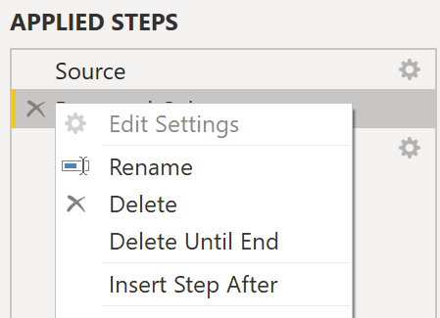](https://learn.microsoft.com/en-us/training/modules/design-model-power-bi/media/05-applied-steps-10-ss.png#lightbox)

Under **Add Column** on the Home ribbon, select **Custom Column**. Enter the following equation, which will concatenate the **Year** and **Month** columns, and then add a dash in between the column names.

M

Column = Table.AddColumn(#"Renamed Columns", "Custom", each [Year] & "-" &[Month])

Change the data type to **Date** and then rename the column. Your Budget table should resemble the following figure.

[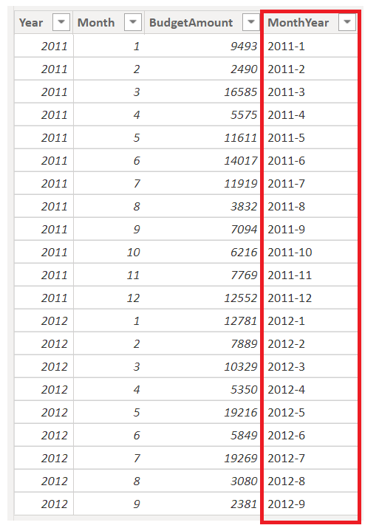](https://learn.microsoft.com/en-us/training/modules/design-model-power-bi/media/05-custom-column-date-02-ssm.png#lightbox)

Now, you can create a relationship between the Budget and the Calendar tables.

#### Create a relationship between tables

Power BI automatically detects relationships, but you can also go to **Manage Relationships > New** and create the relationship on the **Date** column. The relationship should resemble the following figure.

[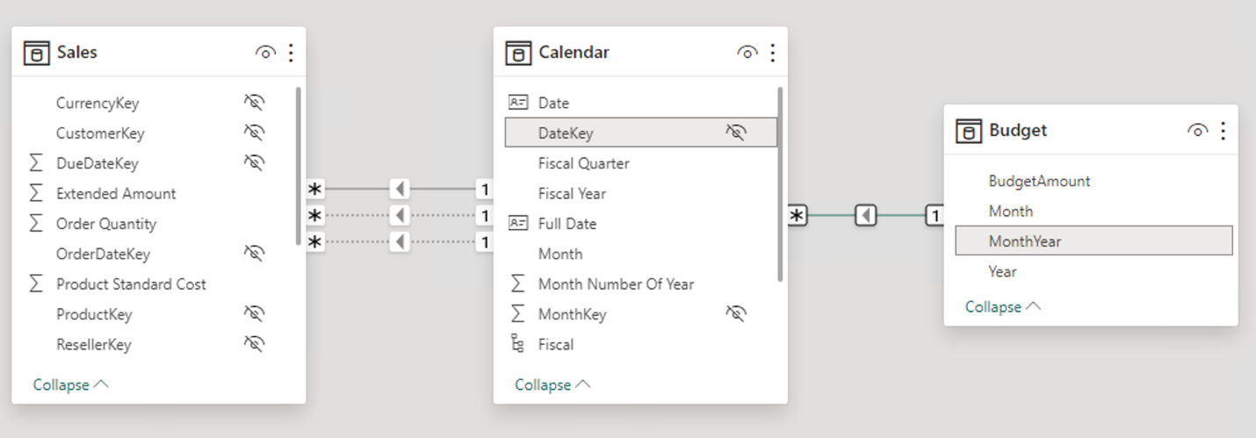](https://learn.microsoft.com/en-us/training/modules/design-model-power-bi/media/05-establishing-relationships-03-ssm.png#lightbox)

By completing this task, you've ensured that the granularity is the same between your different tables. Now, you need to create DAX measures to calculate **Total Sales** and **BudgetAmount**. Go to the **Data** pane on Power BI Desktop, select **New Measure**, and then create two measures with the following equations:

DAX

TotalSales = SUM(Sales[Total Sales])

DAX

BudgetAmount = SUM (Budget[BudgetAmount])

Select the table visual on the **Visualization** pane, and then enter these measures and the **Date** into the **Values** field. You've now accomplished the goal of building a matrix of the total sales and budgets over time.

[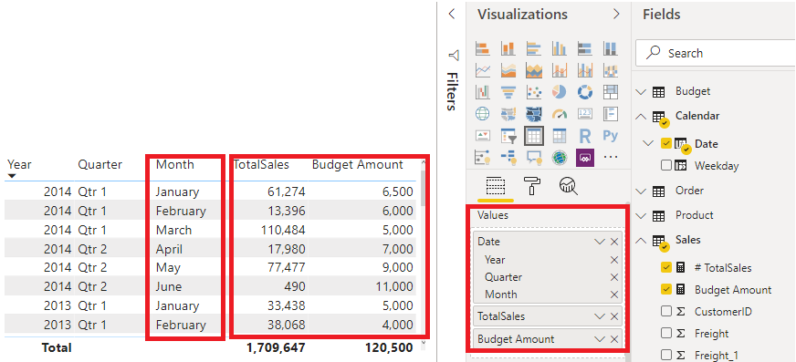](https://learn.microsoft.com/en-us/training/modules/design-model-power-bi/media/05-matrix-visual-being-built-04-ssm.png#lightbox)